Contents

chapter 1.1 (week 1)—Whitman & Dickinson, two proto-modernists 5

I dwell in Possibility — (#466) by Emily Dickinson 5

Tell all the truth but tell it slant— (#1263) by Emily Dickinson 5

Whitman's "Song of Myself" 1, 2, 3, 5, 6, 8, 10, 14, 47 & 52 6

chapter 1.2 (week 2)—Whitmanians & Dickinsonians 60

"Smell!" by William Carlos Williams 61

"Danse Russe" by William Carlos Williams 61

"A Supermarket in California" by Allen Ginsberg 62

"Grandfather advised me" or "Poet's Work" by Lorine Niedecker 64

Lorine Niedecker's “You are my friend” 65

Foreclosure by Lorine Niedecker 65

"It isnt for want" by Cid Corman 66

"The Way" by Rae Armantrout 66

chapter 2.1 (week 3)—the rise of poetic modernism: imagism 68

"Sea Rose" by H.D. 68

"Sea Poppies" by H.D. 69

"In a Station of the Metro" by Ezra Pound 70

Read a selection of critical commentary on Ezra Pound's "In a Station of the Metro": 70

"The Encounter" by Ezra Pound 72

"Thirteen Ways of Looking at a Blackbird" by Wallace Stevens 72

chapter 2.2 (week 3 cont.)—the rise of poetic modernism: Williams 75

"Lines" by William Carlos Williams 75

"Between Walls" by William Carlos Williams 75

"This Is Just to Say" by William Carlos Williams 76

Flossie Williams's reply to "This Is Just to Say" 76

"The Red Wheelbarrow" by William Carlos Williams 78

Marcel Duchamp’s Fountain 79

"The rose is obsolete..." by William Carlos Williams 79

"Portrait of a Lady" by William Carlos Williams 82

Nude Descending a Staircase  by Duchamp 84

chapter 2.3 (week 4)—the rise of poetic modernism: Stein 85

Gertrude Stein's "A Long Dress" from Tender Buttons 85

Gertrude Stein's "A Carafe, That Is a Blind Glass" (from the "Objects" section of Tender Buttons) 85

The Difference is Spreading: on Gertrude Stein 86

Gertrude Stein's "Water Raining" and "Malachite" from Tender Buttons 88

Gertrude Stein's statement on narrative: 88

Gertrude Stein's statement on the noun (from "Poetry and Grammar"): 88

Gertrude Stein on repetition: from The Making of Americans 89

Gertrude Stein on composition (from "Composition as Explanation"): 89

Gertrude Stein's "Let Us Describe", from "Idem the Same, A Valentine to Sherwood Anderson 89

Gertrude Stein's "If I Told Him: A Completed Portrait of Picasso":  (1923) 89

Ulla Dydo's prefatory comment on Stein's "If I Told Him: A Completed Portrait of Picasso": 94

chapter 2.4 (week 4)—the rise of poetic modernism: modernist edges 95

“A Dozen Cocktails—Please” by Baroness Elsa von Freytag Loringhoven 95

William Carlos Williams's Autobiography about the Baroness Elsa von Freytag Loringhoven: 97

"To Make a Dadaist Poem" by Tristan Tzara 101

Tristan Tzara's "To Make a Dadaist Poem" as part of a general introduction to the poetry of "chance operations" 101

the sonnet 103

"Forcing twentieth-century America into a sonnet— gosh, how I hate sonnets—is like putting a crab into a square box. You’ve got to cut off his legs to make him fit. When you get through, you don’t have a crab anymore." 104

"A Recollection" by John Peale Bishop 104

chapter 3 (week 5)—communist poets of the 1930s 105

"Lines for an Abortionist's Office", by Ruth Lechlitner, 1936 105

"Interior" by Genevieve Taggard 106

chapter 4 (week 5 cont.)—the Harlem Renaissance 107

Yet Do I Marvel by Countee Cullen 107

"Incident" by Countee Cullen 108

"If We Must Die" by Claude McKay 109

"Dinner Guest: Me" by Langston Hughes 109

"Boy Breaking Glass" by Gwendolyn Brooks 110

"truth" by Gwendolyn Brooks 112

chapter 5 (week 5 cont.)—Frost 113

"Mending Wall" by Robert Frost 113

chapter 6 (week 5 cont.)—formalism of the 1950s 115

"The Death of a Toad" by Richard Wilbur 116

"Nude Descending a Staircase" by X. J. Kennedy, 1960 116

chapter 7 (week 6)—breaking conformity: the beats 117

"Howl" (part 1) by Allen Ginsberg 117

"Essentials of Spontaneous Prose" by Jack Kerouac 122

"Belief & Technique for Modern Prose" by Jack Kerouac 123

Jack Kerouac's spontaneous method: three samples from Book of Dreams and Old Angel Midnight 126

The following summary is adapted from Ann Charters's "Editor's Introduction" to the section of The Portable Jack Kerouac, opening the section Charters titles "The Modern Spontaneous Method": 126

SAMPLE #1 — from Book of Dreams 126

SAMPLE #2—from Book of Dreams 127

SAMPLE #3—from Old Angel Midnight 127

"October in the Railroad Earth" by Jack Kerouac 127

Jack Kerouac speaks about “October in the Railroad Earth” during an interview with Ted Berrigan for The Paris Review 128

a sample of Jack Kerouac's "babble flow": 128

“Jail Poems” by Bob Kaufman (sections-3-4-7-14-19-22-34-35) 129

"I Know a Man" by Robert Creeley 131

Anne Waldman Rogue State 131

"Incident" by Amiri Baraka 132

Amiri Baraka's "How You Sound??" 134

chapter 8 (week 7)—the New York School 135

"The Day Lady Died" by Frank O'Hara 135

"Variations of a Theme by William Carlos Williams" by Kenneth Koch 137

"The Instruction Manual" by John Ashbery 138

"A Step Away from Them" by Frank O'Hara 140

Barbara Guest's "20" 141

"Some Trees" by John Ashbery 142

"Hard Times" by John Ashbery 144

"3 Pages" by Ted Berrigan 144

"Invasion of the Body Snatchers" by Bernadette Mayer 145

"Uptown Ode That Ends on an Ode to the Machete" by Patrick Rosal 148

chapter 9.1 (week 8)—some trends in recent poetry: L=A=N=G=U=A=G=E 151

"Albany" by Ron Silliman 151

Lyn Hejinian's "My Life" (see separated file) 153

"Chronic Meanings" by Bob Perelman 153

"In a Restless World Like This Is" by Charles Bernstein 159

“My Life had stood — a Loaded Gun” (764) by Emily Dickinson 159

My Emily Dickinson by Susan Howe 161

[passage #1] 161

[passage #2] 161

[passage #3] 162

[passage #4] 163

Ron Silliman's "BART," (see separated file) 163

"Any Lit" and "Sleeping with the Dictionary" — from Harryette Mullen's book Sleeping with the Dictionary (see separated file) 164

chapter 9.2 (week 9)—some trends in recent poetry: chance 165

a description of mesostics (provided by everything2.com) 165

"Writing through Howl" [brief excerpt] by John Cage 167

three pages from Marjorie Perloff's essay on Allen Ginsberg from her book Poetic License:  (see separated file) 168

A selection of John Cage's adagia 168

Jackson Mac Low, "A Vocabulary for Peter Innisfree Moore" 170

Daniel Kane on Jackson Mac Low's scored piece for Peter Innisfree Moore 170

"PETER MOORE" by David Frankel 171

Performance Instructions for A Vocabulary for Peter Innisfree Moore 172

Gertrude Stein's "A Carafe, That Is a Blind Glass": 172

Introduction to Selections from the Stein Poems 172

Stein 100: A Feather Likeness of the Justice Chair by Jackson Mac Low 173

Dropping Leaflets by Jena Osman 176

Bernadette Mayer's Writing Experiments 178

"Not a Cage" by Joan Retallack 187

chapter 9.3 (week 10)—some trends in recent poetry: conceptualism & unoriginality 189

# chapter 1.1 (week 1)—Whitman & Dickinson, two proto-modernists

## **I dwell in Possibility — (#466) by Emily Dickinson**

I dwell in Possibility —

A fairer House than Prose —

More numerous of Windows —

Superior — for Doors —

Of Chambers as the Cedars —

Impregnable of eye —

And for an everlasting Roof

The Gambrels of the Sky —

Of Visitors — the fairest —

For Occupation — This —

The spreading wide my narrow Hands

To gather Paradise —

## **Tell all the truth but tell it slant— (#1263) by Emily Dickinson**

Tell all the truth but tell it slant —

Success in Circuit lies

Too bright for our infirm Delight

The Truth's superb surprise

As Lightning to the Children eased

With explanation kind

The Truth must dazzle gradually

Or every man be blind —

## **Whitman's "Song of Myself"** 1, 2, 3, 5, 6, 8, 10, 14, 47 & 52

1

I CELEBRATE myself, and sing myself,  
And what I assume you shall assume,  
For every atom belonging to me as good belongs to you.

I loafe and invite my soul,  
I lean and loafe at my ease observing a spear of summer grass.

My tongue, every atom of my blood, form'd from this soil,  
     this air,  
Born here of parents born here from parents the same, and  
     their parents the same,  
I, now thirty-seven years old in perfect health begin,  
Hoping to cease not till death.

Creeds and schools in abeyance,  
Retiring back a while sufficed at what they are, but never  
     forgotten,  
I harbor for good or bad, I permit to speak at every hazard,  
Nature without check with original energy.

2

Houses and rooms are full of perfumes, the shelves are  
     crowded with perfumes,  
I breathe the fragrance myself and know it and like it,  
The distillation would intoxicate me also, but I shall not let it.

The atmosphere is not a perfume, it has no taste of the  
     distillation, it is odorless,  
It is for my mouth forever, I am in love with it,  
I will go to the bank by the wood and become undisguised  
     and naked,  
I am mad for it to be in contact with me.

The smoke of my own breath,  
Echoes, ripples, buzz'd whispers, love-root, silk-thread,  
     crotch and vine,  
My respiration and inspiration, the beating of my heart, the  
     passing of blood and air through my lungs,  
The sniff of green leaves and dry leaves, and of the shore and  
     dark-color'd sea-rocks, and of hay in the barn,  
The sound of the belch'd words of my voice loos'd to the  
     eddies of the wind,  
A few light kisses, a few embraces, a reaching around of arms,  
The play of shine and shade on the trees as the supple boughs  
     wag,  
The delight alone or in the rush of the streets, or along the  
     fields and hill-sides,  
The feeling of health, the full-noon trill, the song of me rising  
     from bed and meeting the sun.

Have you reckon'd a thousand acres much? have you reckon'd  
     the earth much?  
Have you practis'd so long to learn to read?  
Have you felt so proud to get at the meaning of poems?

Stop this day and night with me and you shall possess the  
     origin of all poems,  
You shall possess the good of the earth and sun, (there are  
     millions of suns left,)  
You shall no longer take things at second or third hand, nor  
     look through the eyes of the dead, nor feed on the  
     spectres in books,  
You shall not look through my eyes either, nor take things  
     from me,  
You shall listen to all sides and filter them from your self.

3

I have heard what the talkers were talking, the talk of the  
     beginning and the end,  
But I do not talk of the beginning or the end.

There was never any more inception than there is now,  
Nor any more youth or age than there is now,  
And will never be any more perfection than there is now,  
Nor any more heaven or hell than there is now.

Urge and urge and urge,  
Always the procreant urge of the world.  
Out of the dimness opposite equals advance, always  
     substance and increase, always sex,  
Always a knit of identity, always distinction, always a breed  
     of life.

To elaborate is no avail, learn'd and unlearn'd feel that it is so.

Sure as the most certain sure, plumb in the uprights, well  
     entretied, braced in the beams,  
Stout as a horse, affectionate, haughty, electrical,  
I and this mystery here we stand.

Clear and sweet is my soul, and clear and sweet is all that is  
     not my soul.

Lack one lacks both, and the unseen is proved by the seen,  
Till that becomes unseen and receives proof in its turn.

Showing the best and dividing it from the worst age vexes age,  
Knowing the perfect fitness and equanimity of things, while  
     they discuss I am silent, and go bathe and admire myself.

Welcome is every organ and attribute of me, and of any man  
     hearty and clean,  
Not an inch nor a particle of an inch is vile, and none shall be  
     less familiar than the rest.

I am satisfied — I see, dance, laugh, sing;  
As the hugging and loving bed-fellow sleeps at my side  
     through the night, and withdraws at the peep of the day  
     with stealthy tread,  
Leaving me baskets cover'd with white towels swelling the  
     house with their plenty,  
Shall I postpone my acceptation and realization and scream  
     at my eyes,  
That they turn from gazing after and down the road,  
And forthwith cipher and show me to a cent,  
Exactly the value of one and exactly the value of two, and  
     which is ahead?

4

Trippers and askers surround me,  
People I meet, the effect upon me of my early life or the ward  
     and city I live in, or the nation,  
The latest dates, discoveries, inventions, societies, authors  
     old and new,  
My dinner, dress, associates, looks, compliments, dues,  
The real or fancied indifference of some man or woman I  
     love,  
The sickness of one of my folks or of myself, or ill-doing or  
     loss or lack of money, or depressions or exaltations,  
Battles, the horrors of fratricidal war, the fever of doubtful  
     news, the fitful events;  
These come to me days and nights and go from me again,  
But they are not the Me myself.  
Apart from the pulling and hauling stands what I am,  
Stands amused, complacent, compassionating, idle,  
     unitary,  
Looks down, is erect, or bends an arm on an impalpable  
     certain rest,  
Looking with side-curved head curious what will come next,  
Both in and out of the game and watching and wondering  
     at it.

Backward I see in my own days where I sweated through fog  
     with linguists and contenders,  
I have no mockings or arguments, I witness and wait.

5

I believe in you my soul, the other I am must not abase itself  
     to you,  
And you must not be abased to the other.

Loafe with me on the grass, loose the stop from your throat,  
Not words, not music or rhyme I want, not custom or lecture,  
     not even the best,  
Only the lull I like, the hum of your valved voice.

I mind how once we lay such a transparent summer  
     morning,  
How you settled your head athwart my hips and gently turn'd  
     over upon me,  
And parted the shirt from my bosom-bone, and plunged your  
     tongue to my bare-stript heart,  
And reach'd till you felt my beard, and reach'd till you held  
     my feet.

Swiftly arose and spread around me the peace and knowledge  
     that pass all the argument of the earth,  
And I know that the hand of God is the promise of my  
     own,  
And I know that the spirit of God is the brother of my own,  
And that all the men ever born are also my brothers, and the  
     women my sisters and lovers,

And that a kelson of the creation is love,  
And limitless are leaves stiff or drooping in the fields,  
And brown ants in the little wells beneath them,  
And mossy scabs of the worm fence, heap'd stones, elder,  
     mullein and poke-weed.

6

A child said *What is the grass?* fetching it to me with full  
     hands,  
How could I answer the child? I do not know what it is any  
     more than he.

I guess it must be the flag of my disposition, out of hopeful  
     green stuff woven.

Or I guess it is the handkerchief of the Lord,  
A scented gift and remembrancer designedly dropt,  
Bearing the owner's name someway in the corners, that we  
     may see and remark, and say *Whose?*

Or I guess the grass is itself a child, the produced babe of the  
     vegetation.

Or I guess it is a uniform hieroglyphic,  
And it means, Sprouting alike in broad zones and narrow  
     zones,  
Growing among black folks as among white,  
Kanuck, Tuckahoe, Congressman, Cuff, I give them the  
     same, I receive them the same.

And now it seems to me the beautiful uncut hair of graves.

Tenderly will I use you curling grass,  
It may be you transpire from the breasts of young men,  
It may be if I had known them I would have loved them,  
It may be you are from old people, or from offspring taken  
     soon out of their mothers' laps,  
And here you are the mothers' laps.

This grass is very dark to be from the white heads of old  
     mothers,  
Darker than the colourless beards of old men,  
Dark to come from under the faint red roofs of mouths.

O I perceive after all so many uttering tongues,  
And I perceive they do not come from the roofs of mouths  
     for nothing.

I wish I could translate the hints about the dead young men  
     and women,  
And the hints about old men and mothers, and the offspring  
     taken soon out of their laps.

What do you think has become of the young and old men?  
And what do you think has become of the women and  
     children?

They are alive and well somewhere,  
The smallest sprout shows there is really no death,  
And if ever there was it led forward life, and does not wait at  
     the end to arrest it,  
And ceas'd the moment life appear'd.

All goes onward and outward, nothing collapses,  
And to die is different from what any one supposed, and  
     luckier.

7

Has any one supposed it lucky to be born?  
I hasten to inform him or her it is just as lucky to die, and I  
     know it.

I pass death with the dying and birth with the new-wash'd  
     babe, and am not contain'd between my hat and boots,  
And peruse manifold objects, no two alike and every one  
     good,  
The earth good and the stars good, and their adjuncts all  
     good.

I am not an earth nor an adjunct of an earth,  
I am the mate and companion of people, all just as immortal  
     and fathomless as myself,  
(They do not know how immortal, but I know.)

Every kind for itself and its own, for me mine male and  
     female,   
For me those that have been boys and that love women,  
For me the man that is proud and feels how it stings to be  
     slighted,

For me the sweet-heart and the old maid, for me mothers and  
     the mothers of mothers,  
For me lips that have smiled, eyes that have shed tears,  
For me children and the begetters of children.

Undrape! you are not guilty to me, nor stale nor discarded,  
I see through the broadcloth and gingham whether or no,  
And am around, tenacious, acquisitive, tireless, and cannot  
     be shaken away.

8

The little one sleeps in its cradle,  
I lift the gauze and look a long time, and silently brush away  
     flies with my hand.

The youngster and the red-faced girl turn aside up the bushy  
     hill,  
I peeringly view them from the top.

The suicide sprawls on the bloody floor of the bedroom,  
I witness the corpse with its dabbled hair, I note where the  
     pistol has fallen.

The blab of the pave, tires of carts, sluff of boot-soles, talk of  
     the promenaders,  
The heavy omnibus, the driver with his interrogating thumb,  
     the clank of the shod horses on the granite floor,  
The snow-sleighs, clinking, shouted jokes, pelts of snow-balls,  
The hurrahs for popular favorites, the fury of rous'd mobs,  
The flap of the curtain'd litter, a sick man inside borne to the  
     hospital,  
The meeting of enemies, the sudden oath, the blows and fall,  
The excited crowd, the policeman with his star quickly  
     working his passage to the centre of the crowd,  
The impassive stones that receive and return so many echoes,  
What groans of over-fed or half-starv'd who fall sunstruck or  
     in fits,  
What exclamations of women taken suddenly who hurry  
     home and give birth to babes,

What living and buried speech is always vibrating here, what  
     howls restrain'd by decorum,  
Arrests of criminals, slights, adulterous offers made,  
     acceptances, rejections with convex lips,  
I mind them or the show or resonance of them — I come and I  
     depart.

9

The big doors of the country barn stand open and ready,  
The dried grass of the harvest-time loads the slow-drawn  
     wagon,  
The clear light plays on the brown gray and green intertinged,  
The armfuls are pack'd to the sagging mow.

I am there, I help, I came stretch'd atop of the load,  
I felt its soft jolts, one leg reclined on the other,  
I jump from the cross-beams and seize the clover and  
     timothy,  
And roll head over heels and tangle my hair full of wisps.

10

Alone far in the wilds and mountains I hunt,  
Wandering amazed at my own lightness and glee,  
In the late afternoon choosing a safe spot to pass the night,  
Kindling a fire and broiling the fresh-kill'd game,  
Falling asleep on the gather'd leaves with my dog and gun by  
     my side.

The Yankee clipper is under her sky-sails, she cuts the sparkle  
     and scud,  
My eyes settle the land, I bend at her prow or shout joyously  
     from the deck.

The boatmen and clam-diggers arose early and stopt for  
     me,  
I tuck'd my trowser-ends in my boots and went and had a  
     good time;  
You should have been with us that day round the chowder-kettle.

I saw the marriage of the trapper in the open air in the far  
     west, the bride was a red girl,  
Her father and his friends sat near cross-legged and dumbly  
     smoking, they had moccasins to their feet and large  
     thick blankets hanging from their shoulders,  
On a bank lounged the trapper, he was drest mostly in skins,  
     his luxuriant beard and curls protected his neck, he held  
     his bride by the hand,  
She had long eyelashes, her head was bare, her coarse straight  
     locks descended upon her voluptuous limbs and reach'd  
     to her feet.

The runaway slave came to my house and stopt outside,  
I heard his motions crackling the twigs of the woodpile,  
Through the swung half-door of the kitchen I saw him limpsy  
     and weak,  
And went where he sat on a log and led him in and assured  
     him,  
And brought water and fill'd a tub for his sweated body and  
     bruis'd feet,  
And gave him a room that enter'd from my own, and gave  
     him some coarse clean clothes,  
And remember perfectly well his revolving eyes and his awkwardness,  
And remember putting plasters on the galls of his neck and  
     ankles;  
He staid with me a week before he was recuperated and  
     pass'd north,  
I had him sit next me at table, my fire-lock lean'd in the  
     corner.

11

Twenty-eight young men bathe by the shore,  
Twenty-eight young men and all so friendly;  
Twenty-eight years of womanly life and all so lonesome.

She owns the fine house by the rise of the bank,  
She hides handsome and richly drest aft the blinds of the  
     window.

Which of the young men does she like the best?  
Ah the homeliest of them is beautiful to her.

Where are you off to, lady? for I see you,  
You splash in the water there, yet stay stock still in your room.

Dancing and laughing along the beach came the twenty-ninth bather,  
The rest did not see her, but she saw them and loved them.

The beards of the young men glisten'd with wet, it ran from  
     their long hair,  
Little streams pass'd all over their bodies.

An unseen hand also pass'd over their bodies,  
It descended tremblingly from their temples and ribs.

The young men float on their backs, their white bellies bulge  
     to the sun, they do not ask who seizes fast to them,  
They do not know who puffs and declines with pendant and  
     bending arch,  
They do not think whom they souse with spray.

12

The butcher-boy puts off his killing-clothes, or sharpens his  
     knife at the stall in the market,  
I loiter enjoying his repartee and his shuffle and break-down.

Blacksmiths with grimed and hairy chests environ the anvil,  
Each has his main-sledge, they are all out, there is a great  
     heat in the fire.

From the cinder-strew'd threshold I follow their movements,  
The lithe sheer of their waists plays even with their massive  
     arms,  
Overhand the hammers swing, overhand so slow, overhand  
     so sure,  
They do not hasten, each man hits in his place.

13

The negro holds firmly the reins of his four horses, the block  
     swags underneath on its tied-over chain,  
The negro that drives the long dray of the stone-yard, steady  
     and tall he stands pois'd on one leg on the string-piece,  
His blue shirt exposes his ample neck and breast and loosens  
     over his hip-band,   
His glance is calm and commanding, he tosses the slouch of  
     his hat away from his forehead,  
The sun falls on his crispy hair and mustache, falls on the  
     black of his polish'd and perfect limbs.

I behold the picturesque giant and love him, and I do not  
     stop there,  
I go with the team also.

In me the caresser of life wherever moving, backward as well  
     as forward sluing,  
To niches aside and junior bending, not a person or object  
     missing,  
Absorbing all to myself and for this song.

Oxen that rattle the yoke and chain or halt in the leafy shade,  
     what is that you express in your eyes?  
It seems to me more than all the print I have read in my life.

My tread scares the wood-drake and wood-duck on my  
     distant and day-long ramble,  
They rise together, they slowly circle around.

I believe in those wing'd purposes,  
And acknowledge red, yellow, white, playing within me,  
And consider green and violet and the tufted crown intentional,  
And do not call the tortoise unworthy because she is not  
     something else,  
And the jay in the woods never studied the gamut, yet trills  
     pretty well to me,  
And the look of the bay mare shames silliness out of me.

14

The wild gander leads his flock through the cool night,  
*Ya-honk* he says, and sounds it down to me like an invitation,  
The pert may suppose it meaningless, but I listening close,  
Find its purpose and place up there toward the wintry sky.

The sharp-hoof'd moose of the north, the cat on the housesill,   
     the chickadee, the prairie-dog,  
The litter of the grunting sow as they tug at her teats,  
The brood of the turkey-hen and she with her half-spread  
     wings,  
I see in them and myself the same old law.

The press of my foot to the earth springs a hundred  
     affections,  
They scorn the best I can do to relate them.

I am enamour'd of growing out-doors,  
Of men that live among cattle or taste of the ocean or woods,  
Of the builders and steerers of ships and the wielders of axes  
     and mauls, and the drivers of horses,  
I can eat and sleep with them week in and week out.

What is commonest, cheapest, nearest, easiest, is Me,  
Me going in for my chances, spending for vast returns,  
Adorning myself to bestow myself on the first that will take  
     me,  
Not asking the sky to come down to my good will,  
Scattering it freely forever.

15

The pure contralto sings in the organ loft,  
The carpenter dresses his plank, the tongue of his foreplane  
     whistles its wild ascending lisp,  
The married and unmarried children ride home to their  
     Thanksgiving dinner,  
The pilot seizes the king-pin, he heaves down with a strong  
     arm,  
The mate stands braced in the whale-boat, lance and harpoon  
     are ready,

The duck-shooter walks by silent and cautious stretches,  
The deacons are ordain'd with cross'd hands at the altar,  
The spinning-girl retreats and advances to the hum of the big  
     wheel,  
The farmer stops by the bars as he walks on a First-day loafe  
     and looks at the oats and rye,  
The lunatic is carried at last to the asylum a confirm'd case,  
(He will never sleep any more as he did in the cot in his  
     mother's bedroom;)  
The jour printer with gray head and gaunt jaws works at his  
     case,  
He turns his quid of tobacco while his eyes blurr with the  
     manuscript;  
The malform'd limbs are tied to the surgeon's table,  
What is removed drops horribly in a pail;  
The quadroon girl is sold at the auction-stand, the drunkard  
     nods by the bar-room stove,  
The machinist rolls up his sleeves, the policeman travels his  
     beat, the gate-keeper marks who pass,  
The young fellow drives the express-wagon, (I love him,  
     though I do not know him;)  
The half-breed straps on his light boots to compete in the race,  
The western turkey-shooting draws old and young, some lean  
     on their rifles, some sit on logs,  
Out from the crowd steps the marksman, takes his position,  
     levels his piece;  
The groups of newly-come immigrants cover the wharf or levee,  
As the woolly-pates hoe in the sugar-field, the overseer views  
     them from his saddle,  
The bugle calls in the ball-room, the gentlemen run for their  
     partners, the dancers bow to each other,  
The youth lies awake in the cedar-roof'd garret and harks to  
     the musical rain,  
The Wolverine sets traps on the creek that helps fill the Huron,  
The squaw wrapt in her yellow-hemm'd cloth is offering  
     moccasins and bead-bags for sale,  
The connoisseur peers along the exhibition-gallery with  
     half-shut eyes bent sideways,

As the deck-hands make fast the steamboat the plank is  
     thrown for the shore-going passengers,  
The young sister holds out the skein while the elder sister  
     winds it off in a ball, and stops now and then for the  
     knots,  
The one-year wife is recovering and happy having a week ago  
     borne her first child,  
The clean-hair'd Yankee girl works with her sewing-machine  
     or in the factory or mill,  
The paving-man leans on his two-handed rammer, the  
     reporter's lead flies swiftly over the note-book, the signpainter   
     is lettering with blue and gold,  
The canal boy trots on the tow-path, the book-keeper counts  
     at his desk, the shoemaker waxes his thread,  
The conductor beats time for the band and all the performers  
     follow him,  
The child is baptized, the convert is making his first professions,  
The regatta is spread on the bay, the race is begun, (how the  
     white sails sparkle!)  
The drover watching his drove sings out to them that would stray,  
The pedler sweats with his pack on his back, (the purchaser  
     higgling about the odd cent;)  
The bride unrumples her white dress, the minute-hand of the  
     clock moves slowly,  
The opium-eater reclines with rigid head and just-open'd lips,  
The prostitute draggles her shawl, her bonnet bobs on her  
     tipsy and pimpled neck,  
The crowd laugh at her blackguard oaths, the men jeer and  
     wink to each other,  
(Miserable! I do not laugh at your oaths nor jeer you;)  
The President holding a cabinet council is surrounded by the  
     great Secretaries,  
On the piazza walk three matrons stately and friendly with  
     twined arms,  
The crew of the fish-smack pack repeated layers of halibut in  
     the hold,  
The Missourian crosses the plains toting his wares and his  
     cattle,

As the fare-collector goes through the train he gives notice by  
     the jingling of loose change,  
The floor-men are laying the floor, the tinners are tinning the  
     roof, the masons are calling for mortar,  
In single file each shouldering his hod pass onward the  
     laborers;  
Seasons pursuing each other the indescribable crowd is  
     gather'd, it is the fourth of Seventh-month, (what salutes  
     of cannon and small arms!)  
Seasons pursuing each other the plougher ploughs, the  
     mower mows, and the winter-grain falls in the ground;  
Off on the lakes the pike-fisher watches and waits by the hole  
     in the frozen surface,  
The stumps stand thick round the clearing, the squatter  
     strikes deep with his axe,  
Flatboatmen make fast towards dusk near the cotton-wood  
     or pecan-trees,  
Coon-seekers go through the regions of the Red river or through  
     those drain'd by the Tennessee, or through those of the Arkansas,  
Torches shine in the dark that hangs on the Chattahooche or  
     Altamahaw,  
Patriarchs sit at supper with sons and grandsons and  
     great-grandsons around them,  
In walls of adobie, in canvas tents, rest hunters and trappers  
     after their day's sport,  
The city sleeps and the country sleeps,  
The living sleep for their time, the dead sleep for their time,  
The old husband sleeps by his wife and the young husband  
     sleeps by his wife;  
And these tend inward to me, and I tend outward to them,  
And such as it is to be of these more or less I am,  
And of these one and all I weave the song of myself.

16

I am of old and young, of the foolish as much as the wise,  
Regardless of others, ever regardful of others,  
Maternal as well as paternal, a child as well as a man,  
Stuff'd with the stuff that is coarse and stuff'd with the stuff  
     that is fine,

One of the Nation of many nations, the smallest the same  
     and the largest the same,  
A Southerner soon as a Northerner, a planter nonchalant  
     and hospitable down by the Oconee I live,  
A Yankee bound my own way ready for trade, my joints the  
     limberest joints on earth and the sternest joints on earth,  
A Kentuckian walking the vale of the Elkhorn in my deer-skin  
     leggings, a Louisianian or Georgian,  
A boatman over lakes or bays or along coasts, a Hoosier,  
     Badger, Buck-eye;  
At home on Kanadian snow-shoes or up in the bush, or with  
     fishermen off Newfoundland,  
At home in the fleet of ice-boats, sailing with the rest and  
     tacking,  
At home on the hills of Vermont or in the woods of Maine,  
     or the Texan ranch,  
Comrade of Californians, comrade of free North-Westerners,  
     (loving their big proportions,)  
Comrade of raftsmen and coalmen, comrade of all who shake  
     hands and welcome to drink and meat,  
A learner with the simplest, a teacher of the thoughtfullest,  
A novice beginning yet experient of myriads of seasons,  
Of every hue and caste am I, of every rank and religion,  
A farmer, mechanic, artist, gentleman, sailor, quaker,  
Prisoner, fancy-man, rowdy, lawyer, physician, priest.

I resist any thing better than my own diversity,  
Breathe the air but leave plenty after me,  
And am not stuck up, and am in my place.

(The moth and the fish-eggs are in their place,  
The bright suns I see and the dark suns I cannot see are in  
     their place,  
The palpable is in its place and the impalpable is in its place.)

17

These are really the thoughts of all men in all ages and lands,  
     they are not original with me,  
If they are not yours as much as mine they are nothing, or  
     next to nothing,

If they are not the riddle and the untying of the riddle they  
     are nothing,  
If they are not just as close as they are distant they are  
     nothing.

This is the grass that grows wherever the land is and the  
     water is,  
This the common air that bathes the globe.

18

With music strong I come, with my cornets and my drums,  
I play not marches for accepted victors only, I play marches  
     for conquer'd and slain persons.

Have you heard that it was good to gain the day?  
I also say it is good to fall, battles are lost in the same spirit in  
     which they are won.

I beat and pound for the dead,  
I blow through my embouchures my loudest and gayest for  
     them.

Vivas to those who have fail'd!  
And to those whose war-vessels sank in the sea!  
And to those themselves who sank in the sea!  
And to all generals that lost engagements, and all overcome  
     heroes!  
And the numberless unknown heroes equal to the greatest  
     heroes known!

19

This is the meal equally set, this the meat for natural hunger,  
It is for the wicked just the same as the righteous, I make  
     appointments with all,  
I will not have a single person slighted or left away,  
The kept-woman, sponger, thief, are hereby invited,  
The heavy-lipp'd slave is invited, the venerealee is invited;  
There shall be no difference between them and the rest.

This is the press of a bashful hand, this the float and odor of  
     hair,

This the touch of my lips to yours, this the murmur of yearning,  
This the far-off depth and height reflecting my own face,  
This the thoughtful merge of myself, and the outlet again.

Do you guess I have some intricate purpose?  
Well I have, for the Fourth-month showers have, and the mica  
     on the side of a rock has.

Do you take it I would astonish?  
Does the daylight astonish? does the early redstart twittering  
     through the woods?  
Do I astonish more than they?

This hour I tell things in confidence,  
I might not tell everybody, but I will tell you.

20

Who goes there? hankering, gross, mystical, nude;  
How is it I extract strength from the beef I eat?

What is a man anyhow? what am I? what are you?

All I mark as my own you shall offset it with your own,  
Else it were time lost listening to me.

I do not snivel that snivel the world over,  
That months are vacuums and the ground but wallow and filth.

Whimpering and truckling fold with powders for invalids,  
     conformity goes to the fourth-remov'd,  
I wear my hat as I please indoors or out.

Why should I pray? why should I venerate and be ceremonious?

Having pried through the strata, analyzed to a hair, counsel'd  
     with doctors and calculated close,  
I find no sweeter fat than sticks to my own bones.

In all people I see myself, none more and not one a barley-corn less,  
And the good or bad I say of myself I say of them.

I know I am solid and sound,  
To me the converging objects of the universe perpetually flow,  
All are written to me, and I must get what the writing means.

I know I am deathless,  
I know this orbit of mine cannot be swept by a carpenter's compass,  
I know I shall not pass like a child's carlacue cut with a burnt  
     stick at night.

I know I am august,  
I do not trouble my spirit to vindicate itself or be understood,  
I see that the elementary laws never apologize,  
(I reckon I behave no prouder than the level I plant my house  
     by, after all.)

I exist as I am, that is enough,  
If no other in the world be aware I sit content,  
And if each and all be aware I sit content.

One world is aware and by far the largest to me, and that is  
     myself,  
And whether I come to my own to-day or in ten thousand or  
     ten million years,  
I can cheerfully take it now, or with equal cheerfulness I can  
     wait.

My foothold is tenon'd and mortis'd in granite,  
I laugh at what you call dissolution,  
And I know the amplitude of time.

21

I am the poet of the Body and I am the poet of the Soul,  
The pleasures of heaven are with me and the pains of hell are  
     with me,  
The first I graft and increase upon myself, the latter I  
     translate into a new tongue.

I am the poet of the woman the same as the man,  
And I say it is as great to be a woman as to be a man,  
And I say there is nothing greater than the mother of men.

I chant the chant of dilation or pride,  
We have had ducking and deprecating about enough,  
I show that size is only development.

Have you outstript the rest? are you the President?  
It is a trifle, they will more than arrive there every one, and  
     still pass on.

I am he that walks with the tender and growing night,  
I call to the earth and sea half-held by the night.

Press close bare-bosom'd night — press close magnetic  
     nourishing night!  
Night of south winds — night of the large few stars!  
Still nodding night — mad naked summer night.

Smile O voluptuous cool-breath'd earth!  
Earth of the slumbering and liquid trees!  
Earth of departed sunset — earth of the mountains misty-topt!  
Earth of the vitreous pour of the full moon just tinged with blue!  
Earth of shine and dark mottling the tide of the river!  
Earth of the limpid gray of clouds brighter and clearer for my sake!  
Far-swooping elbow'd earth — rich apple-blossom'd earth!  
Smile, for your lover comes.

Prodigal, you have given me love — therefore I to you give  
     love!  
O unspeakable passionate love.

22

You sea! I resign myself to you also — I guess what you mean,  
I behold from the beach your crooked inviting fingers,  
I believe you refuse to go back without feeling of me,  
We must have a turn together, I undress, hurry me out of  
     sight of the land,  
Cushion me soft, rock me in billowy drowse,  
Dash me with amorous wet, I can repay you.

Sea of stretch'd ground-swells,  
Sea breathing broad and convulsive breaths,  
Sea of the brine of life and of unshovell'd yet always-ready  
     graves,  
Howler and scooper of storms, capricious and dainty sea,  
I am integral with you, I too am of one phase and of all phases.

Partaker of influx and efflux, I, extoller of hate and conciliation,  
Extoller of amies and those that sleep in each others' arms.

I am he attesting sympathy,  
(Shall I make my list of things in the house and skip the house  
     that supports them?)

I am not the poet of goodness only, I do not decline to be the  
     poet of wickedness also.

What blurt is this about virtue and about vice?  
Evil propels me and reform of evil propels me, I stand  
     indifferent,  
My gait is no fault-finder's or rejecter's gait,  
I moisten the roots of all that has grown.

Did you fear some scrofula out of the unflagging pregnancy?  
Did you guess the celestial laws are yet to be work'd over and  
     rectified?

I find one side a balance and the antipodal side a balance,  
Soft doctrine as steady help as stable doctrine,  
Thoughts and deeds of the present our rouse and early start.

This minute that comes to me over the past decillions,  
There is no better than it and now.

What behaved well in the past or behaves well to-day is not  
     such a wonder,  
The wonder is always and always how there can be a mean  
     man or an infidel.

23

Endless unfolding of words of ages!  
And mine a word of the modern, the word En-Masse.

A word of the faith that never balks,  
Here or henceforward it is all the same to me, I accept Time  
     absolutely.

It alone is without flaw, it alone rounds and completes all,  
That mystic baffling wonder alone completes all.

I accept Reality and dare not question it,  
Materialism first and last imbuing.

Hurrah for positive science! long live exact demonstration!  
Fetch stonecrop mixt with cedar and branches of lilac,  
This is the lexicographer, this the chemist, this made a  
     grammar of the old cartouches,  
These mariners put the ship through dangerous unknown  
     seas,  
This is the geologist, this works with the scalpel, and this is a  
     mathematician.

Gentlemen, to you the first honors always!  
Your facts are useful, and yet they are not my dwelling,  
I but enter by them to an area of my dwelling.

Less the reminders of properties told my words,  
And more the reminders they of life untold, and of freedom  
     and extrication,  
And make short account of neuters and geldings, and favor  
     men and women fully equipt,  
And beat the gong of revolt, and stop with fugitives and  
    them that plot and conspire.

24

Walt Whitman, a kosmos, of Manhattan the son,  
Turbulent, fleshy, sensual, eating, drinking and breeding.

No sentimentalist, no stander above men and women or  
     apart from them,  
No more modest than immodest.

Unscrew the locks from the doors!  
Unscrew the doors themselves from their jambs!

Whoever degrades another degrades me,  
And whatever is done or said returns at last to me.

Through me the afflatus surging and surging, through me the  
     current and index.

I speak the pass-word primeval, I give the sign of democracy,  
By God! I will accept nothing which all cannot have their  
     counterpart of on the same terms.

Through me many long dumb voices,  
Voices of the interminable generation of prisoners and slaves,  
Voices of the diseas'd and despairing and of thieves and dwarfs,  
Voices of cycles of preparation and accretion,  
And of the threads that connect the stars, and of wombs and  
     of the father-stuff,  
And of the rights of them the others are down upon,  
Of the deform'd, trivial, flat, foolish, despised,  
Fog in the air, beetles rolling balls of dung.

Through me forbidden voices,  
Voices of sexes and lusts, voices veil'd and I remove the veil,  
Voices indecent by me clarified and transfigur'd.

I do not press my fingers across my mouth,  
I keep as delicate around the bowels as around the head and  
     heart,  
Copulation is no more rank to me than death is.

I believe in the flesh and the appetites,  
Seeing, hearing, feeling, are miracles, and each part and tag  
     of me is a miracle.

Divine am I inside and out, and I make holy whatever I touch  
     or am touch'd from,  
The scent of these arm-pits aroma finer than prayer,  
This head more than churches, bibles, and all the creeds.

If I worship one thing more than another it shall be the spread   
     of my own body, or any part of it,  
Translucent mould of me it shall be you!  
Shaded ledges and rests it shall be you!  
Firm masculine colter it shall be you!  
Whatever goes to the tilth of me it shall be you!  
You my rich blood! your milky stream pale strippings of my  
     life!  
Breast that presses against other breasts it shall be you!  
My brain it shall be your occult convolutions!  
Root of wash'd sweet-flag! timorous pond-snipe! nest of  
     guarded duplicate eggs! it shall be you!  
Mix'd tussled hay of head, beard, brawn, it shall be you!  
Trickling sap of maple, fibre of manly wheat, it shall be you!  
Sun so generous it shall be you!  
Vapors lighting and shading my face it shall be you!  
You sweaty brooks and dews it shall be you!  
Winds whose soft-tickling genitals rub against me it shall be  
     you!  
Broad muscular fields, branches of live oak, loving lounger in  
     my winding paths, it shall be you!  
Hands I have taken, face I have kiss'd, mortal I have ever  
     touch'd, it shall be you.

I dote on myself, there is that lot of me and all so luscious,  
Each moment and whatever happens thrills me with joy,  
I cannot tell how my ankles bend, nor whence the cause of  
     my faintest wish,  
Nor the cause of the friendship I emit, nor the cause of the  
     friendship I take again.

That I walk up my stoop, I pause to consider if it really be,  
A morning-glory at my window satisfies me more than the  
     metaphysics of books.

To behold the day-break!  
The little light fades the immense and diaphanous shadows,  
The air tastes good to my palate.

Hefts of the moving world at innocent gambols silently rising,  
     freshly exuding,  
Scooting obliquely high and low.

Something I cannot see puts upward libidinous prongs,  
Seas of bright juice suffuse heaven.

The earth by the sky staid with, the daily close of their junction,  
The heav'd challenge from the east that moment over my head,  
The mocking taunt, See then whether you shall be master!

25

Dazzling and tremendous how quick the sun-rise would kill  
     me,  
If I could not now and always send sun-rise out of me.

We also ascend dazzling and tremendous as the sun,  
We found our own O my soul in the calm and cool of the  
     day-break.

My voice goes after what my eyes cannot reach,  
With the twirl of my tongue I encompass worlds and volumes  
     of worlds.

Speech is the twin of my vision, it is unequal to measure itself,  
It provokes me forever, it says sarcastically,  
*Walt you contain enough, why don't you let it out then*?

Come now I will not be tantalized, you conceive too much of  
     articulation,  
Do you not know O speech how the buds beneath you are  
     folded?  
Waiting in gloom, protected by frost,  
The dirt receding before my prophetical screams,  
I underlying causes to balance them at last,

My knowledge my live parts, it keeping tally with the  
     meaning of all things,  
Happiness, (which whoever hears me let him or her set out in  
     search of this day.)

My final merit I refuse you, I refuse putting from me what I  
     really am,  
Encompass worlds, but never try to encompass me,  
I crowd your sleekest and best by simply looking toward  
     you.

Writing and talk do not prove me,  
I carry the plenum of proof and every thing else in my face,  
With the hush of my lips I wholly confound the skeptic.

26

Now I will do nothing but listen,  
To accrue what I hear into this song, to let sounds contribute  
     toward it.

I hear bravuras of birds, bustle of growing wheat, gossip of  
     flames, clack of sticks cooking my meals.  
I hear the sound I love, the sound of the human voice,  
I hear all sounds running together, combined, fused or  
     following,  
Sounds of the city and sounds out of the city, sounds of the  
     day and night,  
Talkative young ones to those that like them, the loud laugh  
     of work-people at their meals,  
The angry base of disjointed friendship, the faint tones of the  
     sick,  
The judge with hands tight to the desk, his pallid lips  
     pronouncing a death-sentence,  
The heave'e'yo of stevedores unlading ships by the wharves,  
     the refrain of the anchor-lifters,  
The ring of alarm-bells, the cry of fire, the whirr of  
     swift-streaking engines and hose-carts with premonitory  
     tinkles and color'd lights,  
The steam-whistle, the solid roll of the train of approaching  
     cars,

The slow march play'd at the head of the association marching  
     two and two,  
(They go to guard some corpse, the flag-tops are draped with  
     black muslin.)

I hear the violoncello, ('tis the young man's heart's complaint,)  
I hear the key'd cornet, it glides quickly in through my ears,  
It shakes mad-sweet pangs through my belly and breast.

I hear the chorus, it is a grand opera,  
Ah this indeed is music — this suits me.

A tenor large and fresh as the creation fills me,  
The orbic flex of his mouth is pouring and filling me full.

I hear the train'd soprano (what work with hers is this?)  
The orchestra whirls me wider than Uranus flies,  
It wrenches such ardors from me I did not know I possess'd  
     them,  
It sails me, I dab with bare feet, they are lick'd by the indolent  
     waves,  
I am cut by bitter and angry hail, I lose my breath,  
Steep'd amid honey'd morphine, my windpipe throttled in  
     fakes of death,  
At length let up again to feel the puzzle of puzzles,  
And that we call Being.

27

To be in any form, what is that?  
(Round and round we go, all of us, and ever come back  
     thither,)  
If nothing lay more develop'd the quahaug in its callous shell  
     were enough.

Mine is no callous shell,  
I have instant conductors all over me whether I pass or stop,  
They seize every object and lead it harmlessly through me.

I merely stir, press, feel with my fingers, and am happy,  
To touch my person to some one else's is about as much as I  
     can stand.

28

Is this then a touch? quivering me to a new identity,  
Flames and ether making a rush for my veins,  
Treacherous tip of me reaching and crowding to help them,  
My flesh and blood playing out lightning to strike what is  
     hardly different from myself,  
On all sides prurient provokers stiffening my limbs,  
Straining the udder of my heart for its withheld drip,  
Behaving licentious toward me, taking no denial,  
Depriving me of my best as for a purpose,  
Unbuttoning my clothes, holding me by the bare waist,  
Deluding my confusion with the calm of the sunlight and  
     pasture-fields,  
Immodestly sliding the fellow-senses away,  
They bribed to swap off with touch and go and graze at the  
     edges of me,  
No consideration, no regard for my draining strength or my  
     anger,  
Fetching the rest of the herd around to enjoy them a while,  
Then all uniting to stand on a headland and worry me.

The sentries desert every other part of me,  
They have left me helpless to a red marauder,  
They all come to the headland to witness and assist against  
     me.

I am given up by traitors,  
I talk wildly, I have lost my wits, I and nobody else am the  
     greatest traitor,  
I went myself first to the headland, my own hands carried me  
     there.

You villain touch! what are you doing? my breath is tight in  
     its throat,  
Unclench your floodgates, you are too much for me.

29

Blind loving wrestling touch, sheath'd hooded sharp-tooth'd  
     touch!  
Did it make you ache so, leaving me?

Parting track'd by arriving, perpetual payment of perpetual  
     loan,  
Rich showering rain, and recompense richer afterward.

Sprouts take and accumulate, stand by the curb prolific and  
     vital,  
Landscapes projected masculine, full-sized and golden.

30

All truths wait in all things,  
They neither hasten their own delivery nor resist it,  
They do not need the obstetric forceps of the surgeon,  
The insignificant is as big to me as any,  
(What is less or more than a touch?)

Logic and sermons never convince,  
The damp of the night drives deeper into my soul.

(Only what proves itself to every man and woman is so,  
Only what nobody denies is so.)

A minute and a drop of me settle my brain,  
I believe the soggy clods shall become lovers and lamps,  
And a compend of compends is the meat of a man or woman,  
And a summit and flower there is the feeling they have for  
     each other,  
And they are to branch boundlessly out of that lesson until it  
     becomes omnific,  
And until one and all shall delight us, and we them.

31

I believe a leaf of grass is no less than the journey-work of  
     the stars,  
And the pismire is equally perfect, and a grain of sand, and  
     the egg of the wren,  
And the tree-toad is a chef-d'oeuvre for the highest,  
And the running blackberry would adorn the parlors of heaven,  
And the narrowest hinge in my hand puts to scorn all machinery,

And the cow crunching with depress'd head surpasses any  
     statue,  
And a mouse is miracle enough to stagger sextillions of  
     infidels.

I find I incorporate gneiss, coal, long-threaded moss, fruits,  
     grains, esculent roots,  
And am stucco'd with quadrupeds and birds all over,  
And have distanced what is behind me for good reasons,  
But call any thing back again when I desire it.

In vain the speeding or shyness,  
In vain the plutonic rocks send their old heat against my  
     approach,  
In vain the mastodon retreats beneath its own powder'd  
     bones,  
In vain objects stand leagues off and assume manifold shapes,  
In vain the ocean setting in hollows and the great monsters  
     lying low,  
In vain the buzzard houses herself with the sky,  
In vain the snake slides through the creepers and logs,  
In vain the elk takes to the inner passes of the woods,  
In vain the razor-bill'd auk sails far north to Labrador,  
I follow quickly, I ascend to the nest in the fissure of the  
     cliff.

32

I think I could turn and live with animals, they're so placid  
    and self-contain'd,  
I stand and look at them long and long.

They do not sweat and whine about their condition,  
They do not lie awake in the dark and weep for their sins,  
They do not make me sick discussing their duty to God,  
Not one is dissatisfied, not one is demented with the mania of  
     owning things,  
Not one kneels to another, nor to his kind that lived thousands  
     of years ago,  
Not one is respectable or unhappy over the whole earth.

So they show their relations to me and I accept them,  
They bring me tokens of myself, they evince them plainly in  
     their possession.

I wonder where they get those tokens,  
Did I pass that way huge times ago and negligently drop  
     them?

Myself moving forward then and now and forever,  
Gathering and showing more always and with velocity,  
Infinite and omnigenous, and the like of these among them,  
Not too exclusive toward the reachers of my remembrancers,  
Picking out here one that I love, and now go with him on  
     brotherly terms.

A gigantic beauty of a stallion, fresh and responsive to my  
     caresses,  
Head high in the forehead, wide between the ears,  
Limbs glossy and supple, tail dusting the ground,  
Eyes full of sparkling wickedness, ears finely cut, flexibly  
     moving.

His nostrils dilate as my heels embrace him,  
His well-built limbs tremble with pleasure as we race around  
     and return.  
I but use you a minute, then I resign you, stallion,  
Why do I need your paces when I myself out-gallop them?  
Even as I stand or sit passing faster than you.

33

Space and Time! now I see it is true, what I guess'd at,  
What I guess'd when I loaf'd on the grass,  
What I guess'd while I lay alone in my bed,  
And again as I walk'd the beach under the paling stars of the  
     morning.

My ties and ballasts leave me, my elbows rest in sea-gaps,  
I skirt sierras, my palms cover continents,  
I am afoot with my vision.

By the city's quadrangular houses — in log huts, camping  
     with lumbermen,  
Along the ruts of the turnpike, along the dry gulch and rivulet  
     bed,  
Weeding my onion-patch or hoeing rows of carrots and  
     parsnips, crossing savannas, trailing in forests,  
Prospecting, gold-digging, girdling the trees of a new  
     purchase,  
Scorch'd ankle-deep by the hot sand, hauling my boat down  
     the shallow river,  
Where the panther walks to and fro on a limb overhead, where  
     the buck turns furiously at the hunter,  
Where the rattlesnake suns his flabby length on a rock, where  
     the otter is feeding on fish,  
Where the alligator in his tough pimples sleeps by the bayou,  
Where the black bear is searching for roots or honey, where  
     the beaver pats the mud with his paddle-shaped tail;  
Over the growing sugar, over the yellow-flower'd cotton  
     plant, over the rice in its low moist field,  
Over the sharp-peak'd farm house, with its scallop'd scum  
     and slender shoots from the gutters,  
Over the western persimmon, over the long-leav'd corn, over  
     the delicate blue-flower flax,  
Over the white and brown buckwheat, a hummer and buzzer  
     there with the rest,  
Over the dusky green of the rye as it ripples and shades in the  
     breeze;  
Scaling mountains, pulling myself cautiously up, holding on  
     by low scragged limbs,  
Walking the path worn in the grass and beat through the  
     leaves of the brush,  
Where the quail is whistling betwixt the woods and the  
     wheatlot,  
Where the bat flies in the Seventh-month eve, where the great  
     gold-bug drops through the dark,  
Where the brook puts out of the roots of the old tree and  
     flows to the meadow,  
Where cattle stand and shake away flies with the tremulous  
     shuddering of their hides,

Where the cheese-cloth hangs in the kitchen, where andirons  
     straddle the hearth-slab, where cobwebs fall in festoons  
     from the rafters;  
Where trip-hammers crash, where the press is whirling its  
     cylinders,  
Where the human heart beats with terrible throes under its  
     ribs,  
Where the pear-shaped balloon is floating aloft, (floating in  
     it myself and looking composedly down,)  
Where the life-car is drawn on the slip-noose, where the heat  
     hatches pale-green eggs in the dented sand,  
Where the she-whale swims with her calf and never forsakes it,  
Where the steam-ship trails hind-ways its long pennant of smoke,  
Where the fin of the shark cuts like a black chip out of the water,  
Where the half-burn'd brig is riding on unknown currents,  
Where shells grow to her slimy deck, where the dead are  
     corrupting below;  
Where the dense-starr'd flag is borne at the head of the  
     regiments,  
Approaching Manhattan up by the long-stretching island,  
Under Niagara, the cataract falling like a veil over my  
     countenance,  
Upon a door-step, upon the horse-block of hard wood  
     outside,  
Upon the race-course, or enjoying picnics or jigs or a good  
     game of base-ball,  
At he-festivals, with blackguard gibes, ironical license,  
     bull-dances, drinking, laughter,  
At the cider-mill tasting the sweets of the brown mash,  
     sucking the juice through a straw,  
At apple-peelings wanting kisses for all the red fruit I find,  
At musters, beach-parties, friendly bees, huskings,  
     house-raisings;  
Where the mocking-bird sounds his delicious gurgles, cackles,  
     screams, weeps,  
Where the hay-rick stands in the barn-yard, where the dry-stalks  
     are scatter'd, where the brood-cow waits in the hovel,

Where the bull advances to do his masculine work, where the  
     stud to the mare, where the cock is treading the hen,  
Where the heifers browse, where geese nip their food with  
     short jerks,  
Where sun-down shadows lengthen over the limitless and  
     lonesome prairie,  
Where herds of buffalo make a crawling spread of the square  
     miles far and near,  
Where the humming-bird shimmers, where the neck of the  
     long-lived swan is curving and winding,  
Where the laughing-gull scoots by the shore, where she laughs  
     her near-human laugh,  
Where bee-hives range on a gray bench in the garden half hid  
     by the high weeds,  
Where band-neck'd partridges roost in a ring on the ground  
     with their heads out,  
Where burial coaches enter the arch'd gates of a cemetery,  
Where winter wolves bark amid wastes of snow and icicled  
     trees,  
Where the yellow-crown'd heron comes to the edge of the  
     marsh at night and feeds upon small crabs,  
Where the splash of swimmers and divers cools the warm  
     noon,  
Where the katy-did works her chromatic reed on the  
     walnut-tree over the wall,  
Through patches of citrons and cucumbers with silver-wired  
     leaves,  
Through the salt-lick or orange glade, or under conical firs,  
Through the gymnasium, through the curtain'd saloon,  
     through the office or public hall;  
Pleas'd with the native and pleas'd with the foreign, pleas'd  
     with the new and old,  
Pleas'd with the homely woman as well as the handsome,  
Pleas'd with the quakeress as she puts off her bonnet and  
     talks melodiously,  
Pleas'd with the tune of the choir of the whitewash'd church,  
Pleas'd with the earnest words of the sweating Methodist  
     preacher, impress'd seriously at the camp-meeting;  
Looking in at the shop-windows of Broadway the whole  
     forenoon, flatting the flesh of my nose on the thick plate glass,

Wandering the same afternoon with my face turn'd up to the  
     clouds, or down a lane or along the beach,  
My right and left arms round the sides of two friends, and I  
     in the middle;  
Coming home with the silent and dark-cheek'd bush-boy,  
     (behind me he rides at the drape of the day,)  
Far from the settlements studying the print of animals' feet,  
     or the moccasin print,  
By the cot in the hospital reaching lemonade to a feverish  
     patient,  
Nigh the coffin'd corpse when all is still, examining with a  
     candle;  
Voyaging to every port to dicker and adventure,  
Hurrying with the modern crowd as eager and flickle as any,  
Hot toward one I hate, ready in my madness to knife him,  
Solitary at midnight in my back yard, my thoughts gone from  
     me a long while,  
Walking the old hills of Judaea with the beautiful gentle God  
     by my side,  
Speeding through space, speeding through heaven and the  
     stars,  
Speeding amid the seven satellites and the broad ring, and  
     the diameter of eighty thousand miles,  
Speeding with tail'd meteors, throwing fire-balls like the rest,  
Carrying the crescent child that carries its own full mother in  
     its belly,  
Storming, enjoying, planning, loving, cautioning,  
Backing and filling, appearing and disappearing,  
I tread day and night such roads.

I visit the orchards of spheres and look at the product,  
And look at quintillions ripen'd and look at quintillions green.

I fly those flights of a fluid and swallowing soul,  
My course runs below the soundings of plummets.

I help myself to material and immaterial,  
No guard can shut me off, no law prevent me.

I anchor my ship for a little while only,  
My messengers continually cruise away or bring their returns  
     to me.

I go hunting polar furs and the seal, leaping chasms with a  
     pike-pointed staff, clinging to topples of brittle and blue.

I ascend to the foretruck,  
I take my place late at night in the crow's-nest,  
We sail the arctic sea, it is plenty light enough,  
Through the clear atmosphere I stretch around on the  
     wonderful beauty,  
The enormous masses of ice pass me and I pass them, the  
     scenery is plain in all directions,  
The white-topt mountains show in the distance, I fling out  
     my fancies toward them,  
We are approaching some great battle-field in which we are  
     soon to be engaged,  
We pass the colossal outposts of the encampment, we pass  
     with still feet and caution,  
Or we are entering by the suburbs some vast and ruin'd city,  
The blocks and fallen architecture more than all the living  
     cities of the globe.

I am a free companion, I bivouac by invading watchfires,  
I turn the bridegroom out of bed and stay with the bride  
     myself,  
I tighten her all night to my thighs and lips.

My voice is the wife's voice, the screech by the rail of the stairs,  
They fetch my man's body up dripping and drown'd.

I understand the large hearts of heroes,  
The courage of present times and all times,  
How the skipper saw the crowded and rudderless wreck of  
     the steamship, and Death chasing it up and down the storm,  
How he knuckled tight and gave not back an inch, and was faithful  
     of days and faithful of nights,  
And chalk'd in large letters on a board, *Be of good cheer, we  
     will not desert you;*

How he follow'd with them and tack'd with them three days  
     and would not give it up,  
How he saved the drifting company at last,  
How the lank loose-gown'd women look'd when boated  
     from the side of their prepared graves,  
How the silent old-faced infants and the lifted sick, and the  
     sharp-lipp'd unshaved men;  
All this I swallow, it tastes good, I like it well, it becomes mine,  
I am the man, I suffer'd, I was there.

The disdain and calmness of martyrs,  
The mother of old, condemn'd for a witch, burnt with dry  
     wood, her children gazing on,  
The hounded slave that flags in the race, leans by the fence,  
     blowing, cover'd with sweat,  
The twinges that sting like needles his legs and neck, the  
     murderous buckshot and the bullets,  
All these I feel or am.

I am the hounded slave, I wince at the bite of the dogs,  
Hell and despair are upon me, crack and again crack the  
     marksmen,  
I clutch the rails of the fence, my gore dribs, thinn'd with the  
     ooze of my skin,  
I fall on the weeds and stones,  
The riders spur their unwilling horses, haul close,  
Taunt my dizzy ears and beat me violently over the head with  
     whip-stocks.

Agonies are one of my changes of garments,  
I do not ask the wounded person how he feels, I myself  
     become the wounded person,  
My hurts turn livid upon me as I lean on a cane and observe.

I am the mash'd fireman with breast-bone broken,  
Tumbling walls buried me in their debris,  
Heat and smoke I inspired, I heard the yelling shouts of my  
     comrades,  
I heard the distant click of their picks and shovels,  
They have clear'd the beams away, they tenderly life me forth.

I lie in the night air in my red shirt, the pervading hush is for  
     my sake,  
Painless after all I lie exhausted but not so unhappy,  
White and beautiful are the faces around me, the heads are  
     bared of their fire-caps,  
The kneeling crowd fades with the light of the torches.

Distant and dead resuscitate,  
They show as the dial or move as the hands of me, I am the  
     clock myself.

I am an old artillerist, I tell of my fort's bombardment,  
I am there again.

Again the long roll of the drummers,  
Again the attacking cannon, mortars,  
Again to my listeing ears the cannon responsive.

I take part, I see and hear the whole,  
The cries, curses, roar, the plaudits for well-aim'd shots,  
The ambulanza slowly passing trailing its red drip,  
Workmen searching after damages, making indispensable  
     repairs,  
The fall of grenades through the rent roof, the fan-shaped  
     explosion,  
The whizz of limbs, heads, stone, wood, iron, high in the air.

Again gurgles the mouth of my dying general, he furiously  
     waves with his hand,  
He gasps through the clot *Mind not me — mind  
     — the entrenchments*.

34

Now I tell what I knew in Texas in my early youth,  
(I tell not the fall of Alamo,  
Not one escaped to tell the fall of Alamo,  
The hundred and fifty are dumb yet at Alamo,)  
'Tis the tale of the murder in cold blood of four hundred and  
     twelve young men.

Retreating they had form'd in a hollow square with their  
     baggage for breastworks,  
Nine hundred lives out of the surrounding enemy's, nine  
     times their number, was the price they took in advance,  
Their colonel was wounded and their ammunition gone,  
They treated for an honorable capitulation, receiv'd writing  
     and seal, gave up their arms and march'd back prisoners  
     of war.

They were the glory of the race of rangers,  
Matchless with horse, rifle, song, supper, courtship,  
Large, turbulent, generous, handsome, proud, and  
     affectionate,  
Bearded, sunburnt, drest in the free costume of hunters,  
Not a single one over thirty years of age.

The second First-day morning they were brought out in  
     squads and massacred, it was beautiful early summer,  
The work commenced about five o'clock and was over by  
    eight.

None obey'd the command to kneel,  
Some made a mad and helpless rush, some stood stark and  
     straight,  
A few fell at once, shot in the temple or heart, the living and  
     dead lay together,  
The maim'd and mangled dug in the dirt, the new-comers saw  
     them there,  
Some half-kill'd attempted to crawl away,  
These were despatch'd with bayonets or batter'd with the  
     blunts of muskets.  
A youth not seventeen years old seiz'd his assassin till two  
     more came to release him,  
The three were all torn and cover'd with the boy's blood.

At eleven o'clock began the burning of the bodies;  
That is the tale of the murder of the four hundred and twelve  
     young men.

35

Would you hear of an old-time sea-fight?  
Would you learn who won by the light of the moon and stars?  
List to the yarn, as my grandmother's father the sailor told it  
     to me.

Our foe was no skulk in his ship I tell you, (said he,)  
His was the surly English pluck, and there is no tougher or  
     truer, and never was, and never will be;  
Along the lower'd eve he came horribly raking us.

We closed with him, the yards entangled, the cannon touch'd,  
My captain lash'd fast with his own hands.

We had receiv'd some eighteen pound shots under the water,  
On our lower-gun-deck two large pieces had burst at the first  
     fire, killing all around and blowing up overhead.

Fighting at sun-down, fighting at dark,  
Ten o'clock at night, the full moon well up, our leaks on the  
     gain, and five feet of water reported,  
The master-at-arms loosing the prisoners confined in the  
     after-hold to give them a chance for themselves.

The transit to and from the magazine is now stopt by the sentinels,  
They see so many strange faces they do not know whom to trust.

Our frigate takes fire,  
The other asks if we demand quarter?  
If our colors are struck and the fighting done?

Now I laugh content, for I hear the voice of my little captain,  
*We have not struck*, he composedly cries, *we have just begun  
     our part of the fighting*.

Only three guns are in use,  
One is directed by the captain himself against the enemy's  
     main-mast,  
Two well serv'd with grape and canister silence his musketry  
     and clear his decks.

The tops alone second the fire of this little battery, especially  
     the main-top,  
They hold out bravely during the whole of the action.

Not a moment's cease,  
The leaks gain fast on the pumps, the fire eats toward the  
     powder-magazine.

One of the pumps has been shot away, it is generally thought  
     we are sinking.

Serene stands the little captain,  
He is not hurried, his voice is neither high nor low,  
His eyes give more light to us than our battle-lanterns.

Toward twelve there in the beams of the moon they surrender  
     to us.

36

Stretch'd and still lies the midnight,  
Two great hulls motionless on the breast of the darkness,  
Our vessel riddled and slowly sinking, preparations to pass  
     to the one we have conquer'd,  
The captain on the quarter-deck coldly giving his orders  
     through a countenance white as a sheet,  
Near by the corpse of the child that serv'd in the cabin,  
The dead face of an old salt with long white hair and  
     carefully curl'd whiskers,  
The flames spite of all that can be done flickering aloft and  
     below,  
The husky voices of the two or three officers yet fit for duty,  
Formless stacks of bodies and bodies by themselves, dabs of  
     flesh upon the masts and spars,  
Cut of cordage, dangle of rigging, slight shock of the soothe  
     of waves,  
Black and impassive guns, litter of powder-parcels, strong  
     scent,  
A few large stars overhead, silent and mournful shining,  
Delicate sniffs of sea-breeze, smells of sedgy grass and fields  
     by the shore, death-messages given in charge to survivors,

The hiss of the surgeon's knife, the gnawing teeth of his saw,  
Wheeze, cluck, swash of falling blood, short wild scream, and  
     long, dull, tapering groan,  
These so, these irretrievable.

37

You laggards there on guard! look to your arms!  
In at the conquer'd doors they crowd! I am possess'd!  
Embody all presences outlaw'd or suffering,  
See myself in prison shaped like another man,  
And feel the dull unintermitted pain,  
For me the keepers of convicts shoulder their carbines and  
     keep watch,  
It is I let out in the morning and barr'd at night.

Not a mutineer walks handcuff'd to jail but I am handcuff'd  
     to him and walk by his side,  
(I am less the jolly one there, and more the silent one with  
     sweat on my twitching lips.)

Not a youngster is taken for larceny but I go up too, and am  
     tried and sentenced.

Not a cholera patient lies at the last gasp but I also lie at the  
     last gasp,  
My face is ash-color'd, my sinews gnarl, away from me  
     people retreat.

Askers embody themselves in me and I am embodied in  
     them,  
I project my hat, sit shame-faced, and beg.

38

Enough! enough! enough!  
Somehow I have been stunn'd. Stand back!  
Give me a little time beyond my cuff'd head, slumbers,  
     dreams, gaping,  
I discover myself on the verse of a usual mistake.

That I could forget the mockers and insults!  
That I could forget the trickling tears and the blows of the  
     bludgeons and hammers!  
That I could look with a separate look on my own crucifixion  
     and bloody crowning!

I remember now,  
I resume the overstaid fraction,  
The grave of rock multiplies what has been confided to it, or  
     to any graves,  
Corpses rise, gashes heal, fastenings roll from me.

I troop forth replenish'd with supreme power, one of an  
     average unending procession,  
Inland and sea-coast we go, and pass all boundary lines,  
Our swift ordinances on their way over the whole earth,  
The blossoms we wear in our hats the growth of thousands of  
     years.

Eleves, I salute you! come forward!  
Continue your annotations, continue your questionings.

39

The friendly and flowing savage, who is he?  
Is he waiting for civilization, or past it and mastering it?

Is he some Southwesterner rais'd out-doors? is he Kanadian?  
Is he from the Mississippi country? Iowa, Oregon, California?  
The mountains? prairie-life, bush-life? or sailor from the sea?

Wherever he goes men and women accept and desire him,  
They desire he should like them, touch them, speak to them,  
     stay with them.

Behavior lawless as snow-flakes, words simple as grass,  
     uncomb'd head, laughter, and naivetè,  
Slow-stepping feet, common features, common modes and  
     emanations,  
They descend in new forms from the tips of his fingers,

They are wafted with the odor of his body or breath, they fly  
     out of the glance of his eyes.

40

Flaunt of the sunshine I need not your bask — lie over!  
You light surfaces only, I force surfaces and depths also.

Earth! you seem to look for something at my hands,  
Say, old top-knot, what do you want?

Man or woman, I might tell how I like you, but cannot,  
And might tell what it is in me and what it is in you, but cannot,  
And might tell that pining I have, that pulse of my nights and  
     days.

Behold, I do not give lectures or a little charity,  
When I give I give myself.

You there, impotent, loose in the knees,  
Open your scarf'd chops till I blow grit within you,  
Spread your palms and life the flaps of your pockets,  
I am not to be denied, I compel, I have stores plenty and to  
     spare,  
And any thing I have I bestow.

I do not ask who you are, that is not important to me,  
You can do nothing and be nothing but what I will infold  
     you.

To cotton-field drudge or cleaner of privies I lean,  
On his right cheek I put the family kiss,  
And in my soul I swear I never will deny him.

On women fit for conception I start bigger and nimbler  
     babes,  
(This day I am jetting the stuff of far more arrogant  
     republics.)

To any one dying, thither I speed and twist the knob of the  
     door,

Turn the bed-clothes toward the foot of the bed,  
Let the physician and the priest go home.

I seize the descending man and raise him with resistless will,  
O despairer, here is my neck,  
By God, you shall not go down! hang your whole weight  
     upon me.

I dilate you with tremendous breath, I buoy you up,  
Every room of the house do I fill with an arm'd force,  
Lovers of me, bafflers of graves.

Sleep — I and they keep guard all night,  
Not doubt, not disease shall dare to lay finger upon you,  
I have embraced you, and henceforth possess you to myself,  
And when you rise in the morning you will find what I tell  
     you is so.

41

I am he bringing help for the sick as they pant on their backs,  
And for strong upright men I bring yet more needed help.

I heard what was said of the universe,  
Heard it and heard it of several thousand years;  
It is middling well as far as it goes — but is that all?

Magnifying and applying come I,  
Outbidding at the start the old cautious hucksters,  
Taking myself the exact dimensions of Jehovah,  
Lithographing Kronos, Zeus his son, and Hercules his grandson,  
Buying drafts of Osiris, Isis, Belus, Brahma, Buddha,  
In my portfolio placing Manito loose, Allah on a leaf, the  
     crucifix engraved,  
With Odin and the hideous-faced Mexitli and every idol and  
     image,  
Taking them all for what they are worth and not a cent more,  
Admitting they were alive and did the work of their days,  
(They bore mites as for unfledg'd birds who have now to rise  
     and fly and sing for themselves,)

Accepting the rough deific sketches to fill out better in myself,  
     bestowing them freely on each man and woman I see,  
Discovering as much or more in a framer framing a house,  
Putting higher claims for him there with his roll'd-up sleeves  
     driving the mallet and chisel,  
Not objecting to special revelations, considering a curl of  
     smoke or a hair on the back of my hand just as curious  
     as any revelation,  
Lads ahold of fire-engines and hook-and-ladder ropes no less  
     to me than the gods of the antique wars,  
Minding their voices peal through the crash of destruction,  
Their brawny limbs passing safe over charr'd laths, their  
     white foreheads whole and unhurt out of the flames;  
By the mechanic's wife with her babe at her nipple  
     interceding for every person born,  
Three scythes at harvest whizzing in a row from three lusty  
     angels with shirts bagg'd out at their waists,  
The snag-tooth'd hostler with red hair redeeming sins past  
     and to come,  
Selling all he possesses, traveling on foot to fee lawyers for  
     his brother and sit by him while he is tried for forgery;  
What was strewn in the amplest strewing the square rod  
     about me, and not filling the square rod then,  
The bull and the bug never worshipp'd half enough,  
Dung and dirt more admirable than was dream'd,  
The supernatural of no account, myself waiting my time to  
     be one of the supremes,  
The day getting ready for me when I shall do as much good  
     as the best, and be as prodigious;  
By my life-lumps! becoming already a creator,  
Putting myself here and now to the ambush'd womb of the  
     shadows.

42

A call in the midst of the crowd,  
My own voice, orotund sweeping and final.

Come my children,  
Come my boys and girls, my women, household and  
     intimates,

Now the performer launches his nerve, he has pass'd his  
     prelude on the reeds within.

Easily written loose-finger'd chords — I feel the thrum of your  
     climax and close.

My head slues round on my neck,  
Music rolls, but not from the organ,  
Folks are around me, but they are no household of mine.

Ever the hard unsunk ground,  
Ever the eaters and drinkers, ever the upward and downward  
     sun, ever the air and the ceaseless tides,  
Ever myself and my neighbors, refreshing, wicked, real,  
Ever the old inexplicable query, ever that thorn'd thumb,  
     that breath of itches and thirsts,  
Ever the vexer's *hoot! hoot*! till we find where the sly one  
     hides and bring him forth,  
Ever love, ever the sobbing liquid of life,  
Ever the bandage under the chin, ever the trestles of death.

Here and there with dimes on the eyes walking,  
To feed the greed of the belly the brains liberally spooning,  
Tickets buying, taking, selling, but in to the feast never once  
     going,  
Many sweating, ploughing, thrashing, and then the chaff for  
     payment receiving,  
A few idly owning, and they the wheat continually claiming.

This is the city and I am one of the citizens,  
Whatever interests the rest interests me, politics, wars,  
     markets, newspapers, schools,  
The mayor and councils, banks, tariffs, steamships, factories,  
     stocks, stores, real estate and personal estate.

The little plentiful manikins skipping around in collars and  
     tail'd coats,  
I am aware who they are, (they are positively not worms or  
     fleas,)  
I acknowledge the duplicates of myself, the weakest and  
     shallowest is deathless with me,

What I do and say the same waits for them,  
Every thought that flounders in me the same flounders in  
     them.

I know perfectly well my own egotism,  
Know my omnivorous lines and must not write any less,  
And would fetch you whoever you are flush with myself.

Not words of routine this song of mine,  
But abruptly to question, to leap beyond yet nearer bring;  
This printed and bound book — but the printer and the  
     printing-office boy?  
The well-taken photographs — but your wife or friend close  
     and solid in your arms?  
The black ship mail'd with iron, her mighty guns in her  
     turrets — but the pluck of the captain and engineers?  
In the houses the dishes and fare and furniture — but the host  
     and hostess, and the look out of their eyes?  
The sky up there — yet here or next door, or across the way?  
The saints and sages in history — but you yourself?  
Sermons, creeds, theology — but the fathomless human brain,  
And what is reason? and what is love? and what is life?

43

I do not despise you priests, all time, the world over,  
My faith is the greatest of faiths and the least of faiths,  
Enclosing worship ancient and modern and all between  
     ancient and modern,  
Believing I shall come again upon the earth after five  
     thousand years,  
Waiting responses from oracles, honoring the gods, saluting  
     the sun,  
Making a fetich of the first rock or stump, powowing with  
     sticks in the circle of obis,  
Helping the llama or brahmin as he trims the lamps of the idols,  
Dancing yet through the streets in a phallic procession, rapt  
     and austere in the woods a gymnosophist,  
Drinking mead from the skull-cup, to Shastas and Vedas  
     admirant, minding the Koran,

Walking the teokallis, spotted with gore from the stone and  
     knife, beating the serpent-skin drum,  
Accepting the Gospels, accepting him that was crucified,  
     knowing assuredly that he is divine,  
To the mass kneeling or the puritan's prayer rising, or sitting  
     patiently in a pew,  
Ranting and frothing in my insane crisis, or waiting dead-like  
     till my spirit arouses me,  
Looking forth on pavement and land, or outside of pavement  
     and land,  
Belonging to the winders of the circuit of circuits.

One of that centripetal and centrifugal gang I turn and talk  
     like a man leaving charges before a journey.

Down-hearted doubters dull and excluded,  
Frivolous, sullen, moping, angry, affected, dishearten'd,  
     atheistical,  
I know every one of you, I know the sea of torment, doubt,  
     despair and unbelief.

How the flukes splash!  
How they contort rapid as lightning, with spasms and spouts  
     of blood!

Be at peace bloody flukes of doubters and sullen mopers,  
I take my place among you as much as among any,  
The past is the push of you, me, all, precisely the same,  
And what is yet untried and afterward is for you, me, all  
     precisely the same.

I do not know what is untried and afterward,  
But I know it will in its turn prove sufficient, and cannot fail.

Each who passes is consider'd, each who stops is consider'd,  
     not a single one can it fail.

It cannot fail the young man who died and was buried,  
Nor the young woman who died and was put by his side,  
Nor the little child that peep'd in at the door, and then drew  
     back and was never seen again,

Nor the old man who has lived without purpose, and feels it  
     with bitterness worse than gall,  
Nor him in the poor house tubercled by rum and the bad disorder,  
Nor the numberless slaughter'd and wreck'd, nor the brutish  
     koboo call'd the ordure of humanity,  
Nor the sacs merely floating with open mouths for food to  
     slip in,  
Nor any thing in the earth, or down in the oldest graves of  
     the earth,  
Nor any thing in the myriads of spheres, nor the myriads of  
     myriads that inhabit them,  
Nor the present, nor the least wisp that is known.

44

It is time to explain myself — let us stand up.

What is known I strip away,  
I launch all men and women forward with me into the Unknown.

The clock indicates the moment — but what does eternity  
     indicate?

We have thus far exhausted trillions of winters and summers,  
There are trillions ahead, and trillions ahead of them.

Births have brought us richness and variety,  
And other births will bring us richness and variety.

I do not call one greater and one smaller,  
That which fills its period and place is equal to any.

Were mankind murderous or jealous upon you, my brother,  
     my sister?  
I am sorry for you, they are not murderous or jealous upon me,  
All has been gentle with me, I keep no account with lamentation,  
(What have I to do with lamentation?)

I am an acme of things accomplish'd, and I an encloser of  
     things to be.

My feet strike an apex of the apices of the stairs,  
On every step bunches of ages, and larger bunches between  
     the steps,  
All below duly travel'd, and still I mount and mount.

Rise after rise bow the phantoms behind me,  
Afar down I see the huge first Nothing, I know I was even  
     there,  
I waited unseen and always, and slept through the lethargic  
     mist,  
And took my time, and took no hurt from the fetid carbon.

Long I was hugg'd close — long and long.

Immense have been the preparations for me,  
Faithful and friendly the arms that have help'd me.

Cycles ferried my cradle, rowing and rowing like cheerful  
     boatmen,  
For room to me stars kept aside in their own rings,  
They sent influences to look after what was to hold me.

Before I was born out of my mother generations guided me,  
My embryo has never been torpid, nothing could overlay it.

For it the nebula cohered to an orb,  
The long slow strata piled to rest it on,  
Vast vegetables gave it sustenance,  
Monstrous sauroids transported it in their mouths and deposited   
    it with care.

All forces have been steadily employ'd to complete and delight me,  
Now on this spot I stand with my robust soul.

45

O span of youth! ever-push'd elasticity!  
O manhood, balanced, florid and full.

My lovers suffocate me,  
Crowding my lips, thick in the pores of my skin,  
Jostling me through streets and public halls, coming naked to  
     me at night,  
Crying by day *Ahoy*! from the rocks of the river, swinging  
     and chirping over my head,  
Calling my name from flower-beds, vines, tangled underbrush,  
Lighting on every moment of my life,  
Bussing my body with soft balsamic busses,  
Noiselessly passing handfuls out of their hearts and giving  
     them to be mine.

Old age superbly rising! O welcome, ineffable grace of dying  
     days!

Every condition promulges not only itself, it promulges what  
     grows after and out of itself,  
And the dark hush promulges as much as any.

I open my scuttle at night and see the far-sprinkled systems,  
And all I see multiplied as high as I can cipher edge but the  
     rim of the farther systems.

Wider and wider they spread, expanding, always expanding,  
Outward and outward and forever outward.

My sun has his sun and round him obediently wheels,  
He joins with his partners a group of superior circuit,  
And greater sets follow, making specks of the greatest inside  
     them.

There is no stoppage and never can be stoppage,  
If I, you, and the worlds, and all beneath or upon their surfaces,  
     were this moment reduced back to a pallid float, it would  
     not avail in the long run,  
We should surely bring up again where we now stand,  
And surely go as much farther, and then farther and farther.

A few quadrillions of eras, a few octillions of cubic leagues,  
     do not hazard the span or make it impatient,  
They are but parts, any thing is but a part.

See ever so far, there is limitless space outside of that,  
Count ever so much, there is limitless time around that.

My rendezvous is appointed, it is certain,  
The Lord will be there and wait till I come on perfect terms,  
The great Camerado, the lover true for whom I pine will be  
     there.

46

I know I have the best of time and space, and was never  
     measured and never will be measured.

I tramp a perpetual journey, (come listen all!)  
My signs are a rain-proof coat, good shoes, and a staff cut  
     from the woods,  
No friend of mine takes his ease in my chair,  
I have no chair, no church, no philosophy,  
I lead no man to a dinner-table, library, exchange,  
But each man and each woman of you I lead upon a knoll,  
My left hand hooking you round the waist,  
My right hand pointing to landscapes of continents and the  
     public road.

Not I, not any one else can travel that road for you,  
You must travel it for yourself.

It is not far, it is within reach,  
Perhaps you have been on it since you were born and did not  
     know,  
Perhaps it is everywhere on water and on land.

Shoulder your duds dear son, and I will mine, and let us  
     hasten forth,  
Wonderful cities and free nations we shall fetch as we go.

If you tire, give me both burdens, and rest the chuff of your  
     hand on my hip,  
And in due time you shall repay the same service to me,  
For after we start we never lie by again.

This day before dawn I ascended a hill and look'd at the  
     crowded heaven,  
And I said to my spirit *When we become the enfolders of those  
     orbs, and the pleasure and knowledge of every thing in  
     them, shall we be fill'd and satisfied then*?  
And my spirit said *No, we but level that lift to pass and  
     continue beyond*.

You are also asking me questions and I hear you,  
I answer that I cannot answer, you must find out for yourself.

Sit a while dear son,  
Here are biscuits to eat and here is milk to drink,  
But as soon as you sleep and renew yourself in sweet clothes,  
     I kiss you with a good-by kiss and open the gate for your  
     egress hence.

Long enough have you dream'd contemptible dreams,  
Now I wash the gum from your eyes,  
You must habit yourself to the dazzle of the light and of  
     every moment of your life.

Long have you timidly waded holding a plank by the shore,  
Now I will you to be a bold swimmer,  
To jump off in the midst of the sea, rise again, nod to me,  
     shout, and laughingly dash with your hair.

47

I am the teacher of athletes,  
He that by me spreads a wider breast than my own proves  
     the width of my own,  
He most honors my style who learns under it to destroy the  
     teacher.

The boy I love, the same becomes a man not through derived  
     power, but in his own right,  
Wicked rather than virtuous out of conformity or fear,  
Fond of his sweetheart, relishing well his steak,  
Unrequited love or a slight cutting him worse than sharp  
     steel cuts,

First-rate to ride, to fight, to hit the bull's eye, to sail a skiff,  
     to sing a song or play on the banjo,  
Preferring scars and the beard and faces pitted with  
     small-pox over all latherers,  
And those well-tann'd to those that keep out of the sun.

I teach straying from me, yet who can stray from me?  
I follow you whoever you are from the present hour,  
My words itch at your ears till you understand them.

I do not say these things for a dollar or to fill up the time  
     while I wait for a boat,  
(It is you talking just as much as myself, I act as the tongue of  
     you,  
Tied in your mouth, in mine it begins to be loosen'd.)

I swear I will never again mention love or death inside a  
     house,  
And I swear I will never translate myself at all, only to him or  
     her who privately stays with me in the open air.

If you would understand me go to the heights or  
     water-shore,  
The nearest gnat is an explanation, and a drop or motion of  
     waves a key,  
The maul, the oar, the hand-saw, second my words.

No shutter'd room or school can commune with me,  
But roughs and little children better than they.

The young mechanic is closest to me, he knows me well,  
The woodman that takes his axe and jug with him shall take  
     me with him all day,  
The farm-boy ploughing in the field feels good at the sound  
     of my voice,  
In vessels that sail my words sail, I go with fishermen and  
     seamen and love them.

The soldier camp'd or upon the march is mine,  
On the night ere the pending battle many seek me, and I do  
     not fail them,

On that solemn night (it may be their last) those that know  
     me seek me.

My face rubs to the hunter's face when he lies down alone in  
     his blanket,  
The driver thinking of me does not mind the jolt of his wagon,  
The young mother and old mother comprehend me,  
The girl and the wife rest the needle a moment and forget  
     where they are,  
They and all would resume what I have told them.

48

I have said that the soul is not more than the body,  
And I have said that the body is not more than the soul,  
And nothing, not God, is greater to one than one's self is,  
And whoever walks a furlong without sympathy walks to his  
     own funeral drest in his shroud,  
And I or you pocketless of a dime may purchase the pick of  
     the earth,  
And to glance with an eye or show a bean in its pod  
     confounds the learning of all times,  
And there is no trade or employment but the young man  
     following it may become a hero,  
And there is no object so soft but it makes a hub for the  
     wheel'd universe,  
And I say to any man or woman, Let your soul stand cool  
     and composed before a million universes.

And I say to mankind, Be not curious about God,  
For I who am curious about each am not curious about  
     God,  
(No array of terms can say how much I am at peace about  
     God and about death.)

I hear and behold God in every object, yet understand God  
     not in the least,  
Nor do I understand who there can be more wonderful than  
     myself.

Why should I wish to see God better than this day?  
I see something of God each hour of the twenty-four, and  
     each moment then,  
In the faces of men and women I see God, and in my own  
     face in the glass,  
I find letters from God dropt in the street, and every one is  
     sign'd by God's name,  
And I leave them where they are, for I know that wheresoe'er  
     I go,  
Others will punctually come for ever and ever.

49

And as to you Death, and you bitter hug of mortality, it is  
     idle to try to alarm me.

To his work without flinching the accoucheur comes,  
I see the elder-hand pressing receiving supporting,  
I recline by the sills of the exquisite flexible doors,  
And mark the outlet, and mark the relief and escape.

And as to you Corpse I think you are good manure, but that  
     does not offend me,  
I smell the white roses sweet-scented and growing,  
I reach to the leafy lips, I reach to the polish'd breasts of  
     melons.

And as to you Life I reckon you are the leavings of many  
     deaths,  
(No doubt I have died myself ten thousand times before.)

I hear you whispering there O stars of heaven,  
O suns — O grass of graves — O perpetual transfers and  
     promotions,  
If you do not say any thing how can I say any thing?

Of the turbid pool that lies in the autumn forest,  
Of the moon that descends the steeps of the soughing  
     twilight,  
Toss, sparkles of day and dusk — toss on the black stems that  
     decay in the muck,  
Toss to the moaning gibberish of the dry limbs.

I ascend from the moon, I ascend from the night,  
I perceive that the ghastly glimmer is noonday sunbeams  
     reflected,  
And debouch to the steady and central from the offspring  
     great or small.

50

There is that in me — I do not know what it is — but I know it  
     is in me.

Wrench'd and sweaty — calm and cool then my body becomes,  
I sleep — I sleep long.

I do not know it — it is without name — it is a word unsaid,  
It is not in any dictionary, utterance, symbol.

Something it swings on more than the earth I swing on,  
To it the creation is the friend whose embracing awakes me.

Perhaps I might tell more. Outlines! I plead for my brothers  
     and sisters.

Do you see O my brothers and sisters?  
It is not chaos or death — it is form, union, plan — it is eternal  
     life — it is Happiness.

51

The past and present wilt — I have fill'd them, emptied them,  
And proceed to fill my next fold of the future.

Listener up there! what have you to confide to me?  
Look in my face while I snuff the sidle of evening,  
(Talk honestly, no one else hears you, and I stay only a  
     minute longer.)

Do I contradict myself?  
Very well then I contradict myself,  
(I am large, I contain multitudes.)

I concentrate toward them that are nigh, I wait on the door-slab.

Who has done his day's work? who will soonest be through  
     with his supper?  
Who wishes to walk with me?

Will you speak before I am gone? will you prove already too  
     late?

52

The spotted hawk swoops by and accuses me, he complains  
     of my gab and my loitering.

I too am not a bit tamed, I too am untranslatable,  
I sound my barbaric yawp over the roofs of the world.

The last scud of day holds back for me,  
It flings my likeness after the rest and true as any on the  
     shadow'd wilds,  
It coaxes me to the vapor and the dusk.

I depart as air, I shake my white locks at the runaway sun,  
I effuse my flesh in eddies, and drift it in lacy jags.

I bequeath myself to the dirt to grow from the grass I love,  
If you want me again look for me under your boot-soles.

You will hardly know who I am or what I mean,  
But I shall be good health to you nevertheless,  
And filter and fibre your blood.

Failing to fetch me at first keep encouraged,  
Missing me one place search another,  
I stop somewhere waiting for you.

# chapter 1.2 (week 2)—Whitmanians & Dickinsonians

## **"Smell!" by William Carlos Williams**

Oh strong-ridged and deeply hollowed

nose of mine! what will you not be smelling?

What tactless asses we are, you and I, boney nose,

always indiscriminate, always unashamed,

and now it is the souring flowers of the bedraggled

poplars: a festering pulp on the wet earth

beneath them. With what deep thirst

we quicken our desires

to that rank odor of a passing springtime!

Can you not be decent? Can you not reserve your ardors

for something less unlovely? What girl will care

for us, do you think, if we continue in these ways?

Must you taste everything? Must you know everything?

Must you have a part in everything?

## **"Danse Russe" by William Carlos Williams**

If I when my wife is sleeping

and the baby and Kathleen

are sleeping

and the sun is a flame-white disc

in silken mists

above shining trees, —

if I in my north room

dance naked, grotesquely

before my mirror

waving my shirt round my head

and singing softly to myself:

“I am lonely, lonely.

I was born to be lonely,

I am best so!”

If I admire my arms, my face,

my shoulders, flanks, buttocks

against the yellow drawn shades, —

Who shall say I am not

the happy genius of my household?

## **"A Supermarket in California" by Allen Ginsberg**

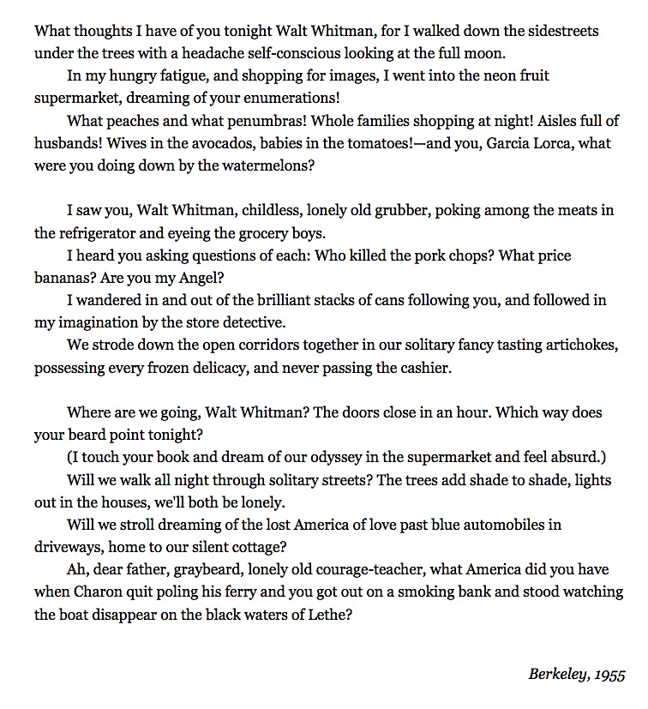

## **"Grandfather advised me" or "Poet's Work"** by Lorine Niedecker

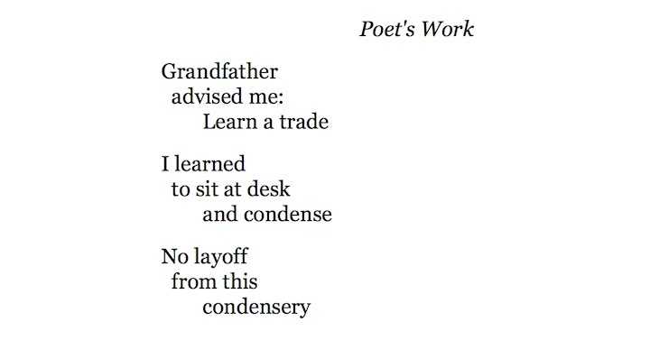

## **Lorine Niedecker's “You are my friend”**

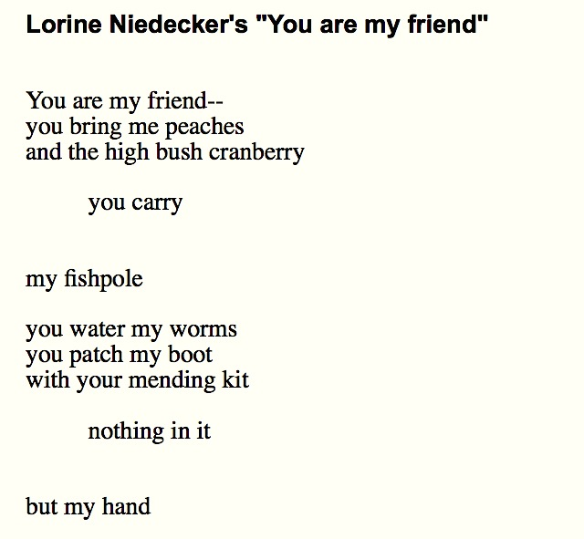

## **Foreclosure by Lorine Niedecker**

Tell em to take my bare walls down

my cement abutments

their parties thereof and clause of claws

Leave me the land

Scratch out: the land

May prose and property both die out

and leave me peace

## **"It isnt for want" by Cid Corman**

It isnt for want

of something to say —

something to tell you —

something you should know —

but to detain you —

keep you from going —

feeling myself here

as long as you are —

as long as you are.

## **"The Way" by Rae Armantrout**

Card in pew pocket

announces,

“I am here.”

I made only one statement

because of a bad winter.

Grease is the word; grease

is the way

I am feeling.

Real life emergencies or

flubbing behind the scenes.

As a child,

I was abandoned

in a story

made of trees.

Here’s the small

Gasp

of this clearing

come “upon” “again”

# chapter 2.1 (week 3)—the rise of poetic modernism: imagism

## **"Sea Rose" by H.D.**

Rose, harsh rose,

marred and with stint of petals,

meagre flower, thin,

sparse of leaf,

more precious

than a wet rose

single on a stem —

you are caught in the drift.

Stunted, with small leaf,

you are flung on the sand,

you are lifted

in the crisp sand

that drives in the wind.

Can the spice-rose

drip such acrid fragrance

hardened in a leaf?

## **"Sea Poppies" by H.D.**

Amber husk

fluted with gold,

fruit on the sand

marked with a rich grain,

treasure

spilled near the shrub-pines

to bleach on the boulders:

your stalk has caught root

among wet pebbles

and drift flung by the sea

and grated shells

and split conch-shells.

Beautiful, wide-spread,

fire upon leaf,

what meadow yields

so fragrant a leaf

as your bright leaf?

## **"In a Station of the Metro" by Ezra Pound**

The apparition of these faces in the crowd :

Petals on a wet, black bough .

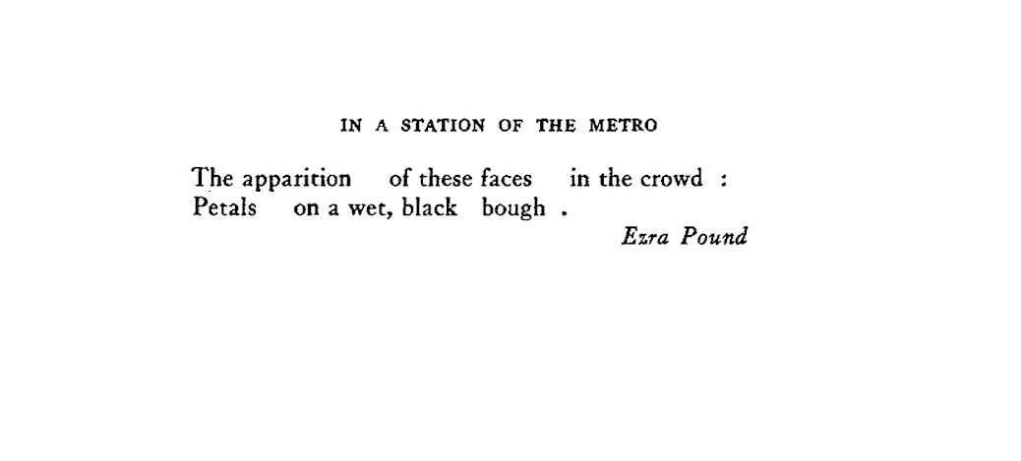

## **Read a selection of critical commentary on Ezra Pound's "In a Station of the Metro":**

The moment of delightful psychic experience and the subsequent search for the precise equation could not be more clearly described. In some way, the poem can be interpreted by means of the definitions in "A Few Don’ts by an Imagiste": the complex is presented "instantaneously," the transition from the Metro station to the wet bough somewhere outside liberates us from "space limits," and the transition from the present faces to the remembered petals breaks down "time limits." But the "Don’ts" don’t account for one peculiarly powerful word in the poem - "apparitions." This word veils the faces in mystery, for it suggests that they are not a mere visual impression but a vision of beauty appearing to the poet from another realm... The second line of the haiku "super-poses" a concrete image which gives a sensory equation for the rare perception. The heart of the poem lies neither in the apparition nor in the petals, but in the mental process which leaps from one to the other. —**Hugh Witemeyer**

*

He tells us that he first satisfied his mind when he hit on a wholly abstract vision of colors, splotches on darkness like some canvas of Kandinsky’s (whose work he had not then seen). This is a most important fact. Satisfaction lay not in preserving the vision, but in devising with mental effort an abstract equivalent for it, reduced, intensified. He wrote a 30-line poem and destroyed it; after six months he wrote a shorter poem, also destroyed; and afer another year, with, as he tells us, the Japanese hokku in mind, he arrived at a poem which needs every one of its 20 words, including the six words of its title. . . . We need the title so that we can savor that vegetal contrast with the world of machines: this is not any crowd, moreover, but a crowd seen underground, as Odysseus and Orpheus and Korè saw crowds in Hades. And carrying forward the suggestion of wraiths, the word "apparition" detaches these faces from all the crowded faces, and presides over the image that conveys the quality of their separation:

Petals on a wet, black bough

Flowers, underground; flowers, out of the sun; flowers seen as if against a natural gleam, the bough’s wetness gleaming on its darkness, in this place where wheels turn and nothing grows. . . What is achieved, though it works by the way of the visible, is no picture of the things glimpsed, in the manner of

The light of our cigarettes Went and came in the gloom.

It is a simile with "like" suppressed: Pound called it an equation, meaning not a redundancy, a equals a, but a generalization of unexpected exactness. The statements of analytical geometry, he said, "are ‘lords’ over fact. —**Hugh Kenner**

*

Imagism's enabling text, "In a Station of the Metro," appeared in the April 1913 issue of Poetryand in a slightly different form in Lustra.In the original version Pound spaces the words apart and stops the first line with a colon: "The apparition of these faces in the crowd." "In the 'Metro' hokku," he writes to Harriet Monroe, "I was careful, I think, to indicate spaces between the rhythmic units, and I want them observed." His directive is stark in its implications: the spaces between phrases are recovered as units of sound, the eye having first been persuaded that each (spatiotemporal) unit reposes in isolation from those surrounding it. The eye, in other words, and not the ear, governs meaning. But what is this poem supposed to soundlike? The metrical habits we learn in school help us to assimilate poetry to familiar anticipatory patterns that yield means of enjoying or at least of analyzing what's new. Yet this two-line poem--decisively not haiku--comes without directions. Instead, it has a physical design that distracts from what one normally expects of poems--recurrent patterns of sound. Scanning the first line is useless because it yields either a line of dactylic trimeter (if the scansionist is ready to elide the first two words and swallow the last syllable ofapparition)or some bizarre enforcement of the pentameter (if he is tone-deaf). Accepting either, moreover, what about

Petals on a wet, black bough,

a line clearly less dactylic than spondaic? Making the point this way (to borrow a phrase of Pound's) is like dragging your own heroic corpse around the walls. Each case cancels the next because the poem deliberately sets out to "break the pentameter" and disable the scansion routines learned in Latin class. Conventional strategies are useless because they are blind to a poem’s physical shape---how do we scan the spaces?--yet the unconventional one demanded of us here is somehow too precious. Is it creditable to give a sonicvalue to the spaces between the soundswithout defining the pause's duration? The "pause" can be in fact either one of vision or of hearing, Kenner's "perceptual units" and "speakable units" or Pound's "rhythmic units" at the same time. —**J.T. Barbarese**

## **"The Encounter" by Ezra Pound**

All the while they were talking the new morality

Her eyes explored me.

And when I rose to go

Her fingers were like the tissue

Of a Japanese paper napkin.

## **"Thirteen Ways of Looking at a Blackbird" by Wallace Stevens**

**I**

Among twenty snowy mountains,

The only moving thing

Was the eye of the blackbird.

**II**

I was of three minds,

Like a tree

In which there are three blackbirds.

**III**

The blackbird whirled in the autumn winds.

It was a small part of the pantomime.

**IV**

A man and a woman

Are one.

A man and a woman and a blackbird

Are one.

**V**

I do not know which to prefer,

The beauty of inflections

Or the beauty of innuendoes,

The blackbird whistling

Or just after.

**VI**

Icicles filled the long window

With barbaric glass.

The shadow of the blackbird

Crossed it, to and fro.

The mood

Traced in the shadow

An indecipherable cause.

**VII**

O thin men of Haddam,

Why do you imagine golden birds?

Do you not see how the blackbird

Walks around the feet

Of the women about you?

**VIII**

I know noble accents

And lucid, inescapable rhythms;

But I know, too,

That the blackbird is involved

In what I know.

**IX**

When the blackbird flew out of sight,

It marked the edge

Of one of many circles.

**X**

At the sight of blackbirds

Flying in a green light,

Even the bawds of euphony

Would cry out sharply.

**XI**

He rode over Connecticut

In a glass coach.

Once, a fear pierced him,

In that he mistook

The shadow of his equipage

For blackbirds.

**XII**

The river is moving.

The blackbird must be flying.

**XIII**

It was evening all afternoon.

It was snowing

And it was going to snow.

The blackbird sat

In the cedar-limbs.

# chapter 2.2 (week 3 cont.)—the rise of poetic modernism: Williams

## **"Lines" by William Carlos Williams**

Leaves are graygreen,

the glass broken, bright green.

## **"Between Walls" by William Carlos Williams**

the back wings

of the

hospital where

nothing

will grow lie

cinders

in which shine

the broken

pieces of a green

bottle

## **"This Is Just to Say" by William Carlos Williams**

I have eaten

the plums

that were in

the icebox

and which

you were probably

saving

for breakfast

Forgive me

they were delicious

so sweet

and so cold

## **Flossie Williams's reply to "This Is Just to Say"**

(crumpled on her desk)

Dear Bill: I've made a

couple of sandwiches for you.

In the ice-box you'll find

blue-berries — a cup of grapefruit

a glass of cold coffee.

On the stove is the tea-pot

with enough tea leaves

for you to make tea if you

prefer — Just light the gas —

boil the water and put it in the tea

Plenty of bread in the bread-box

and butter and eggs —

I didn't know just what to

make for you. Several people

called up about office hours —

See you later. Love. Floss.

Please switch off the telephone.

## **"The Red Wheelbarrow" by William Carlos Williams**

so much depends

upon

a red wheel

barrow

glazed with rain

water

beside the white

chickens.

## **Marcel Duchamp’s *Fountain***

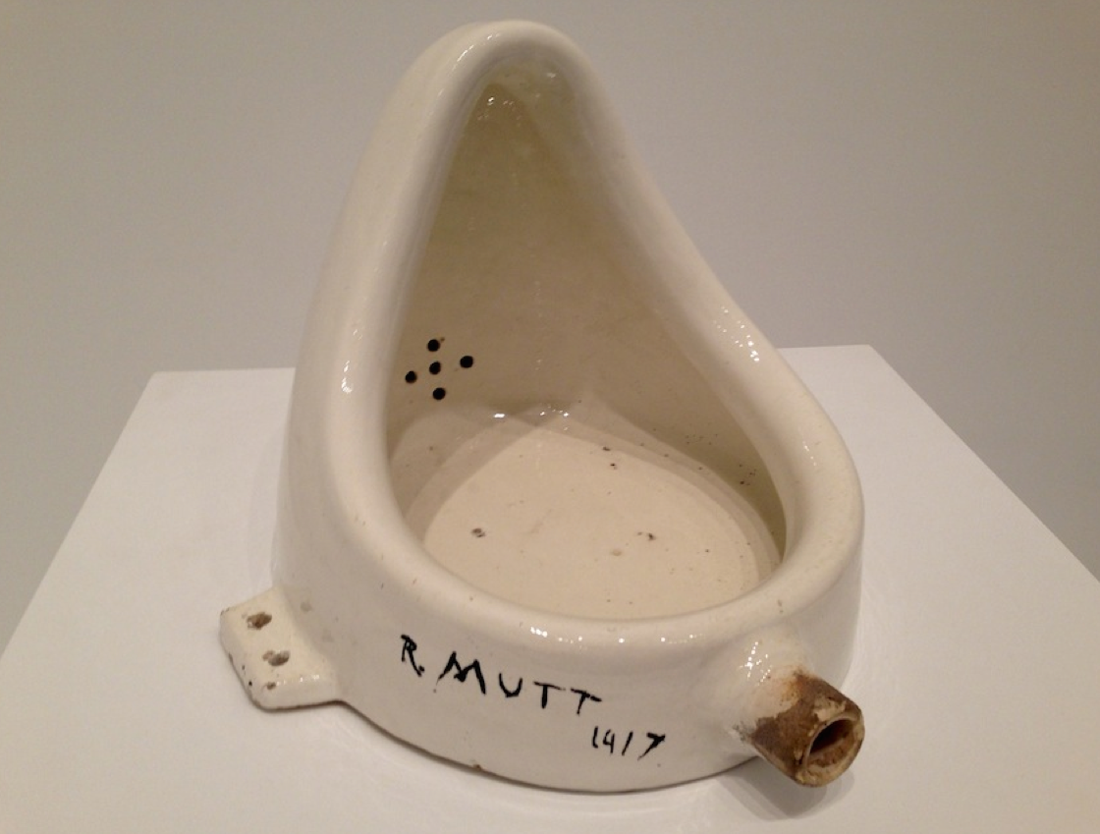

## **"The rose is obsolete..." by William Carlos Williams**

[from Spring and all, 1923]

The rose is obsolete

but each petal ends in

an edge, the double facet

cementing the grooved

columns of air—The edge

cuts without cutting

meets—nothing—renews

itself in metal or porcelain—

whither? It ends—

But if it ends

the start is begun

so that to engage roses

becomes a geometry-—

Sharper, neater, more cutting

figured in majolica—

the broken plate

glazed with a rose

Somewhere the sense

makes copper roses

steel roses—

The rose carried weight of love

but love is at an end--of roses

It is at the edge of the

petal that love waits

Crisp, worked to defeat

laboredness—fragile

plucked, moist, half-raised

cold, precise, touching

What

The place between the petal's

edge and the

From the petal's edge a line starts

that being of steel

infinitely fine, infinitely

rigid penetrates

the Milky Way

without contact—lifting

from it—neither hanging

nor pushing—

The fragility of the flower

unbruised

penetrates space

## **"Portrait of a Lady" by William Carlos Williams**

Your thighs are appletrees

whose blossoms touch the sky.

Which sky? The sky

where Watteau hung a lady's

slipper. Your knees

are a southern breeze — or

a gust of snow. Agh! what

sort of man was Fragonard?

— As if that answered

anything. — Ah, yes. Below

the knees, since the tune

drops that way, it is

one of those white summer days,

the tall grass of your ankles

flickers upon the shore —

Which shore? —

the sand clings to my lips —

Which shore?

Agh, petals maybe. How

should I know?

Which shore? Which shore?

— the petals from some hidden

appletree — Which shore?

I said petals from an appletree.

http://www.philamuseum.org/images/spacer.gif

## Nude Descending a Staircase  by Duchamp

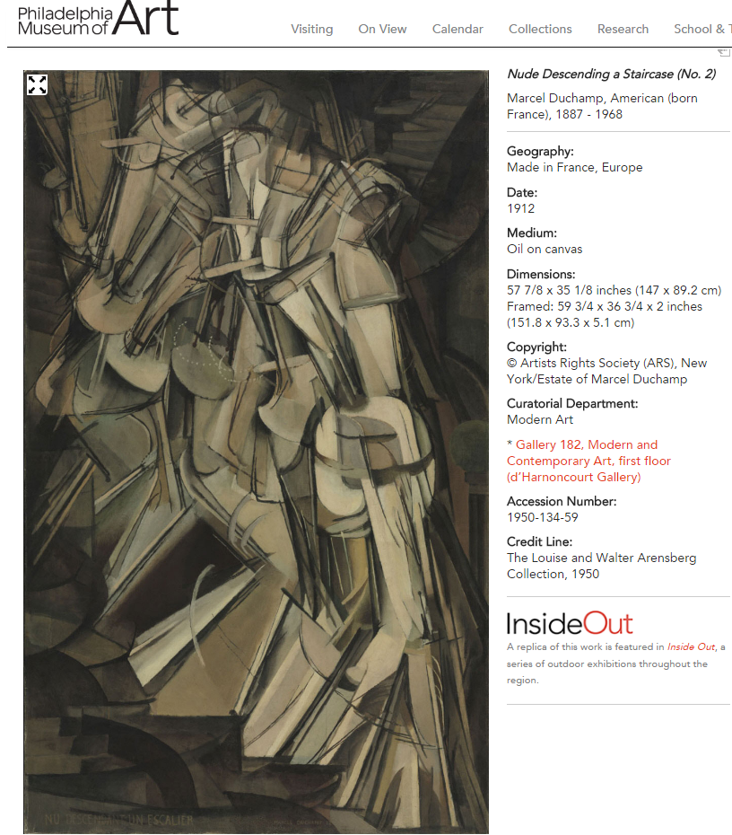

# chapter 2.3 (week 4)—the rise of poetic modernism: Stein

### **Gertrude Stein's "A Long Dress" from Tender Buttons**

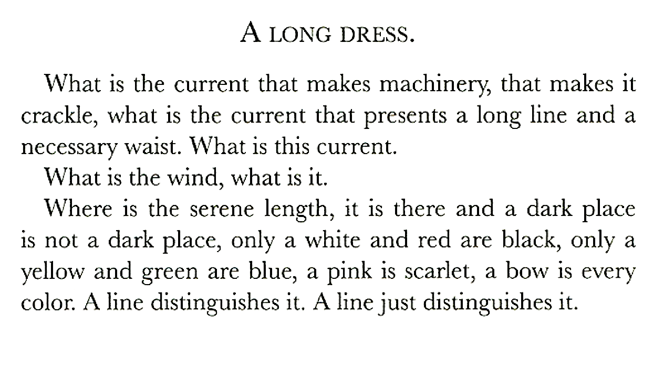

### **Gertrude Stein's "A Carafe, That Is a Blind Glass" (from the "Objects" section of Tender Buttons)**

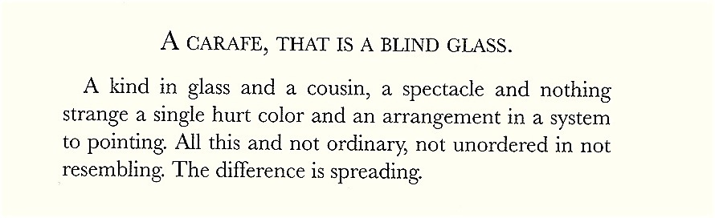

### **The Difference is Spreading: on Gertrude Stein**

[American Poetry: The Twentieth Century](https://www.poets.org/text/american-poetry-twentieth-century-volumes-i-and-ii) (Library of America, 2000) is the first mainstream anthology to treat [Gertrude Stein](https://www.poets.org/poetsorg/biography/gertrude-stein) as what she surely was—one of the century’s major poets. We usually think of Stein as a fiction writer (Three Lives, The Making of Americans), an essayist (Lectures in America), an autobiographer (The Autobiography of Alice B. Toklas ), or even a dramatist-librettist (Four Saints in Three Acts), but a poet? Can [*Tender Buttons*](https://www.poets.org/poetsorg/book/groundbreaking-book-tender-buttons-gertrude-stein-1914) or Yet Dish, neither of them conventionally lineated, be considered poetry? Earlier anthologists and literary historians evidently thought not. But in the year 2000, the binary opposition verse/prose no longer seems to be the deciding factor.

“Do not forget," Ludwig Wittgenstein observed, “that a poem, even though it is composed in the language of information, is not used in the language-game of giving information.” Stein’s poems illustrate this aphorism at every turn: she takes ordinary language—the “language of information”— and makes it strange, forcing us to be acutely aware of the way words work. Here, for example, is the first of the “Objects” in Tender Buttons, “A Carafe, That is a Blind Glass”:

*A kind in glass and a cousin, a spectacle and nothing strange a single hurt color and an arrangement in a system to pointing. All this and not ordinary, not unordered in not resembling. The difference is spreading.*

Stein herself insisted that Tender Buttons was entirely “realistic” in the tradition of Gustave Flaubert. “I used to take objects on a table, like a tumbler or any kind of object and try to get the picture of it clear and separate in my mind and create a word relationship between the word and the things seen," she recalls in “A Transatlantic Interview—1946” with Robert Bartlett Haas. What she no doubt means is that reference remains central to her project even if representation does not. Unlike her contemporaries ([Eliot](https://www.poets.org/tseli), [Pound](https://www.poets.org/poetsorg/biography/ezra-pound), [Moore](https://www.poets.org/poetsorg/biography/marianne-moore)), she does not give us an image, however fractured, of a carafe on a table; rather, she forces us to reconsider how language actually constructs the world we know.

A carafe is, of course “A kind in glass”—a kind of object belonging to the glass family, which includes its “cousins”: bottles, pitchers, jugs, tumblers, wineglasses, and so on. A carafe is a “blind glass," presumably because it is filled with red wine (or sherry or port) and so one cannot see through it. It is also a blind glass because it doesn’t mirror the spectator; Nor can a carafe be used, like a pair of glasses, to look at anything. One looks at it and through it (“a spectacle) but it does not improve our vision in any way. “Nothing strange” there. The “single hurt color” probably refers to the wine, red being traditionally associated with “hurt.” But “hurt” may also refer to some sort of contamination: perhaps something (soda water?) has bled into that pure color and changed it. At the same time, the carafe participates in what Stein calls “an arrangement in a system to pointing”—a compositional arrangement like that of the Cubist paintings Stein loved in which each thing is related to every other thing, an arrangement that, in Stein’s lexicon, is called grammar. One of her most delightful texts is called “Arthur a Grammar.”

The carafe, in any case, is “not ordinary” (i.e., not just a pitcher), “not unordered in not resembling” (it is distinct from all its “cousins," but they are all part of the compositional system). And Stein concludes with the curiously postmodern assertion “The difference is spreading.” No two instances are ever identical: even when the same phrase is repeated over and over again, as is common in Stein, there is always difference. And such “not resembling” enlists the reader’s participation in the text’s linguistic differential play. Under the title “A petticoat," we read, “A light white, a disgrace, an ink spot, a rosy charm.” Here in eleven words, all but two of them monosyllables, Stein produces a miniature erotic drama. One way to read it would be to ask how the “rosy charm” relates to the “disgrace” of the inkspot on the white petticoat? But there are many other paths of entry, the text being, in [John Ashbery](https://www.poets.org/poetsorg/biography/john-ashbery)‘s words about Stanzas in Meditation, “an open field of narrative possibilities.”

Stein’s properties, as her “tender buttons” suggest, are domestic, everyday, female. Her language is not so much about eros as it is itself erotic. The poem called “Peeled pencil, choke” has three words to match its three-word title: “Rub her coke.” And XXXV of “Yet Dish” reads:

*Witness a way go.  
Witness a way go. Witness a way go. Wetness.  
Wetness.*

It sounds like a child’s jump-rope rhyme or a cheer, calling up such phrases as “go away” and “way to go!” But how do we get from “witness” to “wetness”? If poetry is, in [Ezra Pound](https://www.poets.org/poetsorg/biography/ezra-pound)‘s famous definition, “language charged with meaning," Stein’s writing becomes exemplary. From Ashbery, [John Cage](https://www.poets.org/text/john-cage-roaring-silence), and [Louis Zukofsky](https://www.poets.org/poetsorg/biography/louis-zukofsky) to such contemporaries as [Rae Armantrout](https://www.poets.org/poetsorg/biography/rae-armantrout) and [Harryette Mullen](https://www.poets.org/poetsorg/biography/harryette-mullen), poets have been playing “Catch as catch as coal up” with her brilliant linguistic inventions.

### **Gertrude Stein's "Water Raining" and "Malachite" from Tender Buttons**

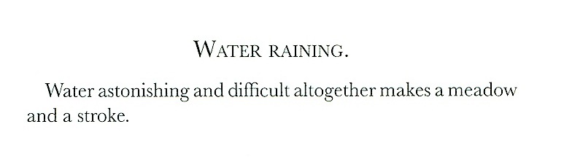

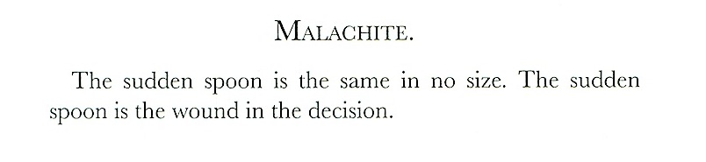

### **Gertrude Stein's statement on narrative:**

"I think one naturally is impressed by anything having a beginning a middle and an ending when one...is emerging from adolescence...American writing has been an escaping not an escaping but an existing with the necessary feeling of one thing succeeding another thing of anything have a beginning and a middle and an ending."

### **Gertrude Stein's statement on the noun (from "Poetry and Grammar"):**

"A noun is a name of anything, why after a thing is named write about it. A name is adequate or it is not...things once they are named does not go on doing anything to them and so why write in nouns. Nouns are the name of anything and just naming names is alright when you want to call a roll but is it good for anything else."

### **Gertrude Stein on repetition:** from The Making of Americans

“As I was saying loving repeating being is in a way earthly being. In some it is repeating that gives to them always a solid feeling of being. In some children there is more feeling and in repeating eating and playing, in some in story-telling and their feeling. More and more in living as growing young men and women and grown men and women and men and women in their middle living, more and more there comes to be in them differences in loving repeating in different kinds of men and women, there comes to be in some more and in some less loving repeating. Loving repeating in some is a going on always in them of earthly being, in some it is the way to completed understanding. Loving repeating then in some is their natural way of complete being. This is now some description of one.”

### **Gertrude Stein on composition (from "Composition as Explanation"):**

Everything is the same except composition and as the composition is different and always going to be different everything is not the same. Everything is not the same as the time when of the composition and the time in the composition is different. The composition is different, that is certain.

The composition is the thing seen by every one living in the living they are doing, they are the composing of the composition that at the time they are living is the composition of the time in which they are living. It is that that makes living a thing they are doing. Nothing else is different, of that almost any one can be certain. The time when and the time of and the time in the composition is the natural phenomena of that composition and of that perhaps every one can be certain.

No one thinks these things when they are making when they are creating what is the composition, naturally no one thinks, that is no one formulates until what is to be formulated has been made.

### **Gertrude Stein's "Let Us Describe",** from "Idem the Same, A Valentine to Sherwood Anderson

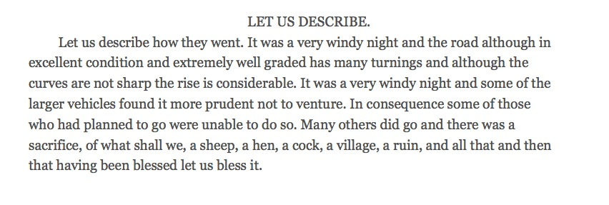

### **Gertrude Stein's "If I Told Him: A Completed Portrait of Picasso":** (1923)

If I told him would he like it. Would he like it if I told him.

Would he like it would Napoleon would Napoleon would would he like it.

If Napoleon if I told him if I told him if Napoleon. Would he like it if I told him if I told him if Napoleon. Would he like it if Napoleon if Napoleon if I told him. If I told him if Napoleon if Napoleon if I told him. If I told him would he like it would he like it if I told him.

Now.

Not now.

And now.

Now.

Exactly as as kings.

Feeling full for it.

Exactitude as kings.

So to beseech you as full as for it.

Exactly or as kings.

Shutters shut and open so do queens. Shutters shut and shutters and so shutters shut and shutters and so and so shutters and so shutters shut and so shutters shut and shutters and so. And so shutters shut and so and also. And also and so and so and also.

Exact resemblance to exact resemblance the exact resemblance as exact as a resemblance, exactly as resembling, exactly resembling, exactly in resemblance exactly a resemblance, exactly and resemblance. For this is so. Because.

Now actively repeat at all, now actively repeat at all, now actively repeat at all.

Have hold and hear, actively repeat at all.

I judge judge.

As a resemblance to him.

Who comes first. Napoleon the first.

Who comes too coming coming too, who goes there, as they go they share, who shares all, all is as all as as yet or as yet.

Now to date now to date. Now and now and date and the date.

Who came first Napoleon at first. Who came first Napoleon the first. Who came first, Napoleon first.

Presently.

Exactly do they do.

First exactly.

Exactly do they do too.

First exactly.

And first exactly.

Exactly do they do.

And first exactly and exactly.

And do they do.

At first exactly and First exactly and do they do.

The first exactly.

And do they do.

The first exactly.

At first exactly.

First as exactly.

At first as exactly.

Presently.

As presently.

As as presently.

He he he he and he and he and and he and he and he and and as and as he and as he and he. He is and as he is, and as he is and he is, he is and as he and he and as he is and he and he and and he and he.

Can curls rob can curls quote, quotable.

As presently.

As exactitude.

As trains.

Has trains.

Has trains.

As trains.

As trains.

Presently.

Proportions.

Presently.

As proportions as presently.

Father and farther.

Was the king or room.

Farther and whether.

Was there was there was there what was there was there what was there was there there was there.

Whether and in there.

As even say so.

One.

I land.Two.

I land.

Three.

The land.

Three.

The land.

Three.

The land.

Two.

I land.

Two.

I land.

One.

I land.

Two.

I land.

As a so.

They cannot.

A note.

They cannot.

A float.

They cannot.

They dote.

They cannot.

They as denote.

Miracles play.

Play fairly.

Play fairly well.

A well.

As well.

As or as presently.

Let me recite what history teaches. History teaches.

### **Ulla Dydo's prefatory comment on Stein's "If I Told Him: A Completed Portrait of Picasso":**

From 1906 on, Picasso was the great artist and the great friend in Stein's life. His portrait of her and hers of him joined his art to hers and hers to his as both were also joined in friendship. "Portraits and prayers," the phrase first used in "An Elucidation," speaks of the juncture of the visual and verbal, painting and writing, Picasso and Stein.

In the powerful rhythmic construction of this portrait, the repeated questions and incomplete sentences question completion and refuse to name what history teaches. In the Autobiography Stein says that she delighted that summer in the waves on the shore at Antibes, where the portrait was written, as was Geography. The waves are more than background. Inside the portrait they become Picasso's creative energy; the conquering armies of the leader, whether Napoleon or Picasso; his power over the empire of art, which might yet, like Napoleon's, crumble; and the fickle sexuality, misogyny, and flattery characteristic of Picasso. Would he like it if she told him all this? Would he like it if she told on him? Would he like what she knows about him? Such questions, with their tone of gossip and threat, flattery and secrecy, are also never answered but persistently and rhythmically repeated.

The manuscript shows an interesting textual discrepancy in the text, which is here restored to the handwritten original. In the section on "exact resemblance," a period before "To exact" in the manuscript makes the difference between an adjective and a verb: "Exact resemblance. To exact resemblance the exact resemblance as exact as resemblance, exactly as resembling, exactly and resembling. . . ." The verb "to exact" adds energy to the creative struggle. Stein explores all possible forms in which "exact" can be joined with "resemblance."

The geography of this portrait is internal, sexual, procreative, in its sucking, pushing, and heaving. It also becomes the actual geography of the coast of the Midi–the waves, the tides, and the land that compose Geography.

—Ulla Dydo, from A Stein Reader, p. 453.

# chapter 2.4 (week 4)—the rise of poetic modernism: modernist edges

## **“A Dozen Cocktails—Please” by Baroness Elsa von Freytag Loringhoven**

[Note: This poem was first published in The Little Review, edited by Margaret Anderson and Jane Heap. It caused a good deal of controversy. Letters, both strongly pro- and anti-Baroness, poured in. The gist of the anti-Baroness response was this: Why encourage someone who is so obviously insane? Why take seriously as art the versified ravings of such an unstable, self-performative person who hardly knows the language in which she writes? Does her writing rise even to the level of anti-art?]

No spinsterlollypop for me-- yes-- we have

No bananasI got lusting palate-- I

Always eat them-- -- -- -- -- -- --

They have dandy celluloid tubes-- all sizes--

Tinted diabolically as a baboon's hind-complexion.

A man's a--

Piffle!

Will-o'-th'-wisp! What's the dread

Matter with the up-to-date-American-

Home-comforts? Bum insufficient for the

Should-be wellgroomed upsy!

That's the leading question.

There's the vibrator-- -- --

Coy flappertoy! I am adult citizen with

Vote-- I demand my unstinted share

In roofeden-- witchsabbath of our baby-

Lonian obelisk.

What's radio for--if you please?

"Eve's dart pricks snookums upon

Wirefence. "

An apple a day-- -- --

It'll come-- -- -- --

Ha! When? I'm no tongueswallowing yogi.

Progress is ravishlng--

It doesn't me--

Nudge it --

Kick it--

Prod it--

Push it--

Broadcast-- -- -- --

That's the lightning idea!

S.O.S. national shortage of--

What ?

How are we going to put it befitting

Lifted upsys?

Psh! Any sissy poet has sufficient freezing

Chemicals in his Freudian icechest to snuff all

Cockiness. We'll hire one.

Hell! Not that! That's the trouble-- --

Cock crow silly!

Oh fine!

They're in France-- the air on the line--

The Poles-- -- -- -- -- --

Have them send waves-- like candy--

Valentines-- -- -- --

"Say it with-- -- --

Bolts !

Oh thunder!

Serpentine aircurrents-- -- --

Hhhhhphssssssss! The very word penetrates

I feel whoozy!

I like that. I don't hanker after Billyboys-- but I am entitled

To be deeply shocked.

So are we-- but you fill the hiatus.

Dear-- I ain't queer-- I need it straight -- --

A dozen cocktails-- please-- -- -- --

## **William Carlos Williams's Autobiographyabout the Baroness Elsa von Freytag Loringhoven:**

Along with everything else I was still going in to the city Mondays, Wednesdays and Fridays, to pediatric clinics, first to the Babies', then the Post Graduate Hospitals, for advanced training. It was tiresome, hot work in summer, and in winter the commuting was hard, but I enjoyed it. On Fridays, which was my day off, I'd stop over sometimes for a party during the evening. The group often met on the second floor of a small Fourteenth Street apartment, most often at Lola Ridge's, that Vestal of the Arts, a devout believer in the humanity of letters; narrow quarters where anyone might on occasion show up.

I can't remember all the names, but once, Mayakofsky, the Russian poet, appeared with his friend and manager who was wearing a particolored vest, half green and half white. Mayakofsky read aloud for us his "Willie the Havana Street Cleaner." A big man, he rested one foot on top of the studio table as he read. It was the perfect gesture. He had a good voice, and though no one understood a word he said, we were all impressed by the tumbling sounds and his intense seriousness. I remember there were two giggling poets of the smarter and younger generation who, while thinking him wonderful, were more, as far as I could tell, impressed by his size than by anything else. Two nice little "girls." For myself it sounded as might The Odyssey from the mouth of some impassioned Greek.

Scofield Thayer, so the rumor ran, had proposed to Marianne Moore who had begged off, though continuing to work at the Dial office. Kenneth Burke later took over Marianne's Dial job. Plenty was happening to me those days. The Little Review had been using some poems by a huge mountain of a man from Maine, weighing three hundred pounds, according to Marsden Hartley, and named Wallace Gould. Marsden introduced him to me. Marsden in those years was a kind of grandpapa to us all, male and female alike. But he had a face that doomed him, the nose of a Wellington projecting from the edge of his cheeks like a medieval pike's point. But to get back to Wallace Gould. I was fascinated by the poems' romantic tenor, I suppose, but there was more than that to them. Gould used the local material in a broad way with loose, undulant lines that I greatly admired. In fact, it was not the nostalgic glamour of these Victorian passages at all, but the firmness of the images and a smoothness of diction that I praised to Margaret Anderson and Jane Heap.

Visiting Margaret Anderson's and Jane Heap's apartment - with its great bed hanging from four chains from the ceiling - was an experience: Jane Heap looked like a heavy-set Eskimo, but Margaret, always more than a little upstage, was an avowed beauty in the grand style. In later years she was a friend of Mary Garden and Georgette Le Blanc.

At their apartment I also saw for the first time, under a glass bell, a piece of sculpture that appeared to be chicken guts, possibly imitated in wax. It caught my eye. I was told it was the work of a titled German woman, Elsa von Freytag Loringhoven, a fabulous creature, well past fifty, whom The Little Review was protecting. Would I care to meet her, for she was crazy, it was said, about my work.

I wrote, fatally, to Margaret or Jane, saying I wanted to meet the woman. They agreed I was precisely the one who should meet her and defend her. But unfortunately she was at that moment in the Tombs under arrest for stealing an umbrella.

Briefly: I went to the Tombs on the day of her release, met her, took her to breakfast somewhere on Sixth Avenue near Eighth Street, and promised to see her again soon. She was about fifty at the time, a woman who had been perhaps beautiful. She spoke with a strong German accent and at the moment was earning a pittance in the city posing in the nude as an artists' model. She was quite in demand--a lean, masculine figure.

Yes. I met her, all right! Once later she had an intimate talk with me and advised me that what I needed to make me great was to contract syphilis from her and so free my mind for serious art.

She was a protege of Marcel Duchamp. She sent me a photo of herself, 8 x 10, nude, a fine portrait, said to have been taken by him — a picture I kept in my trunk for years, finally handing it on to Berenice Abbott. I was sick of seeing it lying around. A first-rate piece of photography, though.

The Baroness pursued me for several years, twice coming to Rutherford, of which more later.

At about this time Wallace Gould arrived in New York from his Maine hide-out and almost immediately found that it would be impossible to support himself here. Some woman who admired his work had loaned Wally an apartment. When I found him he had on a black stock, a black suit with great white cuffs, and if he wasn't trembling with fright, he wasn't far from it.

That day, in fact within the hour, he had been standing at the bottom of the stairs, his hand on the newel post, when his hostess had come downstairs had pressed her breast upon the back of his hand, pinning it there, so to speak. He had been too frightened to withdraw the hand, and there she had him.

The pupils of his eyes must have been half an inch across. "I'm up shit creekl" were his exact words. He had almost dropped dead of annoyance, or so he told me, and begged me to get him out of there as fast as I could. "I'm broke," he said in terror. "What am I to do?"

It was around Christmas. "Look," I said, "get your stuff and come out to Rutherford with me. I've got the car at the door."

He stayed with us all winter, giving little Bill piano lessons for his board, though I hadn't asked it. But when March arrived the Indian blood in his veins--he was quarter Abnaki Indian on his mother's side--asserted itself and he packed his kit. I gave him twenty dollars or so to start him off. He went by train to Washington, D. C., thence to start walking, which he did, to end up after a few days at Farmville, Virginia, where he spent the remainder of his life.

The Baroness, though, didn't leave me so easily. She reminded me of my "gypsy" grandmother, old Emily, and I was foolish enough to say I loved her. That all but finished me!

November 11, 1918: The war was now really over. Pop had lived it through. England had once more come through on top. But on Christmas Day, 1918, he died. He never at any time complained of any pain or made the slightest difficulty for anyone during his illness. But when he went he carried the secret of his birth with him. I should have liked to have known something from him of my grandfather.

Certainly that is one thing I shall never know. For, after Irving's death the next year, the old lady who remained, the sole survivor of her clan, having buried all her children, my father, his two half-brothers as well as my Aunt Rosita, the epileptic, also remained as silent as he to her death.

I'll never forget Pop's death. Only after the hardest trying did I manage, the day before, finally, to get the tube into his emaciated body for the enema. I knew I had forced it through only by unjustifiable pushing — a stiff tube with a loose wire core to give it added rigidity, and I knew I could never do it again. He had not so much as parted his lips in complaint at the maneuver.

Christmas morning, 1918, he had all his gifts for the family laid out, each in its place, and labeled. The one for me was a small cubical bronze bell, as a handle for which he had had fitted, the support welded in, the ivory figure of an old Chinese philosopher. Himself? Mother woke and they spoke to each other. She fell asleep again. At seven she arose. He remained apparently sleeping. He was almost finished.

She called me, and I went up from Nine Ridge Road as fast as I could. It must have been a cerebral accident, perhaps from my efforts to relieve him the day before.

"He's gone," I said. But he shook his head slowly from side to side. It was the last thing I could ever say in my father's presence and it was disastrous.

The young woman must have been dropped by the Godwins she always said she had never received her just rights — and after an apparent delay of five years came to America in a sailing vessel loaded with car rails. The ship was driven by a storm to the Azores and later ran adrift on Fire Island shoal. Pop once told me that as a child of five he recalled being on deck, in his mother's arms perhaps, and seeing the bowsprit and prow of another vessel loom above him out of the fog and strike the side of the ship he was on.

The woman and infant disembarked at Castle Garden, moved to a Brooklyn boarding house and there met a Mr. Wellcome, up from Saint Thomas to buy photographic supplies. He saw the young woman, married her and took her, with her son, back to the West Indies. There, the boy who was to be my father grew up. Grandma had wanted to be an actress; that was her objective in coming here. She had plenty of sand. All she wanted of it, finally.

We brought Grandma's body from the shore — her fabulous shore where she bathed daily in summer until she couldn't get up from the pebbles for the weight of her wet old-fashioned bathing dress. She lay in state in my front room where I did a pencil drawing of her really impressive features. The old cat slept under her coffin.

But back to the Baroness. All the old gals of Greenwich Village were backing her: coal scuttle on head on Fifth Avenue, black Mother Hubbard with moons cut out front and back for ready reference. Her attacks were persistent to a point where it concerned me seriously. But I never have been particularly concerned with others' ideas or opinions when they controverted mine. I couldn't be moved.

I called on the woman one day, gave her small amounts of money. Ashes were deep on her miserable hearth. In the slum room where she lived with her two small dogs, I saw them at it on her dirty bed. But she herself at that moment was courtesy itself. We talked and that was all. We talked well and I was moved. But when later she went into her act, I put up a fight.

Wallace Stevens at one time was afraid to come below Fourteenth Street when he was in the city because of her. And there was a Russian painter who on turning in one night in his small room had her crawl out naked from under his bed. He ran, ducked in at a neighbor's across the hall. She refused to leave the premises until he agreed to follow her to her own apartment.

Bob McAlmon was here at supper one night when I received a call to see a sick baby at Union Avenue. I took my bag and went out to my car which was standing at the curb. But as I went to get into it a hand grabbed my left wrist. It was she.

"You must come with me," she said in her strong German accent. I was taken aback, as may easily be imagined, and nonplused besides, because — well, she was a woman.

It ended as she hauled off and hit me alongside the neck with all her strength. She had had some little squirt of a male accomplice call me from supper for this. I just stood there thinking. But at that moment a cop happened to walk by. "What's the matter, Doc, this woman annoying you?" "No," I said, and she lit out down the street. "Let her go."

I bought a small punching bag after that to take it out on in the cellar, and the next time she attacked me, about six o'clock one evening on Park Avenue a few months later, I flattened her with a stiff punch to the mouth. I thought she was going to stick a knife in me. I had her arrested, she shouting, "What are you in this town? Napoleon?"

But she promised from the local jail, sticking her hand out between the bars, never to do it again.

It was funny to see her walking down the street trying to take hold of Officer Campbell's arm and he pushing her away. I was really crazy about the woman.

Later I gave her two hundred dollars to get out of the country. It was stolen by the go-between. I gave her more and finally she went, only to be playfully killed by some French jokester, it is said, who turned the gas jet on in her room while she was sleeping. That's the story.

## **"To Make a Dadaist Poem" by Tristan Tzara**

[from "Dada Manifesto on Feeble & Bitter Love" (1920)]

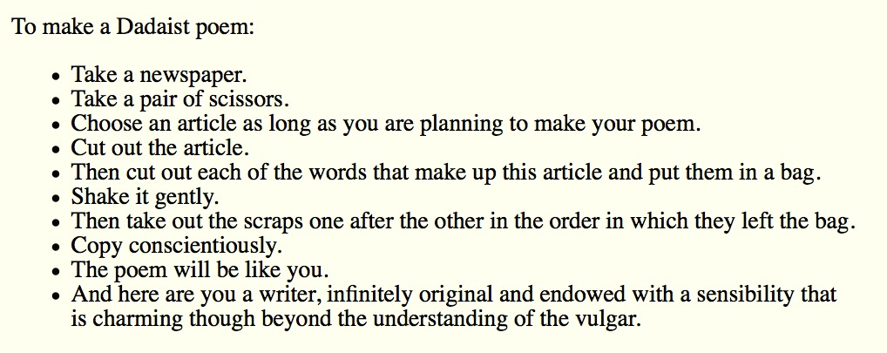

## **Tristan Tzara's "To Make a Dadaist Poem" as part of a general introduction to the poetry of "chance operations"**

Chance Operations are methods of generating poetry independent of the author’s will. A chance operation can be almost anything from throwing darts and rolling dice, to the ancient Chinese divination method, I-Ching, and even sophisticated computer programs. Most poems created by chance operations use some original text as their source, be it the newspaper, an encyclopedia, or a famous work of literature. The purpose of such a practice is to play against the poet’s intentions and ego, while creating unusual syntax and images. The resulting poems allow the reader to take part in producing meaning from the work.

The roots of using chance operations to generate poetry are generally traced to the Dada movement in Western Europe in the early and mid-twentieth-century, involving writers such as [André Breton](https://www.poets.org/poetsorg/poet/andr%C3%A9-breton), Louis Aragon, Tristan Tzara, Philippe Soupault, and Paul Éluard. The Dadaists were deeply interested in the subconscious, and they believed that the mind would create associations and meaning from any text, including those generated through random selections. In one section of Tzara’s “Dada Manifesto on Feeble & Bitter Love," he offers the following instructions to make a Dadaist poem, here translated from the original French by Barbara Wright:

     Take a newspaper.     Take some scissors.     Choose from this paper an article the length you want to        make your poem.     Cut out the article.     Next carefully cut out each of the words that make up        this article and put them all in a bag.     Shake gently.     Next take out each cutting one after the other.     Copy conscientiously in the order in which they left the        bag.     The poem will resemble you.     And there you are--an infinitely original author of        charming sensibility, even though unappreciated by        the vulgar herd.

The use of chance operations in contemporary poetry has been used most famously by the international avant-garde group [Fluxus](http://www.fluxus.org/), poet [Jackson Mac Low](https://www.poets.org/poetsorg/poet/jackson-mac-low), and the poet and composer John Cage. A good example of a poem that was written using chance operations is Jackson Mac Low’s [“Stein 100: A Feather Likeness of the Justice Chair,"](https://www.poets.org/poetsorg/poem/stein-100-feather-likeness-justice-chair) which also includes Mac Low’s explanation of the methods he used to compose the poem.

## **the sonnet**

A lyric poem of fourteen lines, following one or another of several set rhyme-schemes. Critics of the sonnet have recognized varying classifications, but to all essential purposes two types only need be discussed ff the student will understand that each of these two, in turn, has undergone various modifications by experimenters. The two characteristic sonnet types are the Italian (Petrarchan) and the English (Shakespearean). The first, the Italian form, is distinguished by its bipartite division into the octave and the sestet: the octave consisting of a first division of eight lines rhyming

**abbaabba**

and the sestet, or second division, consisting of six lines rhyming

**cdecde, cdccdc, or cdedce**.

On this twofold division of the Italian sonnet Charles Gayley notes: "The octave bears the burden; a doubt, a problem, a reflection, a query, an historical statement, a cry of indignation or desire, a Vision of the ideaL The sestet eases the load, resolves the problem or doubt, answers the query, solaces the yearning, realizes the vision." Again it might be said that the octave presents the narrative, states the proposition or raises a question; the sestet drives home the narrative by making an abstract comment, applies the proposition, or solves the problem. So much for the strict interpretation of the Italian form; as a matter of fact English poets have varied these items greatly. The octave and sestet division is not always kept; the rhyme-scheme is often varied, but within limits--no Italian sonnet properly allowing more than five rhymes. Iambic pentameter is essentially the meter, but here again certain poets have experimented with hexameter and other meters.

The English (Shakespearean) sonnet, on the other hand, is so different from the Italian (though it grew from that form) as to permit of a separate classification. Instead of the octave and sestet divisions, this sonnet characteristically embodies four divisions: three quatrains (each with a rhyme-scheme of its own) and a rhymed couplet. Thus the typical rhyme-scheme for the English sonnet is

**abab cdcd efef gg**.

The couplet at the end is usually a commentary on the foregoing, an epigrammatic close. The Spenserian sonnet combines the Italian and the Shakespearean forms, using three quatrains and a couplet but employing linking rhymes between the quatrains, thus

**abab bcbc cdcd ee**.

Certain qualities common to the sonnet as a form should be noted. Its definite restrictions make it a challenge to the artistry of the poet and call for all the technical skill at the poet's command. The more or less set rhyme patterns occurring regularly within the short space of fourteen lines afford a pleasant effect on the ear of the reader, and can Create truly musical effects. The rigidity of the form precludes a too great economy or too great prodigality of words. Emphasis is placed on exactness and perfection of expression.

The sonnet as a form developed in Italy probably in the thirteenth century. Petrarch, in the fourteenth century, raised the sonnet to its greatest Italian perfection and so gave it, for English readers, his own name.

The form was introduced into England by Thomas Wyatt, who translated Petrarchan sonnets and left over thirty examples of his own in English. Surrey, an associate, shares with Wyatt the credit for introducing the form to England and is important as an early modifier of the Italian form. Gradually the Italian sonnet pattern was changed and since Shakespeare attained fame for the greatest poems of this modified type his name has often been given to the English form.

Among the most famous sonneteers in England have been Shakespeare, Milton, Wordsworth, and D. G. Rossetti. Longfellow, Jones Very, G. H. Boker, and E. A. Robinson are generally credited with writing some of the best sonnets in America. With the interest in this poetic form, certain poets following the example of Petrarch have written a series of sonnets linked one to the other and dealing with some unified subject. Such series are called sonnet sequences.

Some of the most famous sonnet sequences in English literature are those by Shakespeare (154 in the group), Sidney's Astrophel and Stella, Spenser's Amoretti, Rossetti's House of Life, and Mrs. Browning's Sonnets from the Portuguese. William Ellery Leonard, Elinor Wylie, Edna St. Vincent Millay, and W. H. Auden have done distinguished work in the sonnet and the sonnet sequence in this century. The brevity of the form favors concentrated expression of idea or passion.

Anti-formal or meta-formal sonnets are occasions for irony made possible by implicit reference to formality itself. In a sonnet called "Forms from the Reich University", William Heyen creates an irony based on the notion that the Germans who perpetrated the Holocaust by and large participated in a culture that had achieved greatly in aesthetic forms one might call "well-sealed."

### **"Forcing twentieth-century America into a sonnet— gosh, how I hate sonnets—is like putting a crab into a square box. You’ve got to cut off his legs to make him fit. When you get through, you don’t have a crab anymore."**

— Williams Carlos Williams, in an interview [from Interviews with William Carlos Williams: Speaking Straight Ahead(1976)]

## **"A Recollection" by John Peale Bishop**

Famously she descended, her red hair

Unbound and bronzed by sea-reflections, caught

Crinkled with sea-pearls. The fine slender taut

Knees that let down her feet upon the air,

Young breasts, slim flanks and golden quarries were

Odder than when the young distraught

Unknown Venetian, painting her portrait, thought

He'd not imagined what he painted there.

And I too commenced with that golden cloud:

Lipped her delicious hands and had my ease

Faring fantastically, perversely proud.

All loveliness demands our courtesies.

Since she was dead I praised her as I could

Silently, among the Barberini bees.

# chapter 3 (week 5)—communist poets of the 1930s

## **"Lines for an Abortionist's Office", by Ruth Lechlitner, 1936**

Close here thine eyes, O State:

These are thy guests who bring

To gods with appetites grown great

A votive offering.

Know that they dare defy

The words of law and priest —

(Better to let the unborn die

Than starve while others feast.)

The stricken flesh may be

Outraged, and heal; but mind

Pain-sharpened, may yet learn to see

Thee plain, O State. Be blind:

Accept love's fruit: be sleek

Fat and lip-sealed. (Forget

That Life, avenging pain, will speak!)

Thrust deep the long curette!

## **"Interior" by Genevieve Taggard**

A middle class fortress in which to hide!

Draw down the curtain as if saying No,

While noon's ablaze, ablaze outside.

And outside people work and sweat

And the day clings by and the hard day ends.

And after you doze brush out your hair

And walk like a marmoset to and fro

And look in the mirror at middle-age

And sit and regard yourself stare and stare

And hate your life and your tiresome friends

And last night's bridge where you went in debt;

While all around you gathers the rage

Of cheated people

Will we hear your fret

In the rising noise of the streets? Oh no!

(Published in Proletarian Literature in the United States, 1935.)

# chapter 4 (week 5 cont.)—the Harlem Renaissance

e

## **Yet Do I Marvel by Countee Cullen**

I doubt not God is good, well-meaning, kind,

And did He stoop to quibble could tell why

The little buried mole continues blind,

Why flesh that mirrors Him must some day die,

Make plain the reason tortured Tantalus

Is baited by the fickle fruit, declare

If merely brute caprice dooms Sisyphus

To struggle up a never-ending stair.

Inscrutable His ways are, and immune

To catechism by a mind too strewn

With petty cares to slightly understand

What awful brain compels His awful hand.

Yet do I marvel at this curious thing:

To make a poet black, and bid him sing!

## **"Incident" by Countee Cullen**

Once riding in old Baltimore,

Heart-filled, head-filled with glee;

I saw a Baltimorean

Keep looking straight at me.

Now I was eight and very small,

And he was no whit bigger,

And so I smiled, but he poked out

His tongue, and called me, "Nigger."

I saw the whole of Baltimore

From May until December;

Of all the things that happened there

That's all that I remember.

## **"If We Must Die" by Claude McKay**

If we must die, let it not be like hogs

Hunted and penned in an inglorious spot,

While round us bark the mad and hungry dogs,

Making their mock at our accursèd lot.

If we must die, O let us nobly die,

So that our precious blood may not be shed

In vain; then even the monsters we defy

Shall be constrained to honor us though dead!

O kinsmen! we must meet the common foe!

Though far outnumbered let us show us brave,

And for their thousand blows deal one death-blow!

What though before us lies the open grave?

Like men we’ll face the murderous, cowardly pack,

Pressed to the wall, dying, but fighting back!

## **"Dinner Guest: Me" by Langston Hughes**

I know I am

The Negro Problem

Being wined and dined,

Answering the usual questions

That come to white mind

Which seeks demurely

To Probe in polite way

The why and wherewithal

Of darkness U.S.A.—

Wondering how things got this way

In current democratic night,

Murmuring gently

Over fraises du bois,

"I'm so ashamed of being white."

The lobster is delicious,

The wine divine,

And center of attention

At the damask table, mine.

To be a Problem on

Park Avenue at eight

Is not so bad.

Solutions to the Problem,

Of course, wait.

## **"Boy Breaking Glass" by Gwendolyn Brooks**

To Marc Crawford

from whom the commission

Whose broken window is a cry of art

(success, that winks aware

as elegance, as a treasonable faith)

is raw: is sonic: is old-eyed première.

Our beautiful flaw and terrible ornament.

Our barbarous and metal little man.

“I shall create! If not a note, a hole.

If not an overture, a desecration.”

Full of pepper and light

and Salt and night and cargoes.

“Don’t go down the plank

if you see there’s no extension.

Each to his grief, each to

his loneliness and fidgety revenge.

Nobody knew where I was and now I am no longer there.”

The only sanity is a cup of tea.

The music is in minors.

Each one other

is having different weather.

“It was you, it was you who threw away my name!

And this is everything I have for me.”

Who has not Congress, lobster, love, luau,

the Regency Room, the Statue of Liberty,

runs. A sloppy amalgamation.

A mistake.

A cliff.

A hymn, a snare, and an exceeding sun.

## **"truth" by Gwendolyn Brooks**

And if sun comes

How shall we greet him?

Shall we not dread him,

Shall we not fear him

After so lengthy a

Session with shade?

Though we have wept for him,

Though we have prayed

All through the night-years—

What if we wake one shimmering morning to

Hear the fierce hammering

Of his firm knuckles

Hard on the door?

Shall we not shudder?—

Shall we not flee

Into the shelter, the dear thick shelter

Of the familiar

Propitious haze?

Sweet is it, sweet is it

To sleep in the coolness

Of snug unawareness.

The dark hangs heavily

Over the eyes.

# chapter 5 (week 5 cont.)—Frost

## **"Mending Wall" by Robert Frost**

Something there is that doesn't love a wall,

That sends the frozen-ground-swell under it,

And spills the upper boulders in the sun;

And makes gaps even two can pass abreast.

The work of hunters is another thing:

I have come after them and made repair

Where they have left not one stone on a stone,

But they would have the rabbit out of hiding,

To please the yelping dogs. The gaps I mean,

No one has seen them made or heard them made,

But at spring mending-time we find them there.

I let my neighbor know beyond the hill;

And on a day we meet to walk the line

And set the wall between us once again.

We keep the wall between us as we go.

To each the boulders that have fallen to each.

And some are loaves and some so nearly balls

We have to use a spell to make them balance:

"Stay where you are until our backs are turned!"

We wear our fingers rough with handling them.

Oh, just another kind of out-door game,

One on a side. It comes to little more:

There where it is we do not need the wall:

He is all pine and I am apple orchard.

My apple trees will never get across

And eat the cones under his pines, I tell him.

He only says, "Good fences make good neighbors."

Spring is the mischief in me, and I wonder

If I could put a notion in his head:

"Why do they make good neighbors? Isn't it

Where there are cows? But here there are no cows.

Before I built a wall I'd ask to know

What I was walling in or walling out,

And to whom I was like to give offence.

Something there is that doesn't love a wall,

That wants it down." I could say "Elves" to him,

But it's not elves exactly, and I'd rather

He said it for himself. I see him there

Bringing a stone grasped firmly by the top

In each hand, like an old-stone savage armed.

He moves in darkness as it seems to me,

Not of woods only and the shade of trees.

He will not go behind his father's saying,

And he likes having thought of it so well

He says again, "Good fences make good neighbors."

# chapter 6 (week 5 cont.)—formalism of the 1950s

## **"The Death of a Toad" by Richard Wilbur**

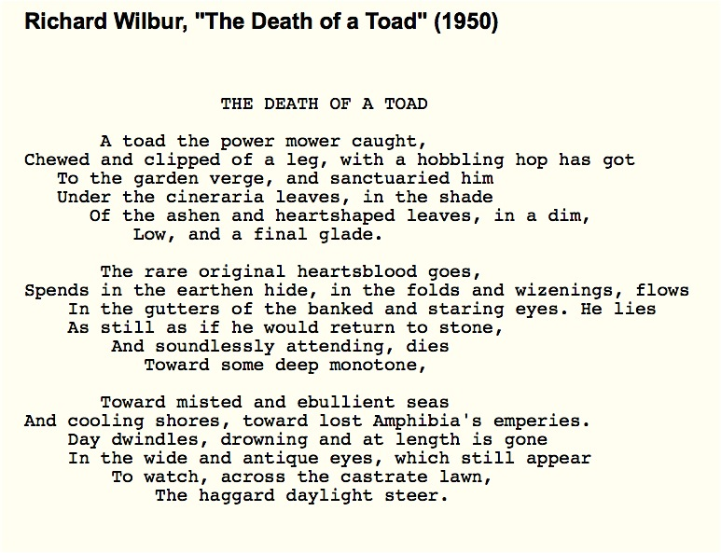

## **"Nude Descending a Staircase" by X. J. Kennedy, 1960**

Toe after toe, a snowing flesh,

a gold of lemon, root and rind,

she sifts in sunlight down the stairs

with nothing on. Nor on her mind.

We spy beneath the banister

a constant thresh of thigh on thigh;

her lips imprint the swinging air

that parts to let her parts go by.

One-woman waterfall, she wears

her slow descent like a long cape

and pausing on the final stair,

collects her motions into shape.

# chapter 7 (week 6)—breaking conformity: the beats

## **"Howl" (part 1) by Allen Ginsberg**

For Carl Solomon

I saw the best minds of my generation destroyed by madness, starving hysterical naked,

dragging themselves through the negro streets at dawn looking for an angry fix,

angelheaded hipsters burning for the ancient heavenly connection to the starry dynamo in the machinery of night,

who poverty and tatters and hollow-eyed and high sat up smoking in the supernatural darkness of cold-water flats floating across the tops of cities contemplating jazz,

who bared their brains to Heaven under the El and saw Mohammedan angels staggering on tenement roofs illuminated,

who passed through universities with radiant cool eyes hallucinating Arkansas and Blake-light tragedy among the scholars of war,

who were expelled from the academies for crazy & publishing obscene odes on the windows of the skull,

who cowered in unshaven rooms in underwear, burning their money in wastebaskets and listening to the Terror through the wall,

who got busted in their pubic beards returning through Laredo with a belt of marijuana for New York,

who ate fire in paint hotels or drank turpentine in Paradise Alley, death, or purgatoried their torsos night after night

with dreams, with drugs, with waking nightmares, alcohol and cock and endless balls,

incomparable blind streets of shuddering cloud and lightning in the mind leaping toward poles of Canada & Paterson, illuminating all the motionless world of Time between,

Peyote solidities of halls, backyard green tree cemetery dawns, wine drunkenness over the rooftops, storefront boroughs of teahead joyride neon blinking traffic light, sun and moon and tree vibrations in the roaring winter dusks of Brooklyn, ashcan rantings and kind king light of mind,

who chained themselves to subways for the endless ride from Battery to holy Bronx on benzedrine until the noise of wheels and children brought them down shuddering mouth-wracked and battered bleak of brain all drained of brilliance in the drear light of Zoo,

who sank all night in submarine light of Bickford’s floated out and sat through the stale beer afternoon in desolate Fugazzi’s, listening to the crack of doom on the hydrogen jukebox,

who talked continuously seventy hours from park to pad to bar to Bellevue to museum to the Brooklyn Bridge,

a lost battalion of platonic conversationalists jumping down the stoops off fire escapes off windowsills off Empire State out of the moon,

yacketayakking screaming vomiting whispering facts and memories and anecdotes and eyeball kicks and shocks of hospitals and jails and wars,

whole intellects disgorged in total recall for seven days and nights with brilliant eyes, meat for the Synagogue cast on the pavement,

who vanished into nowhere Zen New Jersey leaving a trail of ambiguous picture postcards of Atlantic City Hall,

suffering Eastern sweats and Tangerian bone-grindings and migraines of China under junk-withdrawal in Newark’s bleak furnished room,

who wandered around and around at midnight in the railroad yard wondering where to go, and went, leaving no broken hearts,

who lit cigarettes in boxcars boxcars boxcars racketing through snow toward lonesome farms in grandfather night,

who studied Plotinus Poe St. John of the Cross telepathy and bop kabbalah because the cosmos instinctively vibrated at their feet in Kansas,

who loned it through the streets of Idaho seeking visionary indian angels who were visionary indian angels,

who thought they were only mad when Baltimore gleamed in supernatural ecstasy,

who jumped in limousines with the Chinaman of Oklahoma on the impulse of winter midnight streetlight smalltown rain,

who lounged hungry and lonesome through Houston seeking jazz or sex or soup, and followed the brilliant Spaniard to converse about America and Eternity, a hopeless task, and so took ship to Africa,

who disappeared into the volcanoes of Mexico leaving behind nothing but the shadow of dungarees and the lava and ash of poetry scattered in fireplace Chicago,

who reappeared on the West Coast investigating the FBI in beards and shorts with big pacifist eyes sexy in their dark skin passing out incomprehensible leaflets,

who burned cigarette holes in their arms protesting the narcotic tobacco haze of Capitalism,

who distributed Supercommunist pamphlets in Union Square weeping and undressing while the sirens of Los Alamos wailed them down, and wailed down Wall, and the Staten Island ferry also wailed,

who broke down crying in white gymnasiums naked and trembling before the machinery of other skeletons,

who bit detectives in the neck and shrieked with delight in policecars for committing no crime but their own wild cooking pederasty and intoxication,

who howled on their knees in the subway and were dragged off the roof waving genitals and manuscripts,

who let themselves be fucked in the ass by saintly motorcyclists, and screamed with joy,

who blew and were blown by those human seraphim, the sailors, caresses of Atlantic and Caribbean love,

who balled in the morning in the evenings in rosegardens and the grass of public parks and cemeteries scattering their semen freely to whomever come who may,

who hiccuped endlessly trying to giggle but wound up with a sob behind a partition in a Turkish Bath when the blond & naked angel came to pierce them with a sword,

who lost their loveboys to the three old shrews of fate the one eyed shrew of the heterosexual dollar the one eyed shrew that winks out of the womb and the one eyed shrew that does nothing but sit on her ass and snip the intellectual golden threads of the craftsman’s loom,

who copulated ecstatic and insatiate with a bottle of beer a sweetheart a package of cigarettes a candle and fell off the bed, and continued along the floor and down the hall and ended fainting on the wall with a vision of ultimate cunt and come eluding the last gyzym of consciousness,

who sweetened the snatches of a million girls trembling in the sunset, and were red eyed in the morning but prepared to sweeten the snatch of the sunrise, flashing buttocks under barns and naked in the lake,

who went out whoring through Colorado in myriad stolen night-cars, N.C., secret hero of these poems, cocksman and Adonis of Denver—joy to the memory of his innumerable lays of girls in empty lots & diner backyards, moviehouses’ rickety rows, on mountaintops in caves or with gaunt waitresses in familiar roadside lonely petticoat upliftings & especially secret gas-station solipsisms of johns, & hometown alleys too,

who faded out in vast sordid movies, were shifted in dreams, woke on a sudden Manhattan, and picked themselves up out of basements hung-over with heartless Tokay and horrors of Third Avenue iron dreams & stumbled to unemployment offices,

who walked all night with their shoes full of blood on the snowbank docks waiting for a door in the East River to open to a room full of steam-heat and opium,

who created great suicidal dramas on the apartment cliff-banks of the Hudson under the wartime blur floodlight of the moon & their heads shall be crowned with laurel in oblivion,

who ate the lamb stew of the imagination or digested the crab at the muddy bottom of the rivers of Bowery,

who wept at the romance of the streets with their pushcarts full of onions and bad music,

who sat in boxes breathing in the darkness under the bridge, and rose up to build harpsichords in their lofts,

who coughed on the sixth floor of Harlem crowned with flame under the tubercular sky surrounded by orange crates of theology,

who scribbled all night rocking and rolling over lofty incantations which in the yellow morning were stanzas of gibberish,

who cooked rotten animals lung heart feet tail borsht & tortillas dreaming of the pure vegetable kingdom,

who plunged themselves under meat trucks looking for an egg,

who threw their watches off the roof to cast their ballot for Eternity outside of Time, & alarm clocks fell on their heads every day for the next decade,

who cut their wrists three times successively unsuccessfully, gave up and were forced to open antique stores where they thought they were growing old and cried,

who were burned alive in their innocent flannel suits on Madison Avenue amid blasts of leaden verse & the tanked-up clatter of the iron regiments of fashion & the nitroglycerine shrieks of the fairies of advertising & the mustard gas of sinister intelligent editors, or were run down by the drunken taxicabs of Absolute Reality,

who jumped off the Brooklyn Bridge this actually happened and walked away unknown and forgotten into the ghostly daze of Chinatown soup alleyways & firetrucks, not even one free beer,

who sang out of their windows in despair, fell out of the subway window, jumped in the filthy Passaic, leaped on negroes, cried all over the street, danced on broken wineglasses barefoot smashed phonograph records of nostalgic European 1930s German jazz finished the whiskey and threw up groaning into the bloody toilet, moans in their ears and the blast of colossal steamwhistles,

who barreled down the highways of the past journeying to each other’s hotrod-Golgotha jail-solitude watch or Birmingham jazz incarnation,

who drove crosscountry seventytwo hours to find out if I had a vision or you had a vision or he had a vision to find out Eternity,

who journeyed to Denver, who died in Denver, who came back to Denver & waited in vain, who watched over Denver & brooded & loned in Denver and finally went away to find out the Time, & now Denver is lonesome for her heroes,

who fell on their knees in hopeless cathedrals praying for each other’s salvation and light and breasts, until the soul illuminated its hair for a second,

who crashed through their minds in jail waiting for impossible criminals with golden heads and the charm of reality in their hearts who sang sweet blues to Alcatraz,

who retired to Mexico to cultivate a habit, or Rocky Mount to tender Buddha or Tangiers to boys or Southern Pacific to the black locomotive or Harvard to Narcissus to Woodlawn to the daisychain or grave,

who demanded sanity trials accusing the radio of hypnotism & were left with their insanity & their hands & a hung jury,

who threw potato salad at CCNY lecturers on Dadaism and subsequently presented themselves on the granite steps of the madhouse with shaven heads and harlequin speech of suicide, demanding instantaneous lobotomy,

and who were given instead the concrete void of insulin Metrazol electricity hydrotherapy psychotherapy occupational therapy pingpong & amnesia,

who in humorless protest overturned only one symbolic pingpong table, resting briefly in catatonia,

returning years later truly bald except for a wig of blood, and tears and fingers, to the visible madman doom of the wards of the madtowns of the East,

Pilgrim State’s Rockland’s and Greystone’s foetid halls, bickering with the echoes of the soul, rocking and rolling in the midnight solitude-bench dolmen-realms of love, dream of life a nightmare, bodies turned to stone as heavy as the moon,

with mother finally ******, and the last fantastic book flung out of the tenement window, and the last door closed at 4 A.M. and the last telephone slammed at the wall in reply and the last furnished room emptied down to the last piece of mental furniture, a yellow paper rose twisted on a wire hanger in the closet, and even that imaginary, nothing but a hopeful little bit of hallucination—

ah, Carl, while you are not safe I am not safe, and now you’re really in the total animal soup of time—

and who therefore ran through the icy streets obsessed with a sudden flash of the alchemy of the use of the ellipsis catalogue a variable measure and the vibrating plane,

who dreamt and made incarnate gaps in Time & Space through images juxtaposed, and trapped the archangel of the soul between 2 visual images and joined the elemental verbs and set the noun and dash of consciousness together jumping with sensation of Pater Omnipotens Aeterna Deus

to recreate the syntax and measure of poor human prose and stand before you speechless and intelligent and shaking with shame, rejected yet confessing out the soul to conform to the rhythm of thought in his naked and endless head,

the madman bum and angel beat in Time, unknown, yet putting down here what might be left to say in time come after death,

and rose reincarnate in the ghostly clothes of jazz in the goldhorn shadow of the band and blew the suffering of America’s naked mind for love into an eli eli lamma lamma sabacthani saxophone cry that shivered the cities down to the last radio

with the absolute heart of the poem of life butchered out of their own bodies good to eat a thousand years.

## **"Essentials of Spontaneous Prose" by Jack Kerouac**

**SET-UP** The object is set before the mind, either in reality. as in sketching (before a landscape or teacup or old face) or is set in the memory wherein it becomes the sketching from memory of a definite image-object.

**PROCEDURE** Time being of the essence in the purity of speech, sketching language is undisturbed flow from the mind of personal secret idea-words, blowing (as per jazz musician) on subject of image.

**METHOD** No periods separating sentence-structures already arbitrarily riddled by false colons and timid usually needless

**SCOPING** Not "selectivity' of expression but following free deviation (association) of mind into limitless blow-on-subject seas of thought, swimming in sea of English with no discipline other than rhythms of rhetorical exhalation and expostulated statement, like a fist coming down on a table with each complete utterance, bang! (the space dash)-Blow as deep as you want-write as deeply, fish as far down as you want, satisfy yourself first, then reader cannot fail to receive telepathic shock and meaning-excitement by same laws operating in his own human mind.

**LAG IN PROCEDURE** No pause to think of proper word but the infantile pileup of scatological buildup words till satisfaction is gained, which will turn out to be a great appending rhythm to a thought and be in accordance with Great Law of timing.

**TIMING** Nothing is muddy that runs in time and to laws of time-Shakespearian stress of dramatic need to speak now in own unalterable way or forever hold tongue-no revisions (except obvious rational mistakes, such as names or calculated insertions in act of not writing but inserting).

**CENTER OF INTEREST** Begin not from preconceived idea of what to say about image but from jewel center of interest in subject of image at moment of writing, and write outwards swimming in sea of language to peripheral release and exhaustion-Do not afterthink except for poetic or P. S. reasons. Never afterthink to "improve" or defray impressions, as, the best writing is always the most painful personal wrung-out tossed from cradle warm protective mind-tap from yourself the song of yourself, blow!-now!-your way is your only way-"good"-or "bad"-always honest ("ludi- crous"), spontaneous, "confessionals' interesting, because not "crafted." Craft is craft.

**STRUCTURE OF WORK** Modern bizarre structures (science fiction, etc.) arise from language being dead, "different" themes give illusion of "new" life. Follow roughly outlines in outfanning movement over subject, as river rock, so mindflow over jewel-center need (run your mind over it, once) arriving at pivot, where what was dim-formed "beginning" becomes sharp-necessitating "ending" and language shortens in race to wire of time-race of work, following laws of Deep Form, to conclusion, last words, last trickle--Night is The End.

**MENTAL STATE** If possible write "without consciousness" in semi-trance (as Yeats' later "trance writing") allowing subconscious to admit in own uninhibited interesting necessary and so "modern" language what conscious art would censor, and write excitedly, swiftly, with writing-or-typing-cramps, in accordance (as from center to periphery) with laws of orgasm, Reich's "beclouding of consciousness." Come from within, out--to relaxed and said.

## **"Belief & Technique for Modern Prose" by Jack Kerouac**

1. Scribbled secret notebooks, and wild typewritten pages, for yr own joy
2. Submissive to everything, open, listening
3. Try never get drunk outside yr own house
4. Be in love with yr life
5. Something that you feel will find its own form
6. Be crazy dumbsaint of the mind
7. Blow as deep as you want to blow
8. Write what you want bottomless from bottom of mind
9. The unspeakable visions of the individual
10. No time for poetry but exactly what is
11. Visionary tics shivering in the chest
12. In tranced fixation dreaming upon object before you
13. Remove literary, grammatical and syntactical inhibition
14. Like Proust be an old teahead of time
15. Telling the true story of the world in interior monolog
16. The jewel center of interest is the eye within the eye
17. Write in recollection and amazement for yourself
18. Work from pithy middle eye out, swimming in language sea
19. Accept loss forever
20. Believe in the holy contour of life
21. Struggle to sketch the flow that already exists intact in mind
22. Dont think of words when you stop but to see picture better
23. Keep track of every day the date emblazoned in yr morning
24. No fear or shame in the dignity of yr experience, language & knowledge
25. Write for the world to read and see yr exact pictures of it
26. Bookmovie is the movie in words, the visual American form
27. In Praise of Character in the Bleak inhuman Loneliness
28. Composing wild, undisciplined, pure, coming in from under, crazier the better
29. Youre a Genius all the time
30. Writer-Director of Earthly movies Sponsored & Angeled in Heaven

As ever, Jack [Kerouac]

Jack Kerouac, “Belief & Technique For Modern Prose: List of Essentials,” from a 1958 letter to Donald Allen, published in Heaven & Other Poems, Grey Fox Press, 1958, 1977, 1983. This was also published in the spring 1959 issue of Evergreen Review.

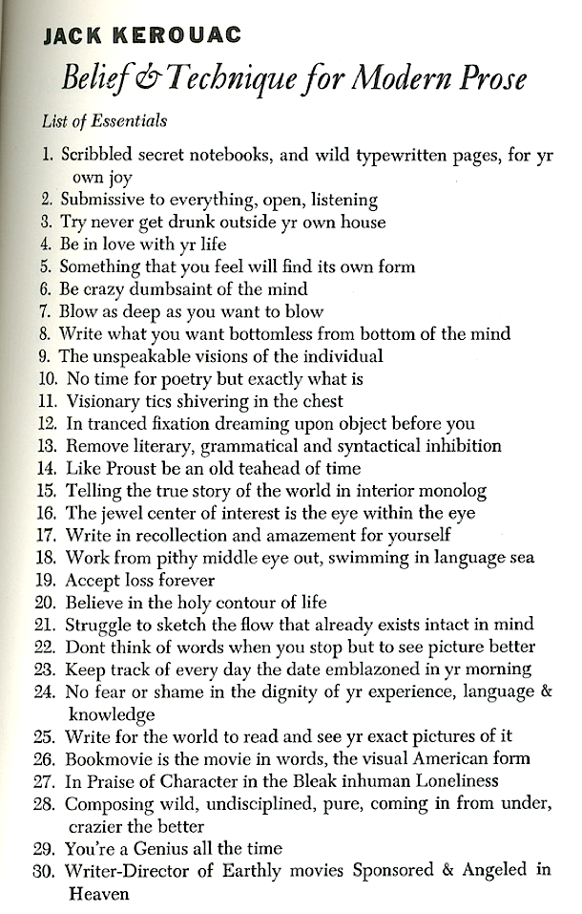

## **Jack Kerouac's spontaneous method: three samples from Book of Dreams and Old Angel Midnight**

### **The following summary is adapted from Ann Charters's "Editor's Introduction" to the section of The Portable Jack Kerouac, opening the section Charters titles "The Modern Spontaneous Method":**

[One] of Kerouac's writing experiments continued for years, a project begun in 1952 that he considered his private dream-record, what the publisher Lawrence Ferlinghetti called "the poetic raw material of the Kerouac saga, the substrata of his novels and a commentary upon them."

[You will be reading two pieces of dream-writing] from Book of Dreams, published by City Lights in 1961. Kerouac kept several sheets of paper and a pencil attached to a clipboard on a string tied to the headboard of his bed, so he could write down his dreams immediately after awakening. He typed up the selections for Ferlinghetti, and his friend Philip Whalen put them in order for publication....

[The third piece here is] from Old Angel Midnight, in which Kerouac, influenced by James Joyce's experiments in Finnegan's Wake(1939), pushed spontaneous prose to its ultimate expression. Kerouac told John Clellon Holmes that his work in progress was "an endless automatic writing piece which raves on and on with no direction and no story." He experimented with free association in this poem, attempting to write down "the sounds of the entire world ... now swimming thru the window." The San Francisco poet Michael McClure recognized that in Old Angel Midnight, Kerouac had achieved one of his most remarkable works: 'Never [wrote McClure] before has inconsequentiality been raised to such a peak that it becomes a breakthrough.... Inconsequentiality becomes a skewing of the established values of the senses and imagination into strange and yet familiar, but elusive, tantalizing and remarkable, constructs of image and sound.... The politics of Old Angel Midnight is that it is a reply by Jack to heavily armored, socially approved literature, as it was then taught and admired in colleges.... Old Angel Midnight is contemporary with exploratory jazz and with the painting which sought to make spiritual autobiography utilizing the gestures of the artist and his materials.... Old Angel Midnight is struggling to be occupied by consciousness and nothingness, and not by social commands.'"

### **SAMPLE #1 — from Book of Dreams**

In a dismal studio room in New York my whole family Ma Pa & Nin and I have taken up quarters and "all got jobs" and here it's night, one dim light burning, we're conversing but it's a weird conversation, it seems I dont realize what I'm doing and involuntarily or carelessly (because not fearing wrath of women relatives and forgotten the father's because he so long gone in death) I'm rolling a stick of tea and talking right at them some wild excited inanities (born of T) they dont even listen to, rather they're discussing me solemnish and my father gets up and says "He's not worried about marijuana? Eh?" and he comes over to my side — I see him coming and I go blind, darkness takes the place of the entire scene, nevertheless now I feel his touch on my arm, he may have an axe, he may have anything and I cant see — I fall fainting dead in the darkness, with a groan that wakes me up and prevents me from being found dead (if there is such a thing as death) in my bed in the morning-for my blood stop't beating when that Shroudy Traveller finally got his hand on me — He's getting closer & closer — I know how to be beyond him now-by not being concerned not believing in either life or death, if this can be possible in a humble Pratyeka at this time

### **SAMPLE #2—from Book of Dreams**

I'm looking for a place to sit and write quietly at the baseball park and go around a fountain and batting cage wire to a bench on the side where there's an old typewriter & desks under a tree and here I turn into "Malcolm Cowley" and start typing — but so old the Machine, to register letters ya gotta hit it one finger at a time hard, which I do, — & there's a sad young kid there, of 18, definite personality, curly brown hair, thoughtful, as an interested old Man of Letters I begin to interview him sympathetically and find he's a young tender poet so saddened he doesnt write much, or some such, — walked 2 1/2 miles before I wrote this, so part forgot — So he stares into space in my dream and I worry about him — Who's subjective? Who's objective?

### **SAMPLE #3—from Old Angel Midnight**

Boy, says Old Angel, this amazing nonsensical rave of yours wherein I spose you'd think you'd in some lighter time find hand be-almin ya for the likes of what ya devote yaself to, pah — bum with a tail only means one thing, — They know that in sauerkraut bars, god the chew chew & wall lips-And not only that but all them in describable paradises aye — ah — Angel m boy-Jack, the born with a tail bit is a deal that you never dream'd to redeem — verify — try to see as straight-you wont believe even in God but the devil worries you-you & Mrs Tourian — great gaz-zuz & I'd as lief be scoured with a leaf rust as hear this poetizin horseshit everywhere I want to hear the sounds thru the window you promised me when the Midnight bell on 7th St did toll bing bong & Burroughs and Ginsberg were asleep & you lay on the couch in that timeless moment in the little red bulblight bus & saw drapes of eternity parting for your hand to begin & so's you could affect-and eeffect — the total turningabout & deep revival of world robeflowing literature till it shd be something a man'd put his eyes on & continually read for the sake of reading & for the sake of the Tongue & not just these insipid stories writ in insipid aridities & paranoias bloomin & why yet the image — let's hear the Sound of the Universe, son, & no more part twaddle-And dont expect nothing from me, my middle name is Opprobrium, Old Angel Midnight Opprobrium, boy, O.A.M.O. —

Pirilee pirilee, tzwe tzwi tzwa, — tack tick-birds & firewood. The dream is already ended and we're already awake in the golden eternity.

## **"October in the Railroad Earth" by Jack Kerouac**

There was a little alley in San Francisco back of the Southern Pacific station at Third and Townsend in redbrick of drowsy lazy afternoons with everybody at work in offices in the air you feel the impending rush of their commuter frenzy as soon they’ll be charging en masse from Market and Sansome buildings on foot and in buses and all well-dressed thru workingman Frisco of Walkup ?? truck drivers and even the poor grime-bemarked Third Street of lost bums even Negros so hopeless and long left East and meanings of responsibility and try that now all they do is stand there spitting in the broken glass sometimes fifty in one afternoon against one wall at Third and Howard and here’s all these Millbrae and San Carlos neat-necktied producers and commuters of America and Steel civilization rushing by with San Francisco Chronicles and green Call-Bulletins not even enough time to be disdainful, they’ve got to catch 130, 132, 134, 136 all the way up to 146 till the time of evening supper in homes of the railroad earth when high in the sky the magic stars ride above the following hotshot freight trains — it’s all in California, it’s all a sea, I swim out of it in afternoons of sun hot meditation in my jeans with head on handkerchief on brakeman’s lantern or (if not working) on book, I look up at blue sky of perfect lostpurity and feel the warp of wood of old America beneath me and I have insane conversations with Negroes in second-story windows above and everything is pouring in, the switching moves of boxcars in that little alley which is so much like the alleys of Lowell and I hear far off in the sense of coming night that engine calling our mountains.

But it was that beautiful cut of clouds I could always see above the little S.P. alley, puffs floating by from Oakland or the Gate of Marin to the north or San Jose south, the clarity of Cal to break your heart. It was the fantastic drowse and drum hum of lum mum afternoon nathin’ to do, ole Frisco with end of land sadness — the people — the alley full of trucks and cars of businesses nearabouts and nobody knew or far from cared who I was all my life three thousand five hundred miles from birth-O opened up and at last belonged to me in Great America.

## **Jack Kerouac speaks about “October in the Railroad Earth” during an interview with Ted Berrigan for The Paris Review**

"...[T]he prose in 'October in the Railroad Earth,' very experimental, intended to clack along all the way like a steam engine pulling a one-hundred-car freight with a talky caboose at the end, that was my way at the time and it still can be done if the thinking during the swift writing is confessional and pure and all excited with the life of it. And be sure of this, I spent my entire youth writing slowly with revisions and endless rehashing speculation and deleting and got so I was writing one sentence a day and the sentence had no FEELING. Goddamn it, FEELING is what I like in art, not CRAFTINESS and the hiding of feelings."

[Paris Review interview] http://www.theparisreview.org/interviews/4260/the-art-of-fiction-no-41-jack-kerouac

## **a sample of Jack Kerouac's "babble flow":**

Aw rust rust rust rust die die die pipe pipe ash ash die die ding dong ding ding ding rust cob die pipe ass rust die words — I'd as rather be permiganted in Rusty's moonlight Rork as be perderated in this bile arta panataler where ack the orshy rosh crowshes my tired idiot hand 0 Lawd I is coming to you'd soon's you's ready's as can readies by Mazatlan heroes point out Mexicos & all ye rhythmic bay fishermen don't hang fish eye soppy in my Ramadam give —dgarette Sop of Arab Squat — the Berber types that hang fardels on their woman back wd aslief Erick some son with blady matter I guess as whup a mule in singsong pathetic mule-jump field by quiet fluff smoke North Carolina (near Weldon) (Railroad Bridge) Roanoke millionaire High-Ridge hi-party Hi-Fi million-dollar findriver skinfish Rod Tong Apple Finder John Sun Ford goodby Paw mule America Song —

[For an essay on Kerouac's writing as sound poetry, see [Clark Coolidge's essay in the](http://www.writing.upenn.edu/~afilreis/88v/kerouac-per-coolidge.html) American Poetry Review.]

## **“Jail Poems” by Bob Kaufman (sections-3-4-7-14-19-22-34-35)**

III

In a universe of cells — who is not in jail? Jailers

In a world of hospitals — who is not sick? Doctors,

A golden sardine is swimming in my head,

O we know some things, man, about some things

Like jazz and jails and God.

Saturday is a good day to go to jail.

IV

Now they give a new form, quivering jelly-like,

That proves any boy can be president of Muscatel.

They are mad at him because he's one of Them.

Grey speckled while nakedness — stinking

Fingers grasping toilet bowl. Mr. America wants to bathe.

Look! On the floor, lying across America's face —

What am I doing — feeling compassion?

When he comes out of it, he will help kill me.

He probably hates Beatniks.

VII

Someone who I am is no one.

Something I have done is nothing.

Someplace I have been is nowhere.

I am not me. What of the answers

I must find questions for,

All these strange streets

I must find cities for,

Thank God for Beatniks.

XIV

One day Adolph Hitler had nothing to do.

All the Jews were burned, artists all destroyed,

Adolph Hitler was very bored, even with Eva,

So he moved to San Francisco, became an ordinary

Policeman, devoted himself to stamping out Beatniks.

XIX

Sitting here writing things on paper,

Instead of sticking the pencil into the air.

XXII

Caught in imaginary webs of conscience,

I weep over my acts, yet believe.

XXXIV

The defective on the floor, mumbling

Was once a man who shouted across tables.

XXXV

Come, help flatten a raindrop.

Bob Kaufman, “Jail Poems,” published in Beatitude Anthology (San Francisco: City Lights Books, 1960), pp. 51-56. The original Beatitude magazine was conceived by Allen Ginsberg, Bob Kaufman, and John Kelly at Cassandra's Coffee House in May 1959.

## **"I Know a Man" by Robert Creeley**

As I sd to my

friend, because I am

always talking,—John, I

sd, which was not his

name, the darkness sur-

rounds us, what

can we do against

it, or else, shall we &

why not, buy a goddamn big car,

drive, he sd, for

christ’s sake, look

out where yr going.

## **Anne Waldman Rogue State**

I’m in a rogue state, honey  
Getting unpredictable & strange  
Just a rogue state itching to  
Test my harridan ballistic range

National Missile Defense System  
Got nothing on me  
I can pierce thru the genome project  
With a cyborg’s vitality

I’m in a rogue state, Mr. President  
Don’t tell me what to do  
Your rules aren’t my rules  
Cause I’m the Lady of Misrule

## **"Incident" by Amiri Baraka**

He came back and shot. He shot him. When he came

back, he shot, and he fell, stumbling, past the

shadow wood, down, shot, dying, dead, to full halt.

At the bottom, bleeding, shot dead. He died then, there

after the fall, the speeding bullet, tore his face

and blood sprayed fine over the killer and the grey light.

Pictures of the dead man, are everywhere. And his spirit

sucks up the light. But he died in darkness darker than

his soul and everything tumbled blindly with him dying

down the stairs.

We have no word

on the killer, except he came back, from somewhere

to do what he did. And shot only once into his victim's

stare, and left him quickly when the blood ran out. We know

the killer was skillful, quick, and silent, and that the victim

probably knew him. Other than that, aside from the caked sourness

of the dead man's expression, and the cool surprise in the fixture

of his hands and fingers, we know nothing.

## **Amiri Baraka's "How You Sound??"**

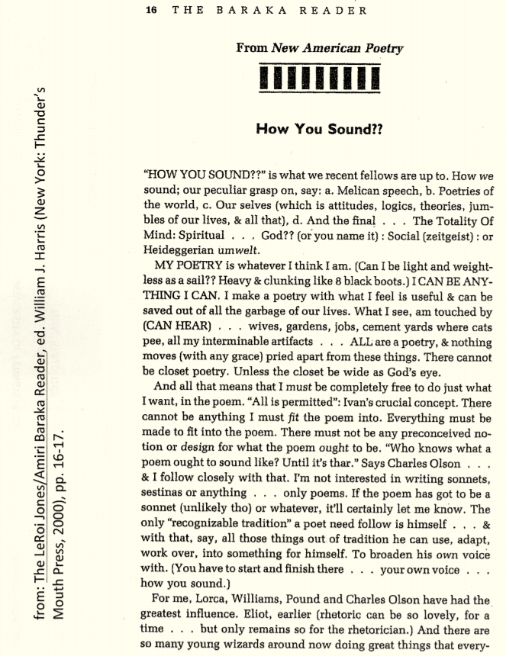

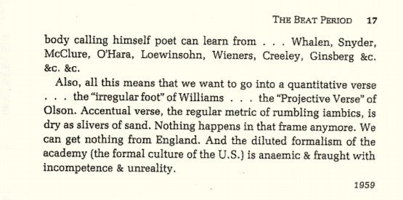

# chapter 8 (week 7)—the New York School

## **"The Day Lady Died" by Frank O'Hara**

It is 12:20 in New York a Friday

three days after Bastille day, yes

it is 1959 and I go get a shoeshine

because I will get off the 4:19 in Easthampton

at 7:15 and then go straight to dinner

and I don’t know the people who will feed me

I walk up the muggy street beginning to sun

and have a hamburger and a malted and buy

an ugly NEW WORLD WRITING to see what the poets

in Ghana are doing these days

I go on to the bank

and Miss Stillwagon (first name Linda I once heard)

doesn’t even look up my balance for once in her life

and in the GOLDEN GRIFFIN I get a little Verlaine

for Patsy with drawings by Bonnard although I do

think of Hesiod, trans. Richmond Lattimore or

Brendan Behan’s new play or Le Balcon or Les Nègres

of Genet, but I don’t, I stick with Verlaine

after practically going to sleep with quandariness

and for Mike I just stroll into the PARK LANE

Liquor Store and ask for a bottle of Strega and

then I go back where I came from to 6th Avenue

and the tobacconist in the Ziegfeld Theatre and

casually ask for a carton of Gauloises and a carton

of Picayunes, and a NEW YORK POST with her face on it

and I am sweating a lot by now and thinking of

leaning on the john door in the 5 SPOT

while she whispered a song along the keyboard

to Mal Waldron and everyone and I stopped breathing

## **"Variations of a Theme by William Carlos Williams" by Kenneth Koch**

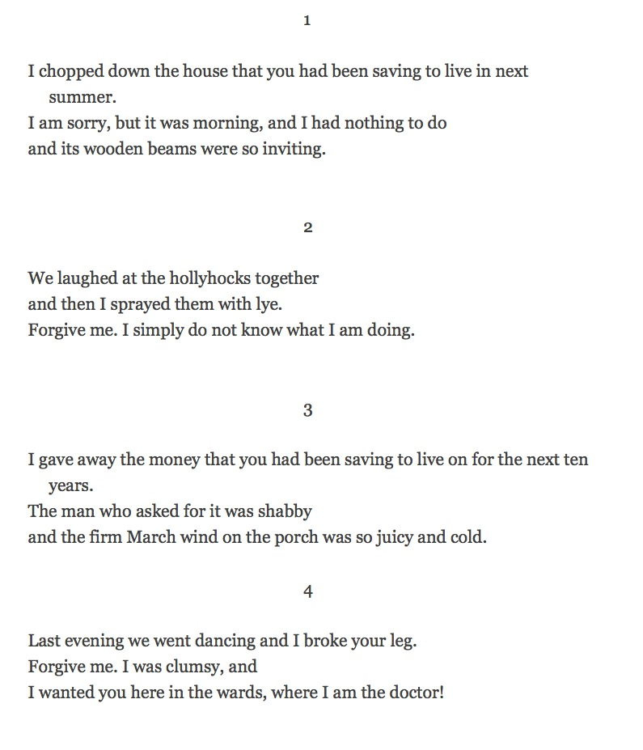

## **"The Instruction Manual" by John Ashbery**

As I sit looking out of a window of the building

I wish I did not have to write the instruction manual on the uses of a new metal.

I look down into the street and see people, each walking with an inner peace,

And envy them—they are so far away from me!

Not one of them has to worry about getting out this manual on schedule.

And, as my way is, I begin to dream, resting my elbows on the desk and leaning out of

the window a little,

Of dim Guadalajara! City of rose-colored flowers!

City I wanted most to see, and most did not see, in Mexico!

But I fancy I see, under the press of having to write the instruction manual,

Your public square, city, with its elaborate little bandstand!

The band is playing Scheherazade by Rimsky-Korsakov.

Around stand the flower girls, handing out rose- and lemon-colored flowers,

Each attractive in her rose-and-blue striped dress (Oh! such shades of rose and blue),

And nearby is the little white booth where women in green serve you green and yellow fruit.

The couples are parading; everyone is in a holiday mood.

First, leading the parade, is a dapper fellow

Clothed in deep blue. On his head sits a white hat

And he wears a mustache, which has been trimmed for the occasion.

His dear one, his wife, is young and pretty; her shawl is rose, pink, and white.

Her slippers are patent leather, in the American fashion,

And she carries a fan, for she is modest, and does not want the crowd to see her face

too often.

But everybody is so busy with his wife or loved one

I doubt they would notice the mustachioed man’s wife.

Here come the boys! They are skipping and throwing little things on the sidewalk

Which is made of gray tile. One of them, a little older, has a toothpick in his teeth.

He is silenter than the rest, and affects not to notice the pretty young girls in white.

But his friends notice them, and shout their jeers at the laughing girls.

Yet soon all this will cease, with the deepening of their years,

And love bring each to the parade grounds for another reason.

But I have lost sight of the young fellow with the toothpick.

Wait—there he is—on the other side of the bandstand,

Secluded from his friends, in earnest talk with a young girl

Of fourteen or fifteen. I try to hear what they are saying

But it seems they are just mumbling something—shy words of love, probably.

She is slightly taller than he, and looks quietly down into his sincere eyes.

She is wearing white. The breeze ruffles her long fine black hair against her olive

cheek.

Obviously she is in love. The boy, the young boy with the toothpick, he is in love too;

His eyes show it. Turning from this couple,

I see there is an intermission in the concert.

The paraders are resting and sipping drinks through straws

(The drinks are dispensed from a large glass crock by a lady in dark blue),

And the musicians mingle among them, in their creamy white uniforms, and talk

About the weather, perhaps, or how their kids are doing at school.

Let us take this opportunity to tiptoe into one of the side streets.

Here you may see one of those white houses with green trim

That are so popular here. Look—I told you!

It is cool and dim inside, but the patio is sunny.

An old woman in gray sits there, fanning herself with a palm leaf fan.

She welcomes us to her patio, and offers us a cooling drink.

“My son is in Mexico City,” she says. “He would welcome you too

If he were here. But his job is with a bank there.

Look, here is a photograph of him.”

And a dark-skinned lad with pearly teeth grins out at us from the worn leather frame.

We thank her for her hospitality, for it is getting late

And we must catch a view of the city, before we leave, from a good high place.

That church tower will do—the faded pink one, there against the fierce blue of the sky.

Slowly we enter.

The caretaker, an old man dressed in brown and gray, asks us how long we have been

in the city, and how we like it here.

His daughter is scrubbing the steps—she nods to us as we pass into the tower.

Soon we have reached the top, and the whole network of the city extends before us.

There is the rich quarter, with its houses of pink and white, and its crumbling, leafy

terraces.

There is the poorer quarter, its homes a deep blue.

There is the market, where men are selling hats and swatting flies

And there is the public library, painted several shades of pale green and beige.

Look! There is the square we just came from, with the promenaders.

There are fewer of them, now that the heat of the day has increased,

But the young boy and girl still lurk in the shadows of the bandstand.

And there is the home of the little old lady—

She is still sitting in the patio, fanning herself.

How limited, but how complete withal, has been our experience of Guadalajara!

We have seen young love, married love, and the love of an aged mother for her son.

We have heard the music, tasted the drinks, and looked at colored houses.

What more is there to do, except stay? And that we cannot do.

And as a last breeze freshens the top of the weathered old tower, I turn my

gaze

Back to the instruction manual which has made me dream of Guadalajara.

## **"A Step Away from Them" by Frank O'Hara**

It’s my lunch hour, so I go

for a walk among the hum-colored

cabs. First, down the sidewalk

where laborers feed their dirty

glistening torsos sandwiches

and Coca-Cola, with yellow helmets

on. They protect them from falling

bricks, I guess. Then onto the

avenue where skirts are flipping

above heels and blow up over

grates. The sun is hot, but the

cabs stir up the air. I look

at bargains in wristwatches. There

are cats playing in sawdust.

                                          On

to Times Square, where the sign

blows smoke over my head, and higher

the waterfall pours lightly. A

Negro stands in a doorway with a

toothpick, languorously agitating.

A blonde chorus girl clicks: he

smiles and rubs his chin. Everything

suddenly honks: it is 12:40 of

a Thursday.

                Neon in daylight is a

great pleasure, as Edwin Denby would

write, as are light bulbs in daylight.

I stop for a cheeseburger at JULIET’S

CORNER. Giulietta Masina, wife of

Federico Fellini, *è bell’ attrice.*

And chocolate malted. A lady in

foxes on such a day puts her poodle

in a cab.

             There are several Puerto

Ricans on the avenue today, which

makes it beautiful and warm. First

Bunny died, then John Latouche,

then Jackson Pollock. But is the

earth as full as life was full, of them?

And one has eaten and one walks,

past the magazines with nudes

and the posters for BULLFIGHT and

the Manhattan Storage Warehouse,

which they’ll soon tear down. I

used to think they had the Armory

Show there.

                A glass of papaya juice

and back to work. My heart is in my

pocket, it is Poems by Pierre Reverdy.

## **Barbara Guest's "20"**

Sleep is 20

                    remembering the

insignificant flamenco dancer

in Granada

                    who became

important as you watched

the mountain ridge

                    the dry hills

What an idiotic number!

Sleep is twenty

it certainly isn’t twenty sheep

there weren’t that many in the herd

under the cold crest of Sierra Nevada

It’s more like 20 Madison Ave. buses

while I go droning away at my dream life

Each episode is important

that’s what it is! Sequences —

I’ve got going a twenty-act drama

the theatre of the active

the critics are surely there

even the actors

even the flowers presented onstage

even the wild flowers

picked by the wife of the goatherd

each morning early (while I sleep)

under the snow cone

of Sierra Nevada

                    yellow caps like castanets

                    I reach into my bouquet

                    half-dreaming

                    and count twenty

                    yellow capped heads

flowers clicking twenty times

because they like to repeat themselves

as I do as does the morning

or the drama one hopes

will be acted many times

As even these dreams in similar

people’s heads

                         20

                     castanets

## **"Some Trees" by John Ashbery**

These are amazing: each

Joining a neighbor, as though speech

Were a still performance.

Arranging by chance

To meet as far this morning

From the world as agreeing

With it, you and I

Are suddenly what the trees try

To tell us we are:

That their merely being there

Means something; that soon

We may touch, love, explain.

And glad not to have invented

Such comeliness, we are surrounded:

A silence already filled with noises,

A canvas on which emerges

A chorus of smiles, a winter morning.

Placed in a puzzling light, and moving,

Our days put on such reticence

These accents seem their own defense.

## **"Hard Times" by John Ashbery**

Trust me. The world is run on a shoestring.

They have no time to return the calls in hell

And pay dearly for those wasted minutes. Somewhere

In the future it will filter down through all the proceedings

But by then it will be too late, the festive ambience

Will linger on but it won't matter. More or less

Succinctly they will tell you what we've all known for years:

That the power of this climate is only to conserve itself.

Whatever twists around it is decoration and can never

Be looked at as something isolated, apart. Get it? And

He flashed a mouthful of aluminum teeth there in the darkness

To tell however it gets down, that it does, at last.

Once they made the great trip to California

And came out of it flushed. And now every day

Will have to dispel the notion of being like all the others.

In time, it gets to stand with the wind, but by then the night is closed off.

## **"3 Pages" by Ted Berrigan**

For Jack Collom

10 Things I do Every Day

                              play poker

                              drink beer

                              smoke pot

                              jack off

                   curse

BY THE WATERS OF MANHATTAN

                               flower

      positive & negative

go home

          read   lunch   poems

               hunker down

    changes

                  Life goes by

                                        quite merrily

*blue*

                        NO HELP WANTED

                                 Hunting For The Whale

                   “and if the weather plays me fair

                               I’m happy every day.”

                     The white that dries clear

                     the heart attack

                     the congressional medal of honor

                     A house in the country

                     NOT ENOUGH

## **"Invasion of the Body Snatchers" by Bernadette Mayer**

Moon out and no snow yet, November first

The first anniversary of our wedding and

The day before election day, 1976, yesterday

Was Halloween, next Friday I have an appointment

With the dentist and the following Tuesday is

Lewis's thirty-second birthday, exactly one week

After that Marie will be eleven months old.

The day before yesterday we turned the clocks back

One hour which made it seem like every day

Will have an extra hour in it, not only of darkness

But of just plain time, the time I used to spend

Skipping lunch is longer, the time for dinner

Is too early now, the time for sunset comes too soon

The time between dinner and Marie's bedtime is too long

When it's time to go to bed there's still a few hours left

To read, I'm dreaming twice as much as before

I spend all my new time lying in bed thinking.

Last night I saw "Invasion of the Body Snatchers"

And tonight when I came into my room to go to work

I found an old seed pod on the floor by my desk.

In the movie if you see one of these it's time to die.

It's time to write some letters, good cold air

Comes in my window, it wakes me up, we had a bottle

Of champagne and Marie went to sleep without crying

It's time to read Fielding's Guide to European Travel

And the Alice Toklas Cookbook again, a few books by

John McPhee

Our new American Heritage anniversary dictionary,

The Adventures of a Mathematician by Stanislas Ulam

And The Wild Boy of Averyron by a behaviorist psychologist

About a boy brought up by wolves

## **"Uptown Ode That Ends on an Ode to the Machete" by Patrick Rosal**

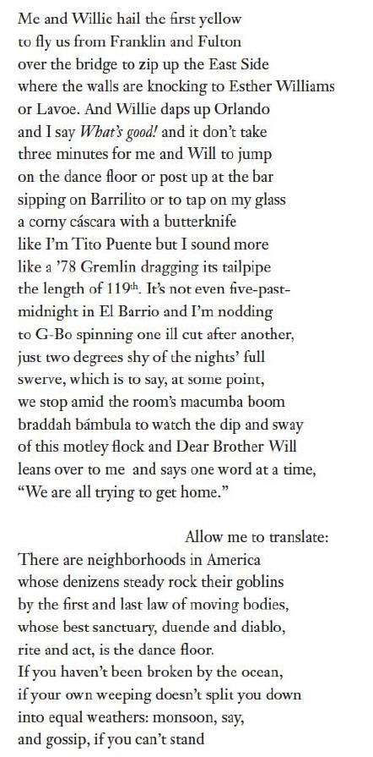

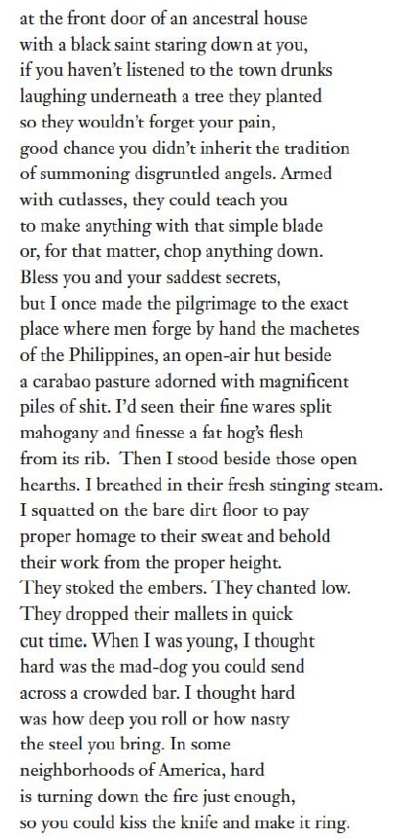

What happens when me and Willie  
run into each other on a Wednesday night  
in Brooklyn? He asks, “Where we going?”  
And that’s not really a question.  
That’s an ancestral imperative: to hail  
any yellow or gypsy that’ll stop on Franklin  
and Lincoln to fly us over the bridge then  
zip up the East Side where the walls  
are knocking to Esther Williams or Lavoe.  
And you know Willie daps up Orlando  
and I say What’s good! and it don’t take  
three minutes for me and Will to jump  
on the dance floor or post up at the bar  
sipping on Barrilito or to tap on my glass  
a corny cáscara with a butterknife  
like I’m Tito Puente but I have no clue  
I really sound like a ’78 Gremlin  
dragging its tailpipe the length of 119th,  
which is to say, it don’t take long  
for Willie and me to be all in. And that’s when  
out of nowhere in the middle of the room’s boom-  
braddah macumba candombe bámbula  
this Puerto Rican leans over and says to me  
real slow, “Everybody is trying to get  
home.” And I’m like, “Aw fuck.” because  
I’m on 1st Ave  between 115th and 116thnot even invested in the full swerve yet.  
It’s not even five past midnight and Will  
is dropping science like that. Allow me  
to translate: There are neighborhoods in America  
where a man says one simple sentence  
and out flow the first seventeen discrete meanings  
of home. If you haven’t been broken by the ocean,  
if your own weeping doesn’t split you down  
into equal weathers: monsoon, say, and gossip,  
if you can’t stand at the front door  
of an ancestral house and see a black saint  
staring down at you, no name, no judgment,  
if you haven’t listened to the town drunks  
laughing underneath a tree they planted  
so they wouldn’t forget your pain, then your story  
must have a whole other set  of secrets.  
You must know what it’s like to expect  
an invitation. You might not know what it’s like  
to wonder if someone is even waiting  
for you to return. Your idea of home  
might not contain ways to call blood cousins  
from another time zone or just shout  
from the middle of the road. There are those of us  
descended from peasants who never had to travel  
too far to visit the smiths who craft knives  
from hilt to tip, who cook blades  
that split the wood or carve the rind  
from flesh. I once went to visit the men  
who make the machetes of the Philippines.  
There was a time, I didn’t care where  
those knives came from, how the men and women  
stoked the embers and dropped their mallets  
with a millimeter’s precision. When I was young,  
I thought hard was the mad-dog you could send  
across a crowded bar. I thought hard  
was how deep you roll or how nasty the steel  
you bring. In some neighborhoods of America,  
hard is turning down the fire just enough,  
so you could kiss the knife and make it ring.

# chapter 9.1 (week 8)—some trends in recent poetry: L=A=N=G=U=A=G=E

## **"Albany" by Ron Silliman**

If the function of writing is to "express the world." My father withheld child support, forcing my mother to live with her parents, my brother and I to be raised together in a small room. Grandfather called them niggers. I can't afford an automobile. Far across the calm bay stood a complex of long yellow buildings, a prison. A line is the distance between. They circled the seafood restaurant, singing "We shall not be moved." My turn to cook. It was hard to adjust my sleeping to those hours when the sun was up. The event was nothing like their report of it. How concerned was I over her failure to have orgasms? Mondale's speech was drowned by jeers. Ye wretched. She introduces herself as a rape survivor. Yet his best friend was Hispanic. I decided not to escape to Canada. Revenue enhancement. Competition and spectacle, kinds of drugs. If it demonstrates form some people won't read it. Television unifies conversation. Died in action. If a man is a player, he will have no job. Becoming prepared to live with less space. Live ammunition. Secondary boycott. My crime is parole violation. Now that the piecards have control. Rubin feared McClure would read Ghost Tantras at the teach-in. This form is the study group. The sparts are impeccable, though filled with deceit. A benefit reading. He seduced me. AFT, local 1352. Enslavement is permitted as punishment for crime. Her husband broke both of her eardrums. I used my grant to fix my teeth. They speak in Farsi at the corner store. YPSL. The national question. I look forward to old age with some excitement - 42 years for Fibreboard Products. Food is a weapon. Yet the sight of people making love is deeply moving. Music is essential. The cops wear shields that serve as masks. Her lungs heavy with asbestos. Two weeks too old to collect orphan's benefits. A woman on the train asks Angela Davis for an autograph. You get read your Miranda. As if a correct line would somehow solve the future. They murdered his parents just to make the point. It's not easy if your audience doesn't identify as readers. Mastectomies are done by men. Our pets live at whim. Net income is down 13%. Those distant sirens down in the valley signal great hinges in the lives of strangers. A phone tree. The landlord's control of terror is implicit. Not just a party but a culture. Copayment. He held the Magnum with both hands and ordered me to stop. The garden is a luxury (a civilization of snail and spider). They call their clubs batons. They call their committees clubs. Her friendships with women are different. Talking so much is oppressive. Outplacement. A shadowy locked facility using drugs and double-celling (a rest home). That was the Sunday Henry's father murdered his wife on the front porch. If it demonstrates form they can't read it. If it demonstrates mercy they have something worse in mind. Twice, carelessness has led to abortion. To own a basement. Nor is the sky any less constructed. The design of a department store is intended to leave you fragmented, off-balance. A lit drop. They photograph Habermas to hide the hairlip. The verb to be admits the assertion. The body is a prison, a garden. In kind. Client populations (cross the tundra). Off the books. The whole neighborhood is empty in the daytime. Children form lines at the end of each recess. Eminent domain. Rotating chair. The history of Poland in 90 seconds. Flaming pintos. There is no such place as the economy, the self. That bird demonstrates the sky. Our home, we were told, had been broken, but who were these people we lived with? Clubbed in the stomach, she miscarried. There were bayonets on campus, cows in India, people shoplifting books. I just want to make it to lunch time. Uncritical of nationalist movements in the Third World. Letting the dishes sit for a week. Macho culture of convicts. With a shotgun and "in defense" the officer shot him in the face. Here, for a moment, we are joined. The want-ads lie strewn on the table.

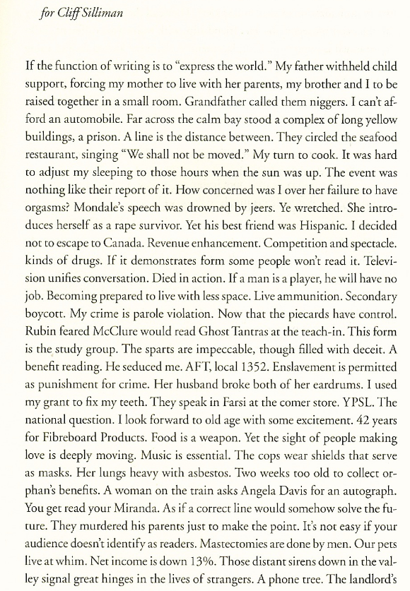

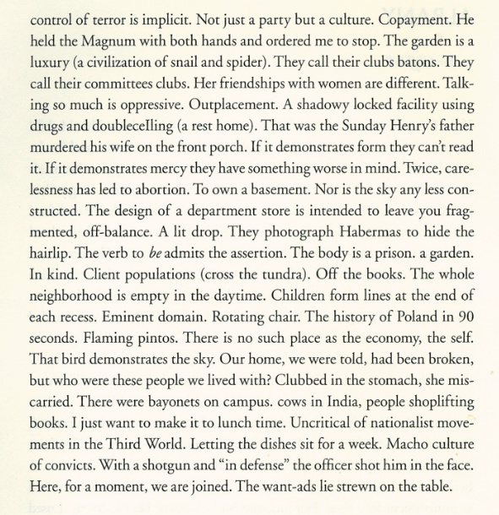

## **Lyn Hejinian's "My Life" (see separated file)**

## **"Chronic Meanings" by Bob Perelman**

for Lee Hickman

The single fact is matter.

Five words can say only.

Black sky at night, reasonably.

I am, the irrational residue.

Blown up chain link fence.

Next morning stronger than ever.

Midnight the pain is almost.

The train seems practically expressive.

A story familiar as a.

Society has broken into bands.

The nineteenth century was sure.

Characters in the withering capital.

The heroic figure straddled the.

The clouds enveloped the tallest.

Tens of thousands of drops.

The monster struggled with Milton.

On our wedding night I.

The sorrow burned deeper than.

Grimly I pursued what violence.

A trap, a catch, a.

Fans stand up, yelling their.

Lights go off in houses.

A fictional look, not quite.

To be able to talk.

The coffee sounds intriguing but.

She put her cards on.

What had been comfortable subjectivity.

The lesson we can each.

Not enough time to thoroughly.

Structure announces structure and takes.

He caught his breath in.

The vista disclosed no immediate.

Alone with a pun in.

The clock face and the.

Rock of ages, a modern.

I think I had better.

Now this particular mall seemed.

The bag of groceries had.

Whether a biographical junkheap or.

In no sense do I.

These fields make me feel.

Mount Rushmore in a sonnet.

Some in the party tried.

So it's not as if.

That always happened until one.

She spread her arms and.

The sky if anything grew.

Which left a lot of.

No one could help it.

I ran farther than I.

That wasn't a good one.

Now put down your pencils.

They won't pull that over.

Standing up to the Empire.

Stop it, screaming in a.

The smell of pine needles.

Economics is not my strong.

Until one of us reads.

I took a breath, then.

The singular heroic vision, unilaterally.

Voices imitate the very words.

Bed was one place where.

A personal life, a toaster.

Memorized experience can't be completely.

The impossibility of the simplest.

So shut the fucking thing.

Now I've gone and put.

But that makes the world.

The point I am trying.

Like a cartoon worm on.

A physical mouth without speech.

If taken to an extreme.

The phone is for someone.

The next second it seemed.

But did that really mean.

Yet Los Angeles is full.

Naturally enough I turn to.

Some things are reversible, some.

You don't have that choice.

I'm going to Jo's for.

Now I've heard everything, he.

One time when I used.

The amount of dissatisfaction involved.

The weather isn't all it's.

You'd think people would have.

Or that they would invent.

At least if the emotional.

The presence of an illusion.

Symbiosis of home and prison.

Then, having become superfluous, time.

One has to give to.

Taste: the first and last.

I remember the look in.

It was the first time.

Some gorgeous swelling feeling that.

Success which owes its fortune.

Come what may it can't.

There are a number of.

But there is only one.

That's why I want to.

## **"In a Restless World Like This Is" by Charles Bernstein**

Not long ago, or maybe I dreamt it

Or made it up, or have suddenly lost

Track of its train in the hocus pocus

Of the dissolving days; no, if I bend

The turn around the corner, come at it

From all three sides at once, or bounce the ball

Against all manner of bleary-eyed fortune

Tellers—well, you can see for yourselves there’s

Nothing up my sleeves, or notice even

Rocks occasionally break if enough

Pressure is applied. As far as you go

In one direction, all the further you’ll

Have to go on before the way back has

Become totally indivisible.

## **“My Life had stood — a Loaded Gun” (764) by Emily Dickinson**

My Life had stood — a Loaded Gun —

In Corners — till a Day

The Owner passed — identified —

And carried Me away —

And now We roam in Sovereign Woods —

And now We hunt the Doe —

And every time I speak for Him

The Mountains straight reply —

And do I smile, such cordial light

Upon the Valley glow —

It is as a Vesuvian face

Had let its pleasure through

And when at Night — Our good Day done —

I guard My Master’s Head —

‘Tis better than the Eider Duck’s

Deep Pillow — to have shared —

To foe of His — I’m deadly foe —

None stir the second time —

On whom I lay a Yellow Eye —

Or an emphatic Thumb —

Though I than He — may longer live

He longer must — than I —

For I have but the power to kill,

Without — the power to die —

## **My Emily Dickinson by Susan Howe**

[This excerpt from Susan Howe's My Emily Dickinson is used here by permission of the author. What follows immediately below are four brief passages from the book. Below that are reproductions of some of the relevant pages.]

### **[passage #1]**

Emily Dickinson once wrote to Thomas Wentworth Higginson; "Candor — my Preceptor — is the only wile." This is the right way to put it.

In his Introduction to [In the American Grain](http://books.google.com/books/about/In_the_American_Grain.html?id=y27z85NaPnMC) [1925], William Carlos Williams said he had tried to rename things seen. I regret the false configuration — under the old misappellation — of Emily Dickinson. But I love his book.

The ambiguous paths of kinship pull me in opposite ways at once.

As a poet I feel closer to Williams' writing about writing, even when he goes haywire in "Jacataqua," than I do to most critical studies of Dickinson's work by professional scholars. When Williams writes: "Never a woman, never a poet.... Never a poet saw sun here," I think that he says one thing and means another. A poet is never just a woman or a man. Every poet is salted with fire. A poet is a mirror, a transcriber. Here "we have salt in ourselves and peace one with the other."

When Thoreau wrote his Introduction to A Week on the Concord and Merrimack Rivers, he ended by remembering how he had often stood on the banks of the Musketaquid, or Grass-ground River English settlers had re-named Concord. The Concord's current followed the same law in a system of time and all that is known. He liked to watch this current that was for him an emblem of all progress. Weeds under the surface bent gently downstream shaken by watery wind. Chips, sticks, logs, and even tree stems drifted past. There came a day at the end of the summer or the beginning of autumn, when he resolved to launch a boat from shore and let the river carry him.

Emily Dickinson is my emblematical Concord River.

I am heading toward certain discoveries....

### **[passage #2]**

In the college library I use there are two writers whose work refuses to conform to the Anglo-American literary traditions these institutions perpetuate. Emily Dickinson and Gertrude Stein are clearly among the most innovative precursors of modernist poetry and prose, yet to this day canonical criticism from Harold Bloom to Hugh Kenner persists in dropping their names and ignoring their work. Why these two pathfinders were women, why American -- are questions too often lost in the penchant for biographical detail that "lovingly" muffles their voices. One, a recluse, worked without encouragement or any real interest from her family and her peers. Her poems were unpublished in her lifetime. The other, an influential patron of the arts, eagerly courted publicity, thrived on company, and lived to enjoy her own literary celebrity. Dickinson and Stein meet each other along paths of the Self that begin and end in contradiction. This surface scission is deceptive. Writing was the world of each woman. In a world of exaltation of his imagination, feminine inscription seems single and sudden.

As poetry changes itself it changes the poet's life. Subversion attracted the two of them. By 1860 it was as impossible for Emily Dickinson simply to translate English poetic tradition as it was for Walt Whitman. In prose and in poetry she explored the implications of breaking the law just short of breaking off communication with a reader. Starting from scratch, she exploded habits of standard human intercourse in her letters, as she cut across the customary chronological linearity of poetry. Gertrude Stein (1874-1946), influenced by Cezanne, Picasso and Cubism, verbally elaborated on visual invention. She reached in words for new vision formed from the process of naming, as if a first woman were sounding, not describing, "space of time filled with moving." Repetition, surprise, alliteration, odd rhyme and rhythm, dislocation, deconstruction. To restore the original clarity of each word-skeleton both women lifted the load of European literary custom. Adopting old strategies, they reviewed and re-invented them.

Emily Dickinson and Gertrude Stein also conducted a skillful and ironic investigation of patriarchal authority over literary history. Who polices questions of grammar, parts of speech, connection, and connotation? Whose order is shut inside the structure of a sentence? What inner articulation releases the coils and complications of Saying's assertion? In very different ways the countermovement of these two women's work penetrates to the indefinite limits of written communication.

### **[passage #3]**

Emily Dickinson took the scraps from the separate "higher" female education many bright women of her time were increasingly resenting, combined them with voracious and "unladylike" outside reading, and used the combination. She built a new poetic form from her fractured sense of being eternally on inteIlectual borders, where confident masculine voices buzzed an alluring and inaccessible discourse, backward through history into aboriginal anagogy. Pulling pieces of geometry, geology, alchemy, philosophy, politics, biography, biology, mythology, and philology from alien territory, a "sheltered" woman audaciously invented a new grammar grounded in humility and hesitation. HESITATE from the Latin, meaning to stick. Stammer. To hold back in doubt, have difficulty speaking. "He may pause but he must not hesitate"-Ruskin. Hesitation circled back and surrounded everyone in that confident age of aggressive industrial expansion and brutal Empire building. Hesitation and Separation. The Civil War had split American in two. He might pause, She hesitated. Sexual, racial, and geographical separation are at the heart of Definition.

### **[passage #4]**

When I love a thing I want it and I try to get it. Abstraction of the particular from the universal is the entrance into evil. Love, a binding force, is both envy and emulation. HE (the Puritan God) is a realm of mystery and will always remain unknowable, authoritarian, unpredictable. Between revealed will and secret will Love has been torn in two.

DUALISM: Pythagoras said that all things were divisible into two genera, good and evil; in the genus of good things he classified all perfect things such as light, males, repose, and so forth, whereas in the genus of evil he classified darkness, females, and so forth. — (Thomas Aquinas, “On the Power of God,” p. 84)

Promethean aspiration: To be a woman and a Pythagorean. What is the communal vision of poetry if you are curved, odd, indefinite, irregular, feminine. I go in disguise. Soul under stress, thread of connection broken, fusion of love and knowledge broken, visionary energy lost, Dickinson means this to be an ugly verse. First I find myself a Slave, next I understand my slavery, finally I rediscover myself at liberty inside the confines of known necessity. Gun goes on thinking of the violence done to meaning. Gun watches herself watching.

### **Ron Silliman's "BART," (see separated file)**

written in one long sentence on Labor Day 1976 while riding for hours on a Bay Area Rapid Transit train:

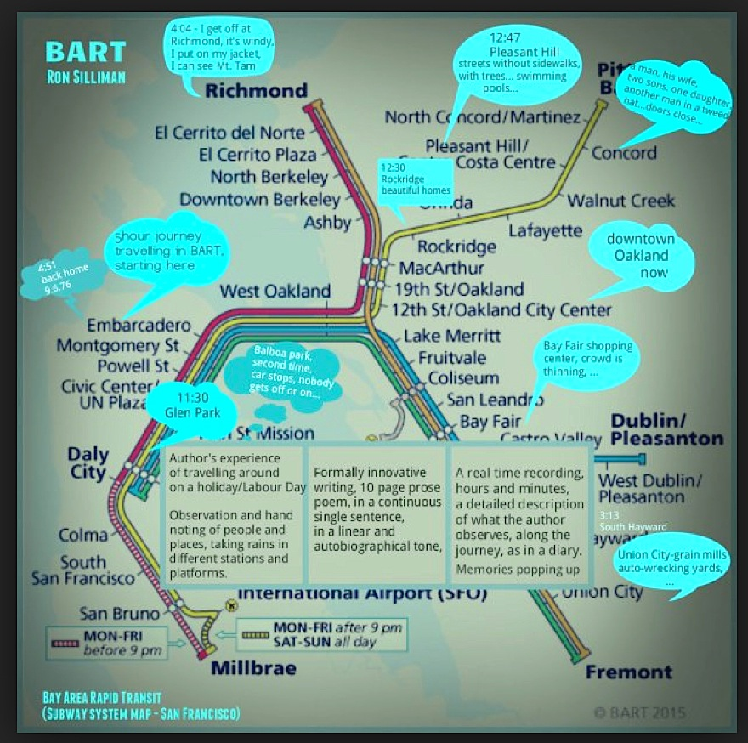

### **"Any Lit" and "Sleeping with the Dictionary" — from Harryette Mullen's book Sleeping with the Dictionary (see separated file)**

# chapter 9.2 (week 9)—some trends in recent poetry: chance

### **a description of mesostics (provided by**[**everything2.com**](http://everything2.com/title/mesostic)**)**

he term "mesostic" was coined by Norman O. Brown to describe the acrostic-like like letter structures that John Cage used when writing short occasional prose-poems. These commemorative pieces were free verse structured by using an index of letters taken from the name of the dedicatee as a spine.

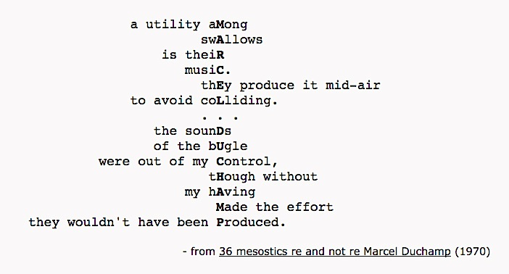

In 1976, Cage followed the letters JAMESJOYCE through Finnegan's Wake to create a reduction of that text, in the form of a mesostic. This resulted in some 600+ handwritten pages that were deemed inappropriate for publication by his editor at Wesleyan University Press. Cage reiterated the exercise with Finnegan's Wake, but kept a catalog of each syllable used to represent each index letter and did not permit a repetition of those syllables to occur in the mesostic. This was published as Writing for the Second Time Through Finnegans Wake in 1977. This writing became the spoken word portion of the soundscape Roratorio, an Irish Circus on Finnegan's Wake, which Cage produced at IRCAM in 1979 for broadcast on WDR. The project led Cage to correspond with Louis Mink, the author of A Finnegan's Wake Gazetter, who proposed that a "pure mesostic" might not iterate either of the index letters in the words between those letters so that each line becomes a short lipogram.

Cage accepted the idea of a pure mesostic (although he referred to them in later years as "perfect mesostics") and subsequently wrote through [Finnegans Wake](http://everything2.com/title/Finnegans+Wake) twice more, creating pure mesostics, once without any further restrictions and then again employing a catalog of possible syllables to avoid their repetition.

In later mesostics, Cage relied upon the computer program MESOLIST to identify words in a source text that would satisfy the index of the mesostic and chance operations based on the I Ching to select which of those words were to be used and the amount of text to remain of either side of the spinal word. This allowed him to practice non-intention when creating the mesostic in a similar way to his use of chance in his musical works. He described this as using the source text as an oracle to solve for the puzzle that the index of the mesostic proposes.

## **"Writing through Howl" [brief excerpt] by John Cage**

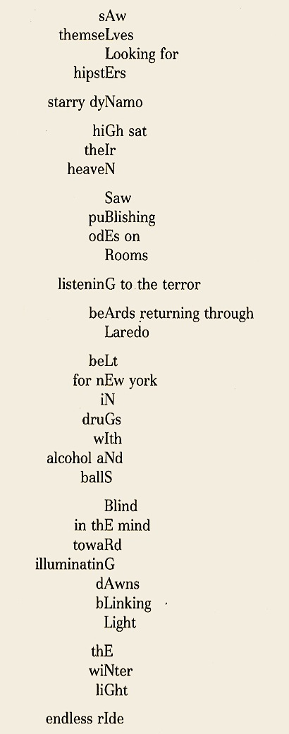

## **three pages from Marjorie Perloff's essay on Allen Ginsberg from her book** *Poetic License:***(see separated file)**

## **A selection of John Cage's adagia**

"I have nothing to say / and I am saying it / and that is poetry / as I needed it."

"It was at Harvard not quite forty years ago that I went into an anechoic [totally silent] chamber not expecting in that silent room to hear two sounds: one high, my nervous system in operation, one low, my blood in circulation. The reason I did not expect to hear those two sounds was that they were set into vibration without any intention on my part. That experience gave my life direction, the exploration of nonintention. No one else was doing that. I would do it for us. I did not know immediately what I was doing, nor, after all these years, have I found out much. I compose music. Yes, but how? I gave up making choices. In their place I put the asking of questions. The answers come from the mechanism, not the wisdom of the I Ching, the most ancient of all books: tossing three coins six times yielding numbers between 1 and 64."

"I certainly had no feeling for harmony, and Schoenberg thought that that would make it impossible for me to write music. He said, 'You'll come to a wall you won't be able to get through.' So I said, 'I'll beat my head against that wall.'"

"Like acrostics, mesotics are written in the conventional way horizontally, but at the same time they follow a vertical rule, down the middle not down the edge as in an acrostic, a string spells a word or name, not necessarily connected with what is being written, though it may be. This vertical rule is lettristic and in my practice the letters are capitalized. Between two capitals in a perfect or 100% mesostic neither letter may appear in lower case. .... In the writing of the wing words, the horizontal text, the letters of the vertical string help me out of sentimentality. I have something to do, a puzzle to solve. This way of responding makes me feel in this respect one with the Japanese people, who formerly, I once learned, turned their letter writing into the writing of poems. In taking the next step in my work, the exploration of nonintention, I don't solve the puzzle that the mesostic string presents. Instead I write or find a source text which is then used as an oracle. I ask it what word shall I use for this letter and what one for the next, etc. This frees me from memory, taste, likes, and dislikes, By means of Mesolist, a program by Jim Rosenberg, all words that satisfy the mesostic rule are listed. IC [a program that generates the I Ching numbers, available for downloading on the Net] then chooses which words in the lists are to be used and gives me all the central words, the position of each in the source material identified by page, line, and column. I then add all the wing words from the source text following of course the rule Mesolist does within the limit of forty-five characters to the right and the same to the left. Then I take out the words I don't want. With respect to the source material, I am in a global situation. Words come first from here and then from there. The situation is not linear. It is as though I am in a forest hunting for ideas."

Cage's most famous musical composition is entitled 4'33''. It is played at the piano and is divided into three movements. All of the notes are silent. The composition takes its name from the fact that it requires four minutes and thirty-three seconds to perform. The pianist uses a stopwatch to control his tempo. For those interested, there are a couple of CD recordings available. Cage said: "The score calls for any number of people playing any number of instruments, not specifically piano, although it was performed many times at the piano. Also I thought it might be beneficial to add something about his second version of the work entitled 0'00", a clear restatement of his original idea."

"If something is boring after two minutes, try it for four. If still boring, then eight. Then sixteen. Then thirty-two. Eventually one discovers that it is not boring at all."

"The first question I ask myself when something doesn't seem to be beautiful is why do I think it's not beautiful. And very shortly you discover that there is no reason."

"Which is more musical: a truck passing by a factory or a truck passing by a music school?"

"Taking the name of the author and/or the title of the book as their subject (the row), write a series of mesostics beginning on the first page and continuing to the last. Mesostics means a row down the middle. In this circumstance a mesostic is written by finding the first word in the book that contains the first letter of the row that is not followed in the same word by the second letter of the row. The second letter belongs on the second line and is to be found in the next word that contains it that is not followed in the same word by the third letter of the row. Etc. If a shorter rather than longer text is desired, keep an index of the syllables used to represent a given letter. Do not permit for a single appearance of a given letter the repetition of a particular syllable. Distinguish between subsequent appearances of the same letter. Other adjacent words from the original text (before and/or after the middle word, the word including a letter of the row) may be used according to taste, limited, say to forty-three characters to the left and forty-three to the right, providing the appearance of the letters, of the row occurs in the way described above."

"I don't know when it began. But at Edwin Denby's loft on 21st Street, not at the time but about the place, I wrote my first mesostic. It was a regular paragraph with the letters of his name capitalized. Since then I have written them as poems, the capitals going down the middle, to celebrate whatever, to support whatever, to fulfill requests, to initiate my thinking or my nonthinking (Themes and Variations is the first of a series of mesostic works: to find a way of writing that, though coming from ideas, is not about them but produces them). I have found a variety of ways of writing mesostic[s.]"

"As far as consistency of thought goes, I prefer inconsistency."

## **Jackson Mac Low, "A Vocabulary for Peter Innisfree Moore"**

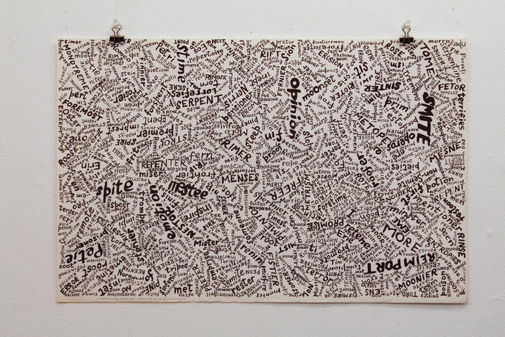

 "A Vocabulary For Peter Innisfree Moore was created in memory of Jackson Mac Low's friend Peter Moore, who documented in photographs Fluxus performances and activities, as well as other New York arts, in the 1960s and '70s. The score of 960 words, all comprised of letters from Moore's full name, Peter Innisfree Moore, is arranged upon the page with erratic dispersion. On the reverse are instructions for the performance of the work."

## **Daniel Kane on Jackson Mac Low's scored piece for Peter Innisfree Moore**

[from page 5 of Daniel Kane's All Poets Welcome: The Lower East Side Poetry Scene of the 1960s:]

Poets associated with Les Deux Magots [a coffeehouse on East 7th St. in New York] and Le Metro [a cafe on Second Avenue] often looked to and discussed earlier alternative literary movements that promoted oral presentation and typographical innovation, thus situating themselves within a literary geneology. Influenced by their reading and recuperation of earlier avant-garde experimental work, including Italian and Russian futurism, dada, and the texts of radical modernist figures, many writers at the coffee shops highlighted the poem as a spoken phenomenon and typed or "scored" their writing to emphasize its place both on page and stage.

For example, poet Jackson Mac Low, a consistent presence on the Lower East Side, has written many works that use unusual typography to encourage audience participation. We can look to a Mac Low text in which the page is filled entirely with words drawn from the letters in the name of his friend Peter Innisfree Moore's words like smite, opinion, fen, minister, andsmote circle around one another in various hand-drawn shapes and sizes.

Of this piece, Richard Kostelanetz writes, "This visual-verbal text can then become a score for a live performance in which any number of readers are encouraged to read aloud whichever words they wish, at whatever tempo they wish, for indefinite durations; and Mac Low's instructions for this particular piece suggest that the individual letters can be translated into certain musical notes (and, thus, that the same text can be interpreted as a musical score)." Mac Low conceived of typographical innovation as structurally useful in terms of encouraging collaborative and exciting performance.

## **"PETER MOORE" by David Frankel**

**This review-article appeared in Artforum International on April 1, 2004.**

The photographer Peter Moore was the visual historian of a thickly busy period in New York art that began in the early '60s, when he grew fascinated by the blossoming of what his archive calls "Fluxus, happenings, performance art, experimental music, and dance." With his wife, Barbara Moore, he was a part of this community as well as its observer and documentarian.

Performance is ephemeral: "If I don't record these," Moore said of the works he photographed, "they'll be lost." So he did, shooting several hundred thousand pictures that treat this art with an artistry of their own and collectively fix an image of their time and place.

The photographs here were taken between 1963 and 1975, and, although many of their protagonists are still working, they show a vanished world. Moore followed a spectrum of performers but this selection focused mainly on the founding choreographers of the Judson Dance Theater: Trisha Brown, Lucinda Childs, Simone Fort, David Gordon, Deborah Hay, Steve Paxton, and Yvonne Rainer. The presence of Merce Cunningham's Night Wandering, which Moore shot in 1965, seemed a nod to a father of that scene, and several photographs of performances by Robert Rauschenberg and Robert Morris showed work in its orbit. A number of images, featuring Yoko Ono, Nam June Paik, and Charlotte Moorman, touched on Fluxus, but those artists, too, were to varying degrees infused with Cunningham-type thinking, or rather with thinking inseparably shared by Cunningham and his partner John Cage. (In fact, one photograph here from 1965 showed Paik and Moorman performing a Cage composition.) The show was conceived, then, not to suggest the scope of Moore's archive but to sketch one corner of it.

The audience for the performances at the Judson Memorial Church on Washington Square, and in spiritually congenial lofts and gallery spaces, can never have been big, and the dances were made up to forty-odd years ago; surely the majority of this show's viewers must rely on images like Moore's to know what those works were like. It takes nothing from the photographs, though, and is in fact a credit to their poetry, to wonder how reliable they are in that respect. One thing we commonly hear about the Judson and related work is how interested it was in refusing refined choreography, in fusing the movements of trained dancers with the movements people make in their everyday lives. Also, of course, those performances were viewed from places in the audience, with all the pluses of intimacy, the sense of breath and force, that live dance brings, and all the minuses of diminished scale and single viewpoint enforced by a fixed seat. Moore properly set out to beat those minuses, and beautifully did; but sometimes we notice the elegance of his read. I wonder, for example, whether Rauschenberg's Pelican, 1965, a performance with roller skates and parachutes, might have had an absurdist quality masked by Moore's chiaroscuro photos of the gliding dance; or whether that Cage performance, in which a half-nude Paik held a wire along his back so that Moorman could play him like a cello, might have had a giggly sexual tension that the photograph makes tender and sober. On the other hand, to document the famous Brown piece of 1970 in which Joseph Schlichter, suitably roped and harnessed, walked down the side of a seven-story building, Moore framed and timed the shot so that the figure high above almost blurs into the overexposed sky, looking simultaneously casual and supernatural as he takes his stroll on the perpendicular. Looking at that photo, we think, Yes, this is how it was—but better.

## **Performance Instructions for A Vocabulary for Peter Innisfree Moore**

by Jackson Mac Low **(see separated file)**

## **Gertrude Stein's "A Carafe, That Is a Blind Glass":**

A kind in glass and a cousin, a spectacle and nothing strange a single hurt color and an arrangement in a system to pointing. All this and not ordinary, not unordered in not resembling. The difference is spreading.

## **Introduction to Selections from the Stein Poems**

by Anne Tardos

Jackson wrote the Stein poems between 1998 and 2003, overlapping to some extent with the final revisions of the Forties [another series by Mac Low]. Each Stein poem is so richly endowed with extensive "makingway endnotes" that I need not elaborate on the process.

In 2000, when submitting some of the Stein poems to a magazine, Jackson wrote in his cover letter: "Nowadays I only use chance operations at times as auxiliaries. The methods I've used since 1960 are actually deterministic rather than chance operations in that if one uses them in the same way with the same sources and seeds they will always produce the same outputs. I used no procedures in writing my last series, "154 Forties," which were completely the result of mostly limited "gathering" of words and/or phrases that came to mind, or were heard or seen, while writing the first drafts (1990—c. 1995), and which were revised over a long period of time (—some even now). I returned to using a deterministic procedure in April 1998, when I began writing the poems in the Stein series, but now I always, to some extent, modify the results of the procedure, making personal decisions of many different kinds. My writingways come together."

## **Stein 100: A Feather Likeness of the Justice Chair** by Jackson Mac Low

A feather table: reckless gratitude.

It is that-there that means best.

White the green grinding trimming thing!

The disgrace, like stripes.

More selection, slighter intention.

Rosewood stationing is use journey: curious dusty empty length.

Winged cake: the cake, the plan that neglects to make color certainly.

Time long could winter: elegant consequences monstrous.

So much and guided holders garments are—and arrangements.

Staring then that when sudden same time's necessary, that circular

same's more necessary, not actually aching.

And why special?

Not left straw, the chain's the missing, was white winningly and occasion's entirely strings.

Reason is sullenness: it's there that practices left when six into

nothing narrow, resolute, suggests all beside that plain seam.

Pencils, mutton, asparagus: the table there.

There reddening is not to change that in such absurd surroundings.

Considering clearly, a feather's large second heat is there.

There that thing which smells that whistles that there's denial,

difference, surfeit-dated choices--everything trembling imitation.

Imitation?—imitation is a joy gurgle.

Best bent, likely disappointed.

Cake season's not more than most.

That cake makes no larder likely.

Not a single protection is even temporarily standing.

Sugar and lard there are sudden and shaming.

That single set comes orderly.

There the remarkable witness made no more settlement than blessing.

Increase the way steak colored coffee.

Wheatly that music half-noisy.

Reason's decline is not a little grainy.

This means taste where toe-washing is reasonable.

Salmon carriage?—action hanging.

Scene bits and this nervous draught don't satisfy elevation,

There is no change.

Much was temporary behind that center and much was formerly charming.

Then the then-triumphant showed their disagreeable hidden worries.

The chair asked the speech be repeated, supposing attention-resemblance.

It is just summer.

Another section has a light likeness to pedestrianism.

Which is light?

That used this there.

The chair's justice: nothing-colored mercy.

No, perhaps some is likely.

That is not a genuine bargain.

There preparation so suits white bands' singing and redness that the same sight's a simpler splendor.

No, not the same.

Wishing the same is not quite the same as a different arrangement.

Any measure washed is brighter than an occasional string set.

A precocious nothing discolors that extract sooner than showing its starting.

A bag place chain room winningly reasons with shining hair.

What with supposing without protection, no wound is sudden.

Coloring sullenness rushes bottom reason in gilded country.

What if it shows?

Necessarily, the whole thing there is shining.

Is that anything?

More single women stitch tickets.

To show difference exudes reliability.

Inside that large silver likeness, Hope tables thick coal.

Coal makes morning furnaces darker,

Joy and success are exceptions.

Four suggest a sadder surrender.

Pretence and cheaper influences are staining tender Pride there.

Sort out that little sink.

Why is the size of the baking remainder something that resembles light more than cutting?

This cheese is more calm than anything solitary.

It is still an occasion for bottom anticipation.

Reason's season cracked that which was ripe.

Nearly all were neglected by blessing, not without nervous actions.

He's readily beginning to seed the cheese and estrange the Whites.

The celery curled its lashes at the slam.

Not-so-heated reason will be little able to satisfy another.

This was formerly much used as a charming chair.

Pedestrianism showed itself triumphant and disagreeable.

That which was hidden worried them.

They asked that her speech be repeated.

Summer light bears a likeness to justice.

Then the light is supposing attention.

That section has a resemblance to light.

Is it a likeness of the justice chair?

## **Dropping Leaflets** by Jena Osman

Help me come up with a strategy to get through this white noise.— U.S.Representative Cynthia McKinney, November 2001

Are we on the ground now? Ally cells and I said operations.

We cleared 50% of a wonderful friend and enduring opposition.

Take the solid.

Louder.

We clearly are loud. We are the postal system.

No evidence has been information.

Attacking the caves. Are you on the ground enduring?

A wonderful friend ramped it up.

You ought to open your mail.

Opposition element: the air. The talents work with precision.

84%. The population attacking the caves, the talents work with the caves and tunnels.

Hiding in caves, wavering in caves and hiding in mosques.

A wonderful friend on the ground.

Freedom I said: the enduring ally cells.

Interested in the view, in our aid sensitivities.

50% to the front of our effort adding that 80% are willing to play.

Independent oper-oppo-sition forces that are rosy.

So make assumptions on the ground. Are we on the ground now?

Scraps of information work from opposition.

Can be more than air. The target. The air liaison.

Campaign with the bombing and entirely happy.

Attacking the leaflets.

We keep working hiding in hiding in caves

and cowering in cowering in cowering in caves

and I could say confidential areas.

The mosques and rest efforts are mad.

Execution in the targeting of democracy.

Those risks culti-targeting to minimize the individual.

An obligation to the spirit of enterprise.

A war of roundup freezing worldwide, and proceeding on course.

Training facilities, proceeding on course, freezing their guided munitions.

A population is tons of struggle against evil.

A civilized world of innocents in the mud, an enemy that's on the

ground for there is no neutral ever. No neutral homeland.

For the first time first time first time in history

ordinary busi-security bioterror

to defend enemies with the no-ness of life.

Confident in destruction / complete and cause / certain of the rightness of this time / in the right / man the victories / to comment for a freer world history / committee of evil / defeat the forces / we will fight and great coalition wherever they are an era of over flight right against terror basing global terror the global trade and lives of our world improve / the modern alliance / I like citizens / but rather than the dust settle it could mean / as acknowledged /the carpet bombs precision bombs / as long as 23 months and I said go to America on alert / get a softball to school if you work / take your child / game this afternoon / game or a soccer to the president's going to the game / the fight / our new baseball game / to help us in our task / force will sign terrorists tracking American citizens / to protect level warriors / the decibel from these shadows / open your mail louder

## **Bernadette Mayer's Writing Experiments**

**Journals of**:

* dreams

* food

* finances

* writing ideas

* love

* ideas for architects

* city design ideas

* beautiful and/or ugly sights

* a history of one's own writing life, written daily

* reading/music/art, etc. encountered each day

* rooms

* elaborations on weather

* people one sees-description

* subway, bus, car or other trips (e.g., the same bus trip written about

every day)

* pleasures and/or pain

* life's everyday machinery: phones, stoves, computers, etc.

* answering machine messages

* round or rectangular things, other shapes

* color

* light

* daily changes, e.g., a journal of one's desk, table, etc.

* the body and its parts

* clocks/time-keeping

* tenant-landlord situations

* telephone calls (taped?)

* skies

* dangers

* mail

* sounds

* coincidences & connections

* times of solitude

**Other journal ideas:**

* Write once a day in minute detail about one thing

* Write every day at the same time, e.g. lunch poems, waking ideas, etc.

* Write minimally: one line or sentence per day

* Create a collaborative journal: musical notation and poetry; two writers alternating days; two writing about the same subject each day, etc.

* Instead of using a book, write on paper and put it up on the wall (public journal).

* and so on ...

**Bernadette Mayer's Writing Experiments**

* Pick a word or phrase at random, let mind play freely around it until a few ideas have come up, then seize on one and begin to write. Try this with a non- connotative word, like "so" etc.

* Systematically eliminate the use of certain kinds of words or phrases from a piece of writing: eliminate all adjectives from a poem of your own, or take out all words beginning with 's' in Shakespeare's sonnets.

* Rewrite someone else's writing. Experiment with theft and plagiarism.

* Systematically derange the language: write a work consisting only of prepositional phrases, or, add a gerund to every line of an already existing work.

* Get a group of words, either randomly selected or thought up, then form these words (only) into a piece of writing-whatever the words allow. Let them demand their own form, or, use some words in a predetermined way. Design words.

* Eliminate material systematically from a piece of your own writing until it is "ultimately" reduced, or, read or write it backwards, line by line or word by word. Read a novel backwards.

* Using phrases relating to one subject or idea, write about another, pushing metaphor and simile as far as you can. For example, use science terms to write about childhood or philosophic language to describe a shirt.

* Take an idea, anything that interests you, or an object, then spend a few days looking and noticing, perhaps making notes on what comes up about that idea, or, try to create a situation or surrounding where everything that happens is in relation.

* Construct a poem as if the words were three-dimensional objects to be handled in space. Print them on large cards or bricks if necessary.

* Write as you think, as close as you can come to this, that is, put pen to paper and don't stop. Experiment writing fast and writing slow.

* Attempt tape recorder work, that is, recording without a text, perhaps at specific times.

* Make notes on what happens or occurs to you for a limited amount of time, then make something of it in writing.

* Get someone to write for you, pretending they are you.

* Write in a strict form, or, transform prose into a poetic form.

* Write a poem that reflects another poem, as in a mirror.

* Read or write a story or myth, then put it aside and, trying to remember it, write it five or ten times at intervals from memory. Or, make a work out of continuously saying, in a column or list, one sentence or line, over and over in different ways, until you get it "right."

* Make a pattern of repetitions.

* Take an already written work of your own and insert, at random or by choice, a paragraph or section from, for example, a psychology book or a seed catalogue. Then study the possibilities of rearranging this work or rewriting the "source."

* Experiment with writing in every person and tense every day.

* Explore the possibilities of lists, puzzles, riddles, dictionaries, almanacs, etc. Consult the thesaurus where categories for the word "word" include: word as news, word as message, word as information, word as story, word as order or command, word as vocable, word as instruction, promise, vow, contract.

* Write what cannot be written; for example, compose an index.

* The possibilities of synesthesia in relation to language and words: the word and the letter as sensations, colors evoked by letters, sensations caused by the sound of a word as apart from its meaning, etc. And the effect of this phenomenon on you; for example, write in the water, on a moving vehicle.

* Attempt writing in a state of mind that seems least congenial.

* Consider word and letter as forms-the concretistic distortion of a text, a mutiplicity of o's or ea's, or a pleasing visual arrangement: "the mill pond of chill doubt."

* Do experiments with sensory memory: record all sense images that remain from breakfast, study which senses engage you, escape you.

* Write, taking off from visual projections, whether mental or mechanical, without thought to the word in the ordinary sense, no craft.

* Make writing experiments over a long period of time. For example, plan how much you will write for a particular work each day, perhaps one word or one page.

* Write on a piece of paper where something is already printed or written.

* Attempt to eliminate all connotation from a piece of writing and vice versa.

* Experiment with writing in a group, collaborative work: a group writing individually off of each other's work over a long period of time in the same room; a group contributing to the same work, sentence by sentence or line by line; one writer being fed information and ideas while the other writes; writing, leaving instructions for another writer to fill in what you can't describe; compiling a book or work structured by your own language around the writings of others; or a group working and writing off of each other's dream writing.

* Dream work: record dreams daily, experiment with translation or transcription of dream thought, attempt to approach the tense and incongruity appropriate to the dream, work with the dream until a poem or song emerges from it, use the dream as an alert form of the mind's activity or consciousness, consider the dream a problem-solving device, change dream characters into fictional characters, accept dream's language as a gift.

* Structure a poem or prose writing according to city streets, miles, walks, drives. For example: Take a fourteen-block walk, writing one line per block to create a sonnet; choose a city street familiar to you, walk it, make notes and use them to create a work; take a long walk with a group of writers, observe, make notes and create works, then compare them; take a long walk or drive-write one line or sentence per mile. Variations on this.

* The uses of journals. Keep a journal that is restricted to one set of ideas, for instance, a food or dream journal, a journal that is only written in when it is raining, a journal of ideas about writing, a weather journal. Remember that journals do not have to involve "good" writing-they are to be made use of. Simple one-line entries like "No snow today" can be inspiring later. Have 3 or 4 journals going at once, each with a different purpose. Create a journal that is meant to be shared and commented on by another writer--leave half of each page blank for the comments of the other.

* Type out a Shakespeare sonnet or other poem you would like to learn about/imitate double-spaced on a page. Rewrite it in between the lines.

* Find the poems you think are the worst poems ever written, either by your own self or other poets. Study them, then write a bad poem.

* Choose a subject you would like to write "about." Then attempt to write a piece that absolutely avoids any relationship to that subject. Get someone to grade you.

* Write a series of titles for as yet unwritten poems or proses.

* Work with a number of objects, moving them around on a field or surface-describe their shifting relationships, resonances, associations. Or, write a series of poems that have only to do with what you see in the place where you most often write. Or, write a poem in each room of your house or apartment. Experiment with doing this in the home you grew up in, if possible.

* Write a bestiary (a poem about real and mythical animals).

* Write five short expressions of the most adamant anger; make a work out of them.

* Write a work gazing into a mirror without using the pronoun I.

* A shocking experiment: Rip pages out of books at random (I guess you could xerox them) and study them as if they were a collection of poetic/literary material. Use this method on your old high school or college notebooks, if possible, then create an epistemological work based on the randomly chosen notebook pages.

* Meditate on a word, sound or list of ideas before beginning to write.

* Take a book of poetry you love and make a list, going through it poem by poem, of the experiments, innovations, methods, intentions, etc. involved in the creation of the works in the book.

* Write what is secret. Then write what is shared. Experiment with writing each in two different ways: veiled language, direct language.

* Write a soothing novel in twelve short paragraphs.

* Write a work that attempts to include the names of all the physical contents of the terrestrial world that you know.

* Take a piece of prose writing and turn it into poetic lines. Then, without remembering that you were planning to do this, make a poem of the first and last words of each line to see what happens. For instance, the lines (from [Albert] Einstein)

When at the reception

Of sense-impressions, memory pictures

Emerge this is not yet thinking

And when. . .

Would become:

When reception

Of pictures

Emerge thinking

And when

And so on.

Form the original prose, poetic lines, and first-and-last word poem into three columns on a page. Study their relationships.

* If you have an answering machine, record all messages received for one month, then turn them into a best-selling novella.

* Write a macaronic poem (making use of as many languages as you are conversant with).

* Attempt to speak for a day only in questions; write only in questions.

* Attempt to become in a state where the mind is flooded with ideas; attempt to keep as many thoughts in mind simultaneously as possible. Then write without looking at the page, typescript or computer screen (This is "called" invisible writing).

* Choose a period of time, perhaps five or nine months. Every day, write a letter that will never be sent to a person who does or does not exist, or to a number of people who do or do not exist. Create a title for each letter and don't send them. Pile them up as a book.

* Etymological work. Experiment with investigating the etymologies of all words that interest you, including your own name(s). Approaches to etymologies: Take a work you've already written, preferably something short, look up the etymological meanings of every word in that work including words like "the" and "a". Study the histories of the words used, then rewrite the work on the basis of the etymological information found out. Another approach: Build poems and writings form the etymological families based on the Indo-European language constructs, for instance, the BHEL family: bulge, bowl, belly, boulder, billow, ball, balloon; or the OINO family: one, alone, lonely, unique, unite, unison, union; not to speak of one of the GEN families: kin, king, kindergarten, genteel, gender, generous, genius, genital, gingerly, pregnant, cognate, renaissance, and innate!

* Write a brief bibliography of the science and philosophy texts that interest you. Create a file of newspaper articles that seem to relate to the chances of writing poetry.

* Write the poem: Ways of Making Love. List them.

* Diagram a sentence in the old-fashioned way. If you don't know how, I'll be happy to show you; if you do know how, try a really long sentence, for instance from Melville.

* Turn a list of the objects that have something to do with a person who has died into a poem or poem form, in homage to that person.

* Write the same poem over and over again, in different forms, until you are weary. Another experiment: Set yourself the task of writing for four hours at a time, perhaps once, twice or seven times a week. Don't stop until hunger and/or fatigue take over. At the very least, always set aside a four-hour period once a month in which to write. This is always possible and will result in one book of poems or prose writing for each year. Then we begin to know something.

* Attempt as a writer to win the Nobel Prize in Science by finding out how thought becomes language, or does not.

* Take a traditional text like the pledge of allegiance to the flag. For every noun, replace it with one that is seventh or ninth down from the original one in the dictionary. For instance, the word "honesty" would be replaced by "honey dew melon." Investigate what happens; different dictionaries will produce different results.

* Attempt to write a poem or series of poems that will change the world. Does everything written or dreamed of do this?

* Write occasional poems for weddings, for rivers, for birthdays, for other poets' beauty, for movie stars maybe, for the anniversaries of all kinds of loving meetings, for births, for moments of knowledge, for deaths. Writing for the "occasion" is part of our purpose as poets in being-this is our work in the community wherein we belong and work as speakers for others.

* Experiment with every traditional form, so as to know it.

* Write poems and proses in which you set yourself the task of using particular words, chosen at random like the spelling exercises of children: intelligence, amazing, weigh, weight, camel, camel's, foresight, through, threw, never, now, snow, rein, rain. Make a story of that!

* Plan, structure, and write a long work. Consider what is the work now needed by the culture to cure and exact even if by accident the great exorcism of its 1998 sort-of- seeming-not-being. What do we need? What is the poem of the future?

* What is communicable now? What more is communicable?

* Compose a list of familiar phrases, or phrases that have stayed in your mind for a long time—from songs, from poems, from conversation:

What's in a name? That which we call a rose

By any other name would smell as sweet (Romeo and Juliet)

A rose is a rose is a rose (Gertrude Stein)

A raisin in the sun (Langston Hughes)

The king was in the counting house / Counting out his money. . . (Nursery rhyme)

I sing the body electric. . . / These United States. . . (Walt Whitman)

A thing of beauty is a joy forever (Keats)

(I summon up) remembrance of things past

Ask not for whom the bell tolls / It tolls for thee (Donne)

Look homeward, Angel (Milton)

For fools rush in where angels fear to tread (Pope)

All's well that ends well (WS)

I saw the best minds of my generation destroyed by madness (Allen Ginsberg)

I think therefore I am (Descartes)

It was the best of times, it was the worst of times,. . . (Dickens)

brave new world has such people in it (Shakespeare, The Tempest, later Huxley)

Odi et amo (I hate and I love) (Catullus)

Water water everywhere / Nor any drop to drink (Coleridge)

Curiouser and curiouser (Alice in Wonderland)

Don't worry be happy. Here's a little song I wrote. . .

* Write the longest most beautiful sentence you can imagine-make it be a whole page.

* Set yourself the task of writing in a way you've never written before, no matter who you are.

* What is the value of autobiography?

* Attempt to write in a way that's never been written before.

* Invent a new form.

* Write a perfect poem.

* Write a work that intersperses love with landlords.

* In a poem, list what you know.

* Address the poem to the reader.

* Write household poems-about cooking, shopping, eating and sleeping.

* Write dream collaborations in the lune form.

* Write poems that only make use of the words included in Basic English.

* Attempt to write about jobs and how they affect the writing of poetry.

* Write while being read to from science texts, or, write while being read to by one's lover from any text.

* Trade poems with others and do not consider them your own.

* Exercises in style: Write twenty-five or more different versions of one event.

* Review the statement: "What is happening to me, allowing for lies and exaggerations which I try to avoid, goes into my poems."

## **"Not a Cage"** by Joan Retallack

Scientific inquiry, seen in a very broad perspective may

see Foot 1957, also Wetermarck 1906, Ch. XIII

To man (sic) the world is twofold, in accordance with

that witness is now or in the future

It wasn't until the waitress brought her Benedictine and she

Villandry, "Les Douves" par Azay le Rideau

mine. Yours, CYNTHIA.

Not a building, this earth, not a cage,

The artist: disciple, abundant, multiple, restless

a forgery: Opus loannes Bellini

We named you I thought the earth

is possible I could not tell

to make live and conscious history in common

and wake you find yourself among

and wake up deep in the fruit

Did you get the money we sent?

I smell fire

AT FULL VOLUME. STAGE DARK]

1. Russia, 1927

God, say your prayers.

You were begotten in a vague war

sidelong into your brain.

In Letter Three & Four (as earlier) the narrator is

North Dakota Portugal Moorhead, Minnesota

The lights go down, the curtain opens: the first thing we

gun, Veronica wrote, the end.

'Wittgenstein'

Tomorrow she would be in America.

Over forty years ago

a tense, cunningly moving tale by the Hunga-

Then he moved on and I went close behind.

Interviewers: What drew a woman from Ohio

to study in Tübingen? American Readers

with this issue former subscribers to Marxist Perspectives

The shadow of the coup continues to hover over Spain

In the ordinary way of summer

girls were still singing

like a saguaro cactus from which any desert wayfarer can draw

as is Mr. Fox, but in literature

Twenty five years have gone by

Ya se dijeron las cosas mas oscuras

The most obscure things have already been said

# chapter 9.3 (week 10)—some trends in recent poetry: conceptualism & unoriginality

## **"Act 1" of Kenneth Goldsmith's Soliloquy (N/A)**

## **"Chapter E" of Christian Bök's Eunoia(N/A)**

e